VETERANS OF FOREIGN WARS BLAZING STAR POST #1574
17 CANNON AVENUE
STATEN ISLAND, NY 10314
718-578-1242
albert.porto38@gmail.com

April 2015

BLAZING STAR POST 1574 CONTACT NUMBERS IN CASE OF DEATH, ILLNESS OR IN NEED OF ASSISTANCE
Al Porto, Commander - 718-578-1242, albert.porto38@gmail.com
Paul Dietrich, Quartermaster - 718-698-5269, paul@the-dietrichs.com
William Alcock, Adjutant - 718-698-1923

Calendar Events
Calendar of Events for 2015:

Date | Event | Location | Time | Remarks
1 April | Blazing Star Post Meeting | Gold Star Post | 1300 | Post Elections
April | Richmond County VFW Meeting | Ollis VFW Post | 1100 | County Elections
19 April | A/L Children in Youth Breakfast | Staaten | 0830 | $30.00
26 April | SSG Ollis Memorial Poker Run | Ollis VFW Post | 1100 | Details below
6 May | Blazing Star Post Meeting | Gold Star Post | 1300
15 May | KWVA Annual Dinner Dance | Staaten | 1930
16 May | Poppy Distribution | Shoprite | 0900 | Volunteers Needed
21 May | Memorial Day Ice Cream Social | St Adalbert's School | 1030 | 718-442-2020
22 May | Poppy Distribution | SI Ferry | 0700 | Volunteers Needed
22 May | Poppy Distribution | Phillips Refinery | 1100 | Volunteers Needed
23 May | Poppy Distribution | Stop & Shop | 0900 | Volunteers Needed
24 May | Poppy Distribution | Stop & Shop | 0900 | Volunteers Needed
25 May | Memorial Day Ceremony | Travis War Memorial | 0900
25 May | Richmond County VFW Ceremony | Oceanview Cemetery | 1100
25 May | Memorial Day Parade | TBD | TBD
30 May | Frank Peters Homecoming Dinner | Staaten | TBA
6 June | Blazing Star Post Meeting | Gold Star Post | 1000
14 June | P.S. 26 Flag Day | P.S. 26 | 0900
19 June | P.S. 26 Graduation | P.S. 26 | 0900
4 July | Travis 4th of July Parade | Showcase Bowling | 1030
11 July | Blazing Star Post Meeting | Gold Star Post | 1000
1 August | Blazing Star Post Meeting | Gold Star Post | 1000
2 September | Blazing Star Post Meeting | Gold Star Post | 1300
7 October | Blazing Star Post Meeting | Gold Star Post | 1300
4 November | Blazing Star Post Meeting | Gold Star Post | 1300
2 December | Blazing Star Post Meeting | Gold Star Post | 1300

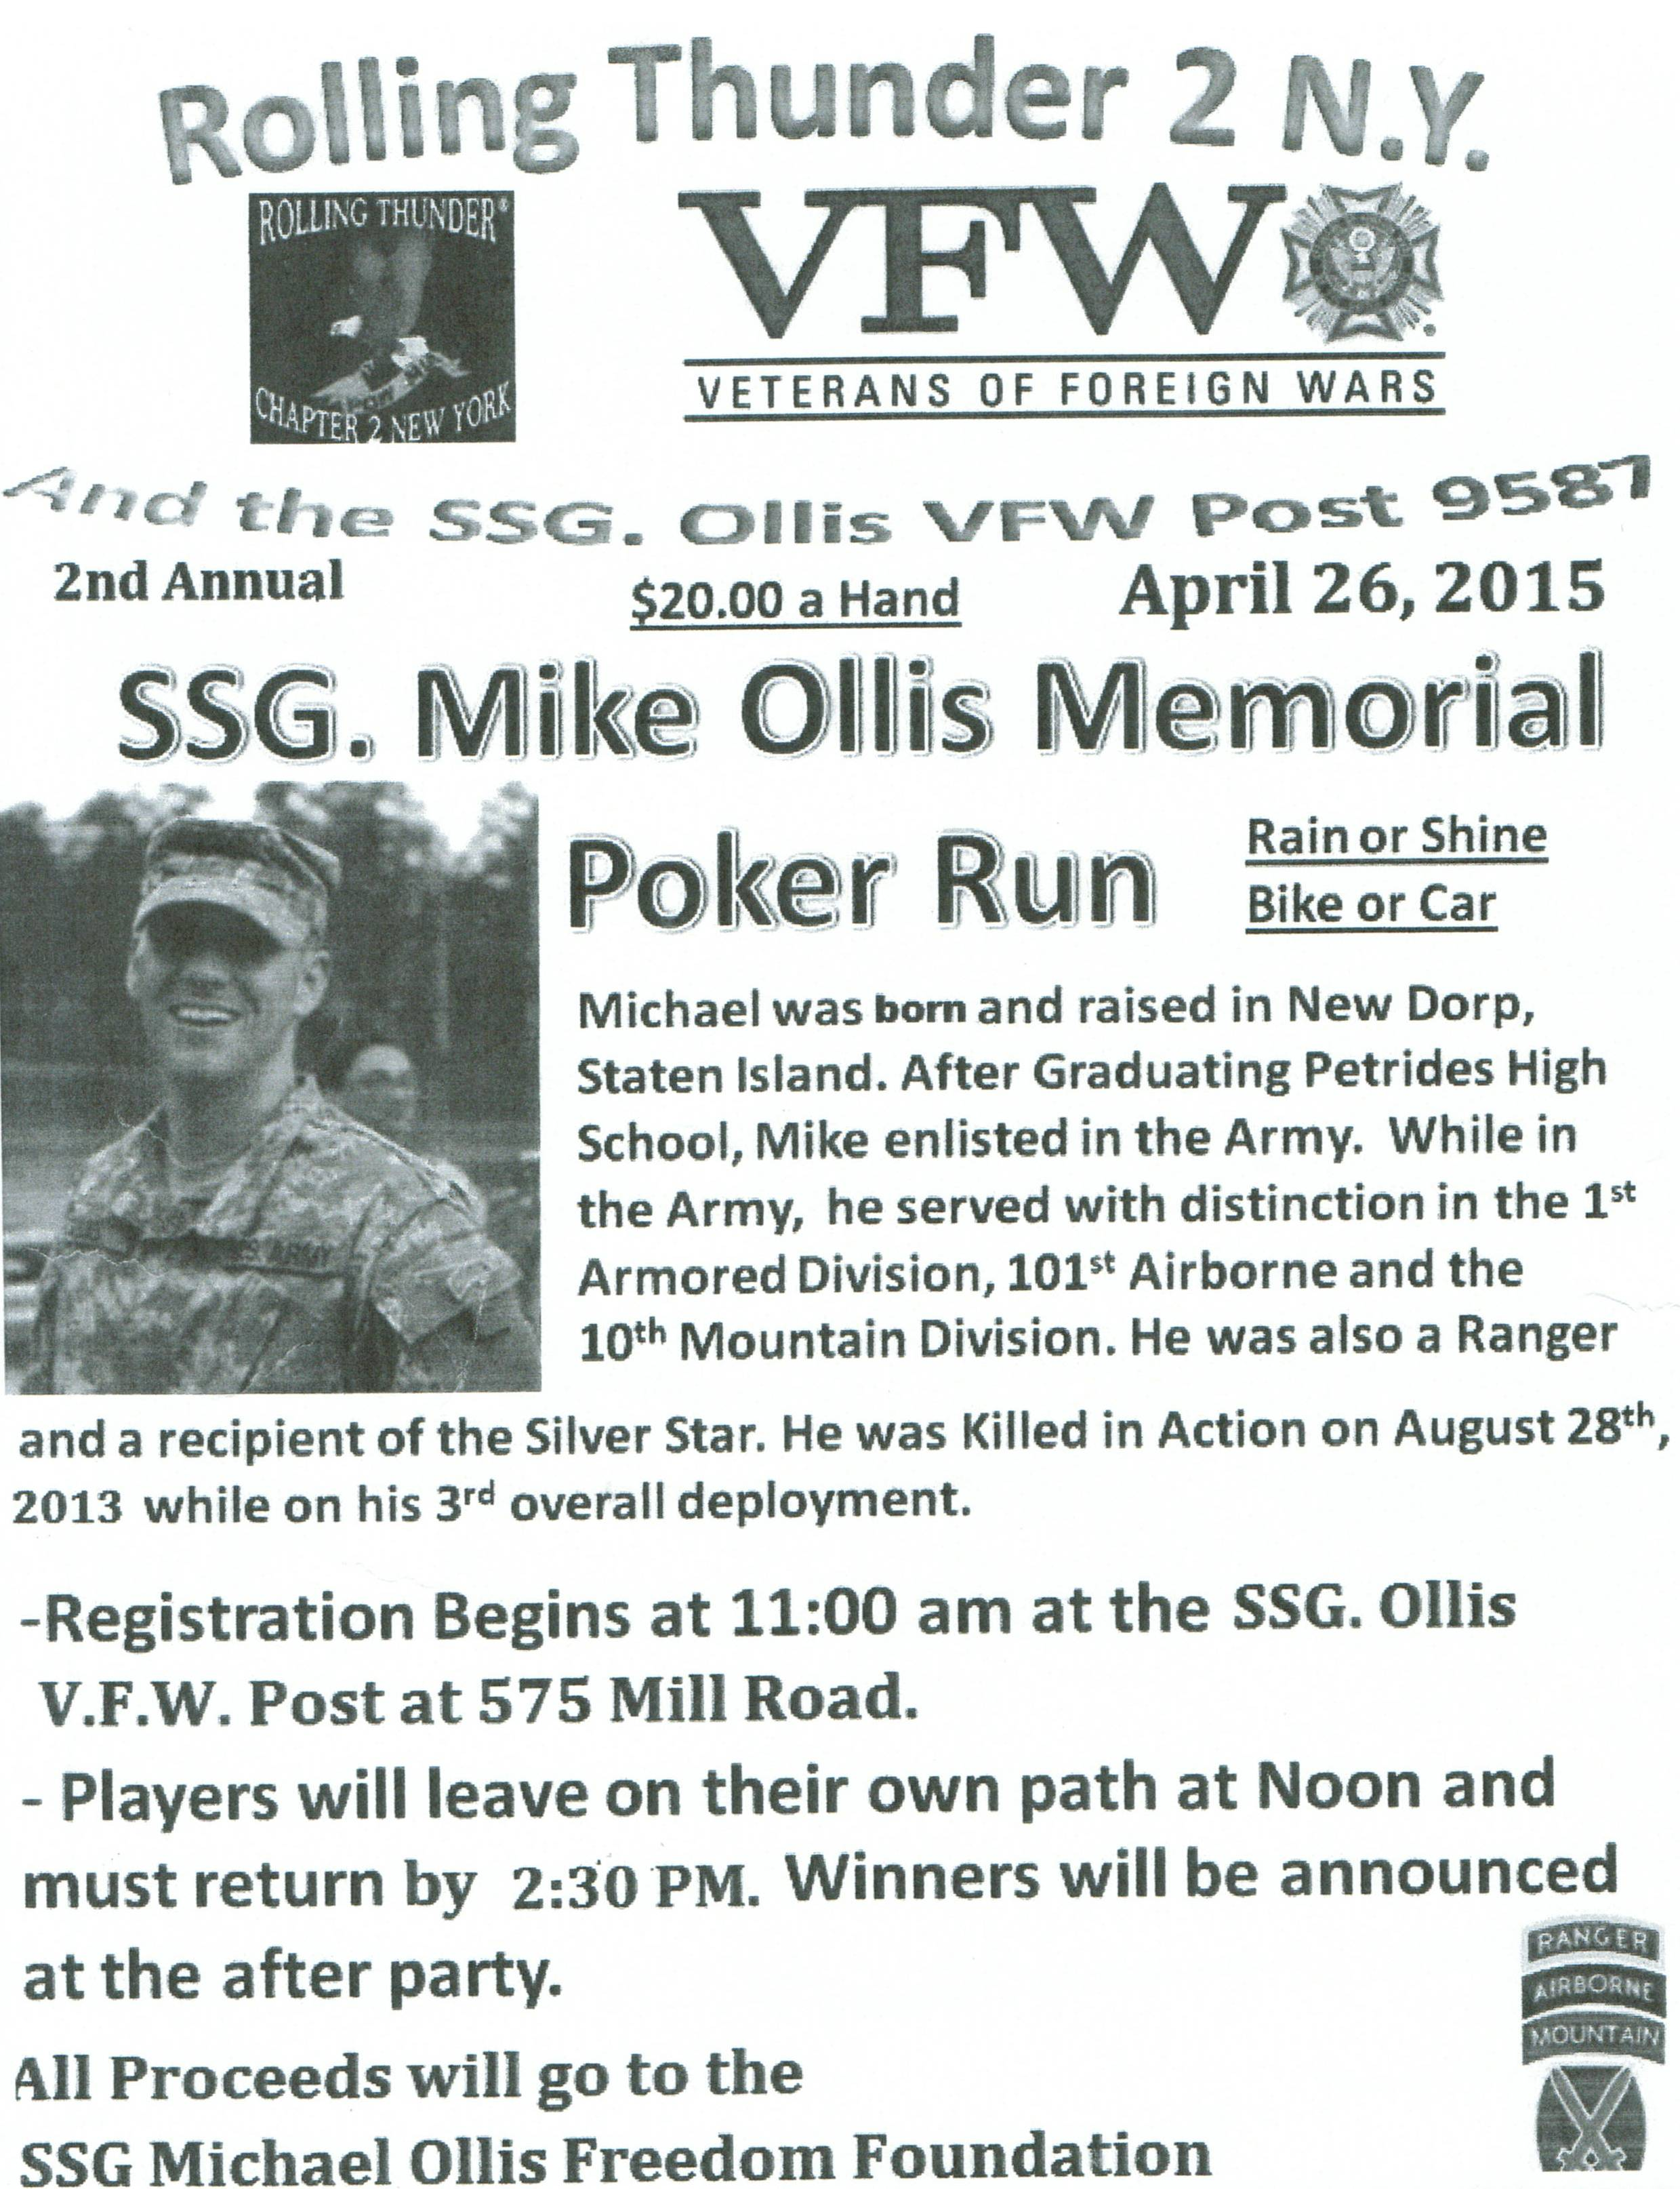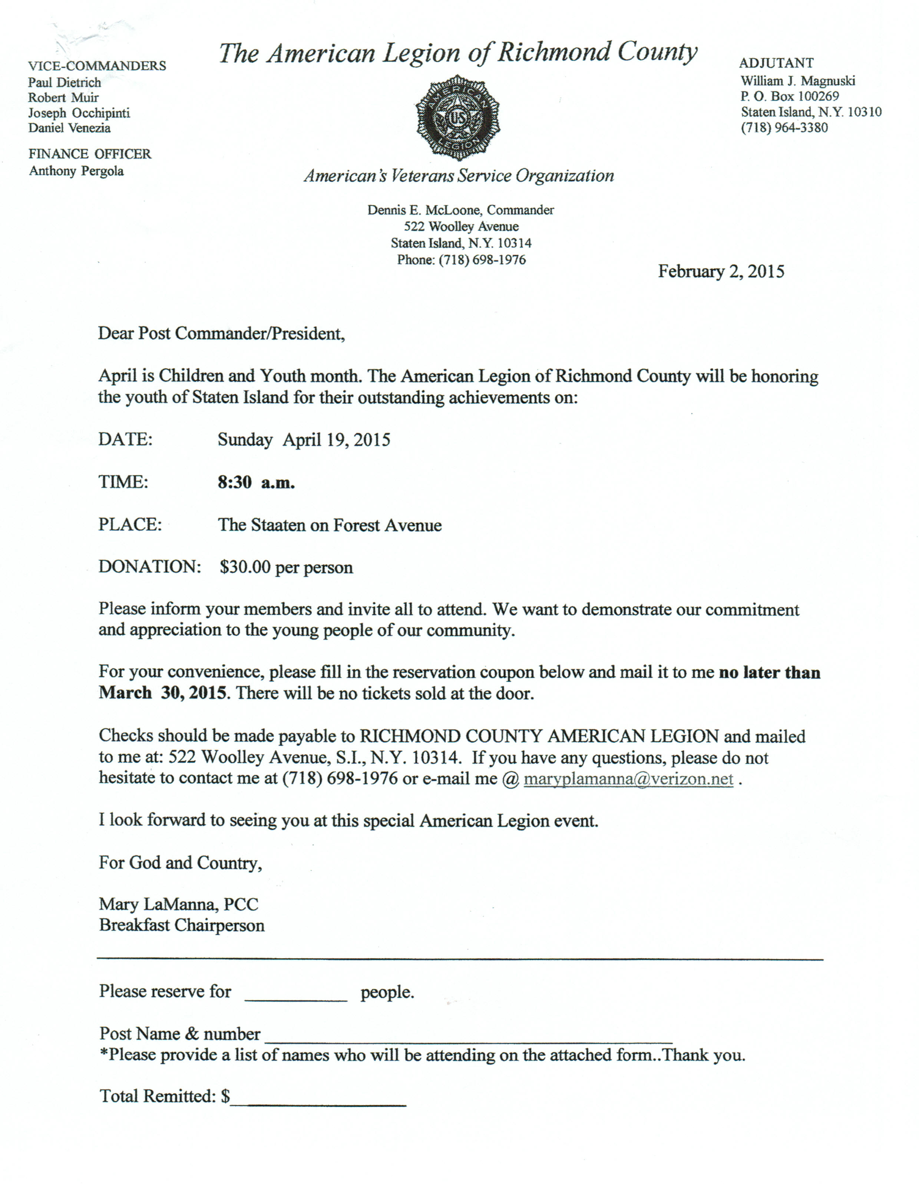

Membership

1. The new dues rate for annual members is $35 per year. Note that dues change was done at the national level. Below are the membership rates for Life membership and Installment Plan Life Membership. Recommend that all members consider installment Life membership when their renewal is due as you save over the long run and eliminate the need to renew yearly.

Age attained on Dec 31 Payment in Full Installment Plan Initial Fee 11 payments of:
Through Age 30 $425.00 $45.00 $38.64
31-40 $410.00 $45.00 $37.27
41-50 $375.00 $45.00 $34.09
51-60 $335.00 $45.00 $30.45
61-70 $290.00 $45.00 $26.36
71-80 $225.00 $45.00 $20.45
81 and over $170.00 $45.00 $15.45

Service Officer

1. Veterans are encouraged to enroll in the VA health care so they are on record should they ever need it. No cost to apply. Apply on line at www.va.gov/healtheligibility/vfw or call 1-877-222-8387.

2. Tri-Care Dental. Tri-Care dental isn't free. You must enroll to be covered. Tri-Care dental web site, www.trdp.org
Delta Dental Tel #. 888-838-8737. The Tri-Care number for NY, is 1-877-874-2273.

3. DD Form 214 website. http://vetrecs.archives.gov. If you need assistance, contact the post service officer, Paul Dietrich.

4. Survivor Outreach Services. The website has a lot of information for those left behind when a service member or veteran passes. http://www.sos.army.mil/ or http://www.westpointmwr.com/acs/survivor_outreach_services.html

5. VA Choice Program Rollout. The Veterans Access, Choice and Accountability Act required VA to start implementation of the Choice Program by November 5, 2014. Starting this week, veterans who live 40 or more miles away from a VA medical facility will have the opportunity to choose whether to receive their health care at VA or in their community, through non-VA doctors. Veterans who live within 40 miles of a VA medical facility, but are currently waiting longer than 30 days for VA care will begin receiving their cards later this month. VA expects that all veterans who were enrolled in the VA health care system on August 1, 2014, will receive their cards by January 2015. However, receiving a Veterans Choice Card does not instantly authorize you to start receiving health care from non-VA doctors. All care received through the Choice Program must be pre-authorized and coordinated by VA.

6. The Department of Veterans Affairs (VA) is working to make filing claims and appeals as fast and easy as possible. Beginning Tuesday, March 24, 2015, claims and appeals must be filed using the appropriate form. Standardizing forms will ease frustration among claimants, make claims processing more efficient and help VA reach more accurate decisions.
There are three major actions that will require a specific form or standardized process: Intent to File, claims applications, and Notice of Disagreement.

When filing a formal claim, the following forms should be completed and submitted to VA either electronically via eBenefits
(ebenefits.va.gov) or the Stakeholder Enterprise Portal (sep.va.gov), or by mailing the completed paper form to VA:
a.. For disability benefits, applicants must now use VA Form 21-526EZ, Application for Disability Compensation and Related Compensation Benefits.
b.. To apply for needs-based pension, use VA Form 21-527EZ, Application for Pension. To file a claim for dependency and indemnity compensation (DIC), survivorâ€™s pension, and accrued benefits, claimants should complete VA Form 21-534EZ, Application for DIC, Death Pension, and/or Accrued Benefits .
Applicants who are not ready to file a claim for disability, but wish to preserve a date of claim while gathering evidence and completing the necessary application form should use one of the following three methods to communicate an intent to file a claim to VA:
a.. 1) electronically via eBenefits (ebenefits.va.gov) or the Stakeholder Enterprise Portal (sep.va.gov),
b.. 2) mailing VA Form 21-0966, Intent to File a Claim for Compensation and/or Pension, or Survivors Pension and/or DIC, or
c.. 3) over the phone with a VA call center representative.
Finally, Veterans filing a Notice of Disagreement with a compensation decision should use VA Form 21-0958, Notice of Disagreement. Veterans and their representatives currently use the form on an optional basis. However, beginning March 24, 2015, Veterans must use this form when VA provides the form with a decision notice letter. Veterans and survivors will not be required to use a standardized notice of disagreement form for other types of claims (i.e., pension or survivors benefits) at this time. If you are unable to download these forms from va.gov/vaforms/, call
800-827-1000 to have the correct form sent to your home. Requiring standard forms will help VA more quickly identify what the applicant is claiming and gather the evidence required to process the claim or appeal. Standardized forms are a key component of VA's transformation, which will help achieve the Department's goal to eliminate the backlog in 2015.

Employment and Education

1. Looking for a job? Need quality employees? USE VETJOBS! www.vetjobs.com

2. Vets looking for jobs, the website: 100000jobsmission.com. Go there to apply and search for available jobs specifically held for veterans.

3. New initiative called the We can't wait program plan helps ex GIs get civilian credentials/licenses for skills learned in the military. For info: http://www.whitehouse.gov/sites/default/files/docs/veterans_report_5-31-2012.pdf

4. Veterans Head Back to Boot Camp to Learn Business Skills. Boots to Business: Reboot is a two-day entrepreneurship workshop presented by the U.S. Small Business Administration and the Institute for Veterans and Military Families (IVMF) available to transitioning service members as a part of the Defense Department’s Transition Assistance Program. Learn
more about the program http://www.military1.com/veterans/article/538543-veterans-head-back-to-boot-camp-to-learn-business-skills.

Bottom of Form

General

1. Staten Island University Hospital's Military Appreciation Program. This program entitles active duty members and veterans free parking 12 times per year at the SIUH parking lot. Call 718-226-4325 for an application.

2. The Defense POW/MIA Office announced the identification of remains belonging to the following personnel. Returned
home are:
- Eight Army Air Forces airmen who had been missing in action since World War II. 1st Lts. William D. Bernier, Bryant E. Poulsen and Herbert V. Young Jr.; Technical Sgts. Charles L. Johnston and Hugh F. Moore; Staff Sgts. John E. Copeland and Charles J. Jones and Sgt. Charles A. Gardner. On April 10, 1944, the B-24D Liberator crewmembers took off from Nazdab Air Field in New Guinea on a mission to attack an anti-aircraft site at Hansa Bay. The aircraft was shot down by enemy anti-aircraft fire.
- Sgt. 1st Class Donald R. Strum, Company C, 19th Infantry Regiment, 24th Infantry Division, who was lost in North Korea on Nov. 4, 1950.
- Cpl. Robert Higgins, 21, Battery C, 15th Field Artillery Battalion, 2nd Infantry Division, when lost in battle in South Korea on Feb. 13, 1951.
- Sgt. Floyd J.R. Jackson, 20, Headquarters Company, 3rd Battalion, 31st Infantry Regiment, 7th Infantry Division died while a POW in North Korea on Feb. 13, 1951.
- Pfc. John R. Bowers, Company L, 3rd Battalion, 9th Infantry Regiment, 2nd Infantry Division, when lost in South Korea on Feb. 14, 1951.
- Sgt. Arnold V. Andring, 25, Company L, 3rd Battalion, 9th Infantry Regiment, 2nd Infantry Division, died while a POW in North Korea after being captured on Feb 14, 1951.
- Pfc. Lotchie J.R. Jones, 18, Company B, 1st Battalion, 8th Cavalry Regiment, 1st Cavalry Division died while a POW in North Korea on Feb. 28, 1951.
- Cpl. Lindsey C. Lockett, 25, Medical Detachment, Headquarters Battery, 503rd Field Artillery Battalion, 2nd Infantry Division died while a POW in North Korea on May 31, 1951.
- Army Air Forces 2nd Lt. Harry B. McGuire, 718th Squadron, 449th Bomber Group, 15th Air Force, lost over Italy on Jan. 30, 1944.
- Army Air Forces 2nd Lt. Edward F. Barker, Headquarters Squadron, 8th Air Service Group, lost over Papua New Guinea on Sept. 30, 1944.
- Army Air Forces 2nd Lt. Alvin Bleethe, 393rd Fighter Squadron, 367th Fighter Group, 9th Air Force, lost over Germany on Nov. 26, 1944.
- Army Air Forces 2nd Lt. Stephen V. Biezis, 575th Bombardment Squadron, 391st Bombardment Group, 9th Air Force, lost over Germany on Dec. 23, 1944.
- Army Air Forces 2nd Lt. John W. Herb, 1st Air Division, 359th Fighter Group, 368th Fighter Squadron, lost over Germany on April 13, 1945.
- Army Sgt. Wallace J. Dawson, Company L. 3rd Battalion, 9th Infantry Regiment, 2nd Infantry Division, lost in South Korea on Feb. 14, 1951.
- Air Force Chief Master Sgt. Edwin E. Morgan, 6252nd Combat Support Group, lost over Laos on March 13, 1966.
- Army Staff Sgt. Bunyan D. Price Jr., 2nd Battalion, 34th Armor Regiment, 1st Cavalry Division, lost in Vietnam on May 2, 1970.
3. CALL GOV CUOMO at 518 474-8390: THE LAST OBSTACLE FOR VETERANS' EQUALITY to place the funded Veteran's Equality Act into the final New York State Budget effective 31 March 2015. Contact Governor Cuomo ((518) 474-8390) and gov.cuomo@chamber.state.ny.us to support the Veterans' Equality Act by agreeing to place it in the NYS Final Budget.

Suggested wording. I know that you agree that all veterans, regardless of where or when they served, are owed a debt of gratitude. Veterans are not given the option of choosing whether or not they will serve in combat or a specific theatre of
operations. It is an absolute disgrace that troops who served in combat in Somalia, Bosnia, Haiti, Kosovo, Afghanistan, Pakistan, and the Korean DMZ are not eligible under current law for military service credit. That is why we must recognize the sacrifices made by all of our veterans by extending the Military Service Credit Law of 2000 to all honorably discharged veterans in the New York State Budget End State: A fully funded Veteran Equality Act in the New York State Budget on March 31, 2015.

4. Cell Phone Numbers Go Public this month. All cell phone numbers are being released to telemarketing companies and you will start to receive sales calls. YOU WILL BE CHARGED FOR THESE CALLS To prevent this, call the following number from your cell phone: 888-382-1222. It is the National DO NOT CALL list It will only take a minute of your time.. It blocks your number for five (5) years. You must call from the cell phone number you want to have blocked. You cannot call from a different phone number.

5. Updated list of Senior Discounts. Uploaded on Blazing Star Web site.

Items of Interest

Bureaucracies
Anybody who's ever worked in a bureaucracy (large OR small) will understand this. Dakota tribal wisdom says that when you discover you are riding a dead horse, the best strategy is to dismount. However, in business we often try other strategies with dead horses, including the following:

1. Buying a bigger whip.
2. Changing riders.
3. Saying things like "This is the way we always have ridden this horse."
4. Appointing a committee to study the horse.
5. Arranging to visit other sites to see how they ride dead horses.
6. Increasing the standards to ride dead horses.
7. Appointing a tiger team to revive the dead horse.
8. Creating a training session to increase our riding ability.
9. Comparing the state of dead horses in today's environment.
10. Change the requirements declaring that "This horse is not dead."
11. Hire contractors to ride the dead horse.
12. Harnessing several dead horses together for increased speed.
13. Declaring that "No horse is too dead to beat."
14. Providing additional funding to increase the horse's performance.
15. Do a cost analysis study to see if contractors can ride it cheaper.
16. Purchase a product to make dead horses run faster.
17. Declare the horse is "better, faster and cheaper" dead.
18. Form a quality circle to find uses for dead horses.
19. Revisit the performance requirements for horses.
20. Say this horse was procured with cost as an independent variable.
21. Promote the dead horse to a supervisory position.

