VETERANS OF FOREIGN WARS BLAZING STAR POST #1574
17 CANNON AVENUE
STATEN ISLAND, NY 10314
Website. http://blazingstarvfwpost1574.org/wp

August 2015

BLAZING STAR POST 1574 CONTACT NUMBERS
Al Porto, Commander - 718-578-1242, albert.porto38@gmail.com
Paul Dietrich, Quartermaster - 718-698-5269, paul@the-dietrichs.com
William Alcock, Adjutant - 718-698-1923

Calendar Events

Calendar of Events for 2015:

Date | Event | Location | Time | Remarks
1 August | Blazing Star Post Meeting | Gold Star Post | 1000
29 August | Military Appreciation Day | Brooklyn Cyclones | 1830 | See Below
2 September | Blazing Star Post Meeting | Gold Star Post | 1300
10 September | Richmond County Council Meeting | Gold Star Post | 1100
19 September | District 2 OTI | Labetti Post | 0900
7 October | Blazing Star Post Meeting | Gold Star Post | 1300
8 October | Richmond County Council Meeting | North Shore Post | 1100
4 November | Blazing Star Post Meeting | Gold Star Post | 1300
5 November (T) | Veterans Day Breakfast | St Adalbert's School | 0815 | 718-442-2020
6 November (T) | Poppy Distribution | SI Ferry | 0700 | Volunteers Needed
6 November (T) | Poppy Distribution | Phillips Refinery | 1100 | Volunteers Needed
7 November (T) | Poppy Distribution | Stop & Shop | 0900 | Volunteers Needed
8 November (T) | Poppy Distribution | Stop & Shop | 0900 | Volunteers Needed
11 November (T) | Memorial Day Ceremony | Travis War Memorial | 0900
11 November (T) | Richmond County VFW Ceremony | Oceanview Cemetery | 1100
11 November | Richmond County Council Meeting | Ollis Post | TBA
14 November (T) | Poppy Distribution | Shop-Rite | 0900 | Volunteers Needed
2 December | Blazing Star Post Meeting | Gold Star Post | 1300
10 December | Richmond County Council Meeting | North Shore Post | 1100

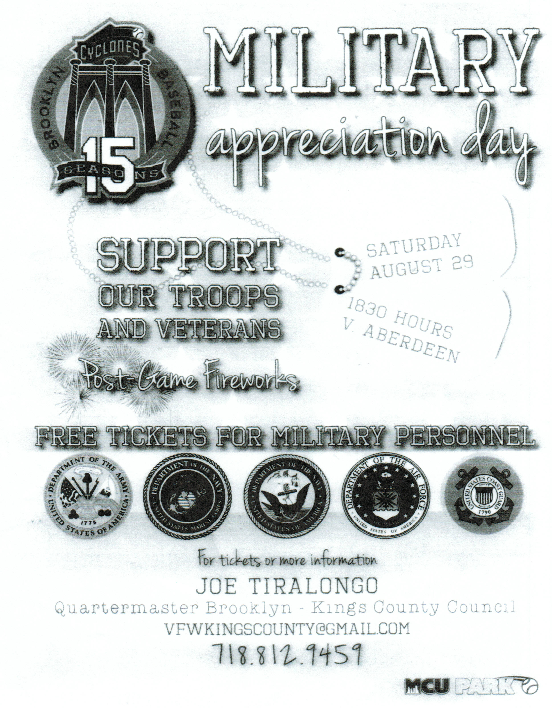 | 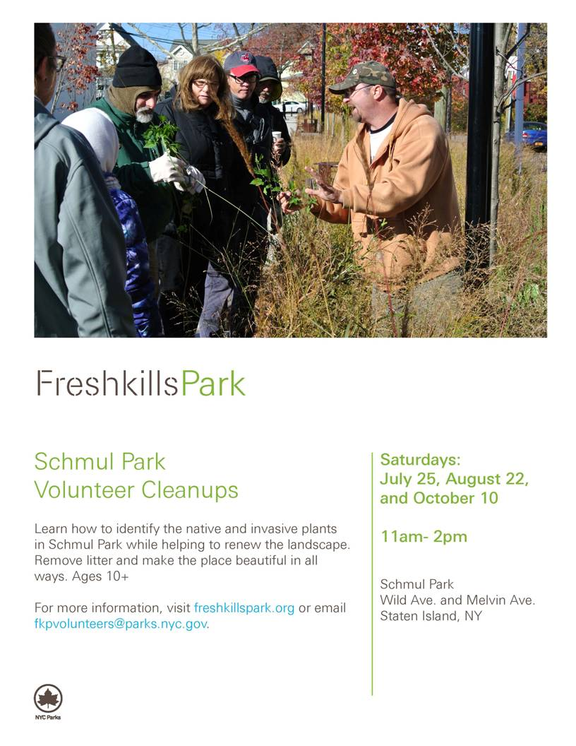

Membership

1. Consider Life Membership. You save money over the long run and eliminate the need to renew yearly. Below are the membership rates for Life membership and Installment Plan Life Membership.
Age attained Payment in Full Installment Plan Option
on Dec. 31st Total: Initial Fee: 11 payments of:
Through Age 30 $425.00 $45.00 $38.64
31-40 $410.00 $45.00 $37.27
41-50 $375.00 $45.00 $34.09
51-60 $335.00 $45.00 $30.45
61-70 $290.00 $45.00 $26.36
71-80 $225.00 $45.00 $20.45
81 and over $170.00 $45.00 $15.45

2. Welcome new members! Joseph C. Sedutto

3. Post member Jim Smith is currently in the Vanderbilt Nursing home rehab section. Jim fell within his house and broke a bone in his foot. Jim would love visitors or phone calls and his number is 718-808-4338.

4. Group photo during welcome home luncheon for Tim Mahoney and his family. The event was captured by CTV and will be shown in the near future on the veterans show "In Honor Of". Tim and his wife and Tim's father were present and thanked the post and its membership for their support and well wishes.
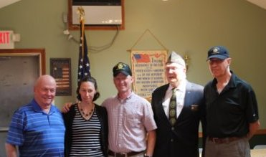

Service Officer

1. Veterans are encouraged to enroll in the VA health care so they are on record should they ever need it. No cost to apply. Apply on line at www.va.gov/healtheligibility/vfw or call 1-877-222-8387.

2. Tri-Care Dental. Tri-Care dental isn't free. You must enroll to be covered. Tri-Care dental web site, www.trdp.org
Delta Dental Tel #. 888-838-8737. The Tri-Care number for NY, is 1-877-874-2273.

3. DD Form 214 website. http://vetrecs.archives.gov. If you need assistance, contact the post service officer, Paul Dietrich.

4. Survivor Outreach Services. The website has a lot of information for those left behind when a service member or veteran passes. http://www.sos.army.mil/ or http://www.westpointmwr.com/acs/survivor_outreach_services.html

5. The Department of Veterans Affairs (VA) is working to make filing claims and appeals as fast and easy as possible. Beginning Tuesday, March 24, 2015, claims and appeals must be filed using the appropriate form. Standardizing forms will ease frustration among claimants, make claims processing more efficient and help VA reach more accurate decisions.
There are three major actions that will require a specific form or standardized process: Intent to File, claims applications, and Notice of Disagreement. When filing a formal claim, the following forms should be completed and submitted to VA either electronically via eBenefits (ebenefits.va.gov) or the Stakeholder Enterprise Portal (sep.va.gov), or by mailing the completed paper form to VA:
a.. For disability benefits, applicants must now use VA Form 21-526EZ, Application for Disability Compensation and Related Compensation Benefits.
b.. To apply for needs-based pension, use VA Form 21-527EZ, Application for Pension. To file a claim for dependency and indemnity compensation (DIC), survivor's pension, and accrued benefits, claimants should complete VA Form 21-534EZ, Application for DIC, Death Pension, and/or Accrued Benefits .
Applicants who are not ready to file a claim for disability, but wish to preserve a date of claim while gathering evidence and completing the necessary application form should use one of the following three methods to communicate an intent to file a claim to VA:
a.. 1) electronically via eBenefits (ebenefits.va.gov) or the Stakeholder Enterprise Portal (sep.va.gov),
b.. 2) mailing VA Form 21-0966, Intent to File a Claim for Compensation and/or Pension, or Survivors Pension and/or DIC, or
c.. 3) over the phone with a VA call center representative.
Finally, Veterans filing a Notice of Disagreement with a compensation decision should use VA Form 21-0958, Notice of Disagreement. Veterans and their representatives currently use the form on an optional basis. However, beginning March 24, 2015, Veterans must use this form when VA provides the form with a decision notice letter. Veterans and survivors will not be required to use a standardized notice of disagreement form for other types of claims (i.e., pension or survivors benefits) at this time. If you are unable to download these forms from va.gov/vaforms/, call
800-827-1000 to have the correct form sent to your home. Requiring standard forms will help VA more quickly identify what the applicant is claiming and gather the evidence required to process the claim or appeal. Standardized forms are a key component of VA's transformation, which will help achieve the Department's goal to eliminate the backlog in 2015. Contact data for VSO on website. Do not file with VSO review.

6. All paid up members of Post 1574 were enrolled in Group Accidental Death and Dismemberment insurance paid for by the post. Coverage is for $1000 and is with the Lockton Affinity LLC, PO box 87-9610 of Kansas City MO 64187-9610. Please keep information on this policy with your family important documents for your relatives and heirs.

Employment and Education

1. Looking for a job? Need quality employees? USE VETJOBS! www.vetjobs.com

2. Vets looking for jobs, the website: 100000jobsmission.com. Go there to apply and search for available jobs specifically held for veterans.

3. New initiative called the We can't wait program plan helps ex GIs get civilian credentials/licenses for skills learned in the military. For info: http://www.whitehouse.gov/sites/default/files/docs/veterans_report_5-31-2012.pdf

4. Veterans Head Back to Boot Camp to Learn Business Skills. Boots to Business: Reboot is a two-day entrepreneurship workshop presented by the U.S. Small Business Administration and the Institute for Veterans and Military Families (IVMF) available to transitioning service members as a part of the Defense Department’s Transition Assistance Program. Learn
more about the program http://www.military1.com/veterans/article/538543-veterans-head-back-to-boot-camp-to-learn-business-skills.

Bottom of Form

General

1. Staten Island University Hospital's Military Appreciation Program. This program entitles active duty members and veterans free parking 12 times per year at the SIUH parking lot. Call 718-226-4325 for an application.

2. The Defense POW/MIA Office announced the identification of remains belonging to the following personnel. Returned
home are:
- Army Sgt. 1st Class John C. Keller, 26, who had been missing in action since the Korean War. In November 1950, Keller was assigned to Company K, 3rd Battalion, 8th Cavalry Regiment, 1st Cavalry Division, when his unit was forced into a fighting withdrawal from their position northwest of Unsan, North Korea. He was reported missing on Nov. 2, 1950. It would be later learned he had been captured by the Chinese, but died in 1951 as a result of malnutrition and medical neglect.
- Army Pvt. Arthur H. Kelder, 26, On Dec. 8, 1941, Kelder was assigned to the Philippine Department, U.S. Army Forces in the Far East, when Japanese forces invaded the Philippine Islands. Thousands of U.S. and Filipino service members were taken prisoner and forced to endure the Bataan Death March en route to Japanese POW camps. Kelder was among those reported captured after the surrender of Corregidor. On Nov. 19, 1942, 14 Americans, including Kelder, were reported to have died. They were buried by their fellow prisoners in a common grave in a local camp cemetery in Cabanatuan.

3. DNA Samples Needed for MIA Identifications There are 83,000 missing and unaccounted for Americans from World War II forward, yet many families of the missing have yet to provide a family reference sample to assist in DNA identifications. Currently, 89 percent of Korean War families have provided samples, as well as 83 percent of Cold War families and 81 percent of Vietnam War families, but only 4 percent of WWII families have. The government last year identified 107 MIAs, but more could have been identified-and faster-if more family reference samples were on file. Please forward the following service casualty office contact information to MIA families in your hometown, as well as to local newspapers:

Army: 800-892-2490 | Navy: 800-443-9298 | State Department: 202-485-6106
Marine Corps: 800-847-1597 | Air Force: 800-531-5501

Items of Interest

Dollar Bill

Take out a one dollar bill and look at it. The one dollar bill you're looking at first came off the presses in 1957 in its present design. This so-called paper money is in fact a cotton and linen blend, with red and blue minute silk fibers running through it. It is actually material. We've all washed it without it falling apart. A special blend of ink is used, the contents we will never know. It is overprinted with symbols and then it is starched to make it water resistant and pressed to give it that nice crisp look. If you look on the front of the bill, you will see the United States Treasury Seal. On the top you will see the scales for the balance-a balanced budget. In the center you have a carpenter's T-square, a tool used for an even cut. Underneath is the Key to the United States Treasury. That's all pretty easy to figure out, but what is on the back of that dollar bill is something we should all know. If you turn the bill over, you will see two circles. Both circles, together, comprise the Great Seal of the United States. The First Continental Congress requested that Benjamin Franklin and a group of men come up with a Seal. It took them four years to accomplish this task and another two years to get it approved. If you look at the left hand circle, you will see a Pyramid. Notice the face is lighted and the western side is dark. This country was just beginning. We had not begun to explore the West or decided what we could do for Western Civilization. The Pyramid is un-capped, again signifying that we were not even close to being finished. Inside the capstone you have the all-seeing eye, and ancient symbol for divinity. It was Franklin's belief that one man couldn't do it alone, but a group of men, with the help of God, could do anything. "IN GOD WE TRUST" is on this currency. The Latin above the pyramid, ANNUIT COEPTIS, means "God has favored our undertaking." The Latin below the pyramid, NOVUS ORDO SECLORUM, means "a new order has begun." At the base of the pyramid is the Roman Numeral for 1776. If you look at the right-hand circle, and check it carefully, you will learn that it is on every National Cemetery in the United States. It is also on the Parade of Flags Walkway at the Bushnell, Florida National Cemetery and is the centerpiece of most hero's monuments. Slightly modified, it is the seal of the President of the United States and it is always visible whenever he speaks, yet no one knows what the symbols mean. The Bald Eagle was selected as a symbol for victory for two reasons: first, he is not afraid of a storm; he is strong and he is smart enough to soar above it. Secondly, he wears no material crown. We had just broken from the King of England. Also, notice the shield is unsupported. This country can now stand on its own. At the top of that shield you have a white bar signifying congress, a unifying factor. We were coming together as one nation. In the Eagle's beak you will read, "E PLURIBUS UNUM", meaning "one nation from many people." Above the Eagle you have thirteen stars representing the thirteen original colonies, and any clouds of misunderstanding rolling away. Again, we were coming together as one. Notice what the Eagle holds in his talons. He holds an olive branch and arrows. This country wants peace, but we will never be afraid to fight to preserve peace. The Eagle always wants to face the olive branch, but in time of war, his gaze turns toward the arrows. They say that the number 13 is an unlucky number. This is almost a worldwide belief. You will usually never see a room numbered 13, or any hotels or motels with a 13th floor. But, think about this: 13 original colonies, 13 signers of the Declaration of
Independence, 13 stripes on our flag, 13 steps on the Pyramid, 13 letters in the Latin above, 13 letters in "E Pluribus Unum", 13 stars above the Eagle, 13 plumes of feathers on each span of the Eagle's wing, 13 bars on that shield, 13 leaves on the olive branch, 13 fruits, and if you look closely, 13 arrows. And for minorities: the 13th Amendment. I always ask people, "Why don't you know this?" Your children don't know this and their history teachers don't know this. Too many veterans have given up too much to ever let the meaning fade. Many veterans remember coming home to an America that didn't care. Too many veterans never came home at all. Tell everyone what is on the back of the one dollar bill and what it stands for, because nobody else will.

