VETERANS OF FOREIGN WARS BLAZING STAR POST #1574
17 CANNON AVENUE
STATEN ISLAND, NY 10314
Website. http://blazingstarvfwpost1574.org/wp

October 2015

BLAZING STAR POST 1574 CONTACT NUMBERS
Al Porto, Commander - 718-578-1242, albert.porto38@gmail.com
Paul Dietrich, Quartermaster - 718-698-5269, paul@the-dietrichs.com
William Alcock, Adjutant - 718-698-1923

Calendar Events

Calendar of Events for 2015:

Date | Event | Location | Time | Remarks
7 October | Blazing Star Post Meeting | Gold Star Post | 1300
8 October | Richmond County Council Meeting | North Shore Post | 1100
11 October | Msgr Farrell BBQ for Veterans | Msgr Farrell HS | 1200-1700 | 718-987-2900
4 November | Blazing Star Post Meeting | Gold Star Post | 1300
5 November | Veterans Day Breakfast | St Adalbert's School | 0800 | 718-442-2020
6 November | Poppy Distribution | SI Ferry | 0700 | Volunteers Needed
6 November | Poppy Distribution | Phillips Refinery | 1100 | Volunteers Needed
7 November (T) | Poppy Distribution | Stop & Shop | 0900 | Volunteers Needed
8 November (T) | Poppy Distribution | Stop & Shop | 0900 | Volunteers Needed
11 November (T) | Veterans Day Ceremony | Travis War Memorial | 0900
11 November (T) | Richmond County VFW Ceremony | To Be Determined | TBA
11 November | Richmond County Council Meeting | Ollis Post | TBA
14 November (T) | Poppy Distribution | Shop-Rite | 0900 | Volunteers Needed
2 December | Blazing Star Post Meeting | Gold Star Post | 1300
10 December | Richmond County Council Meeting | North Shore Post | 1100

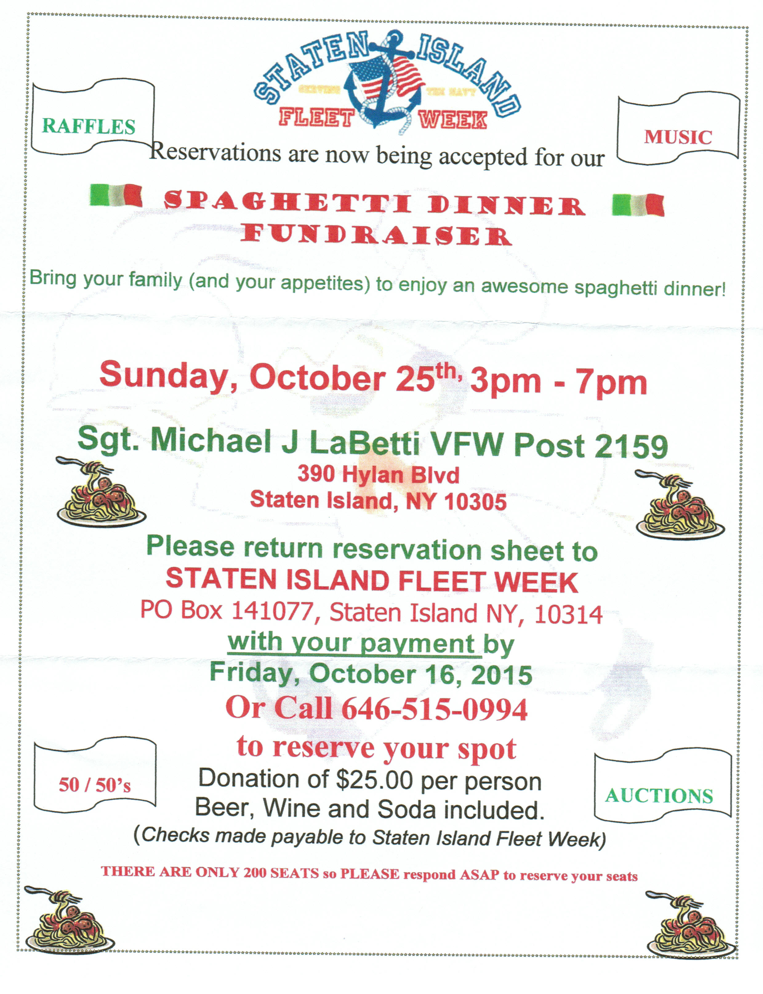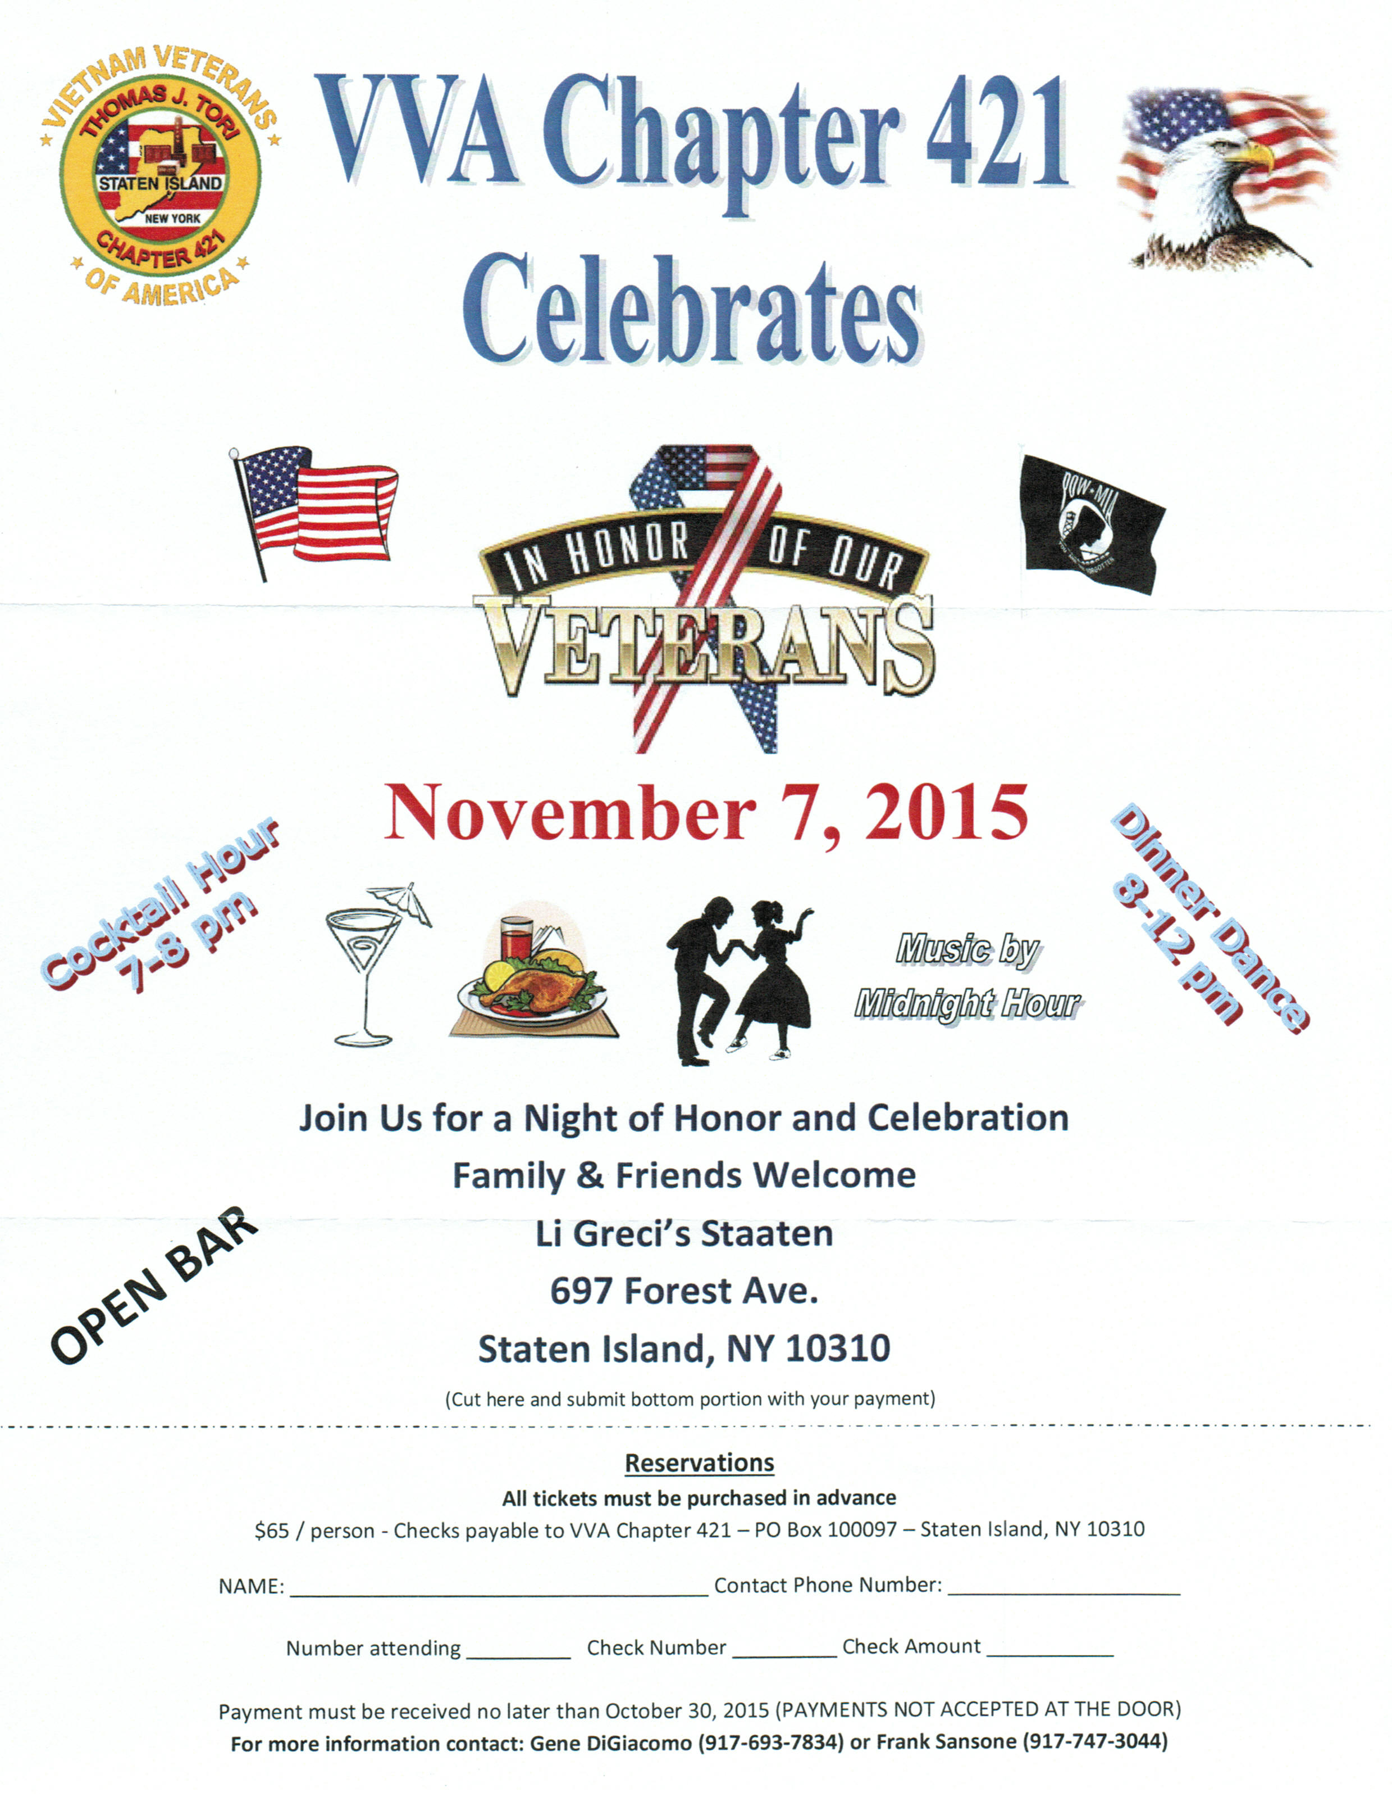

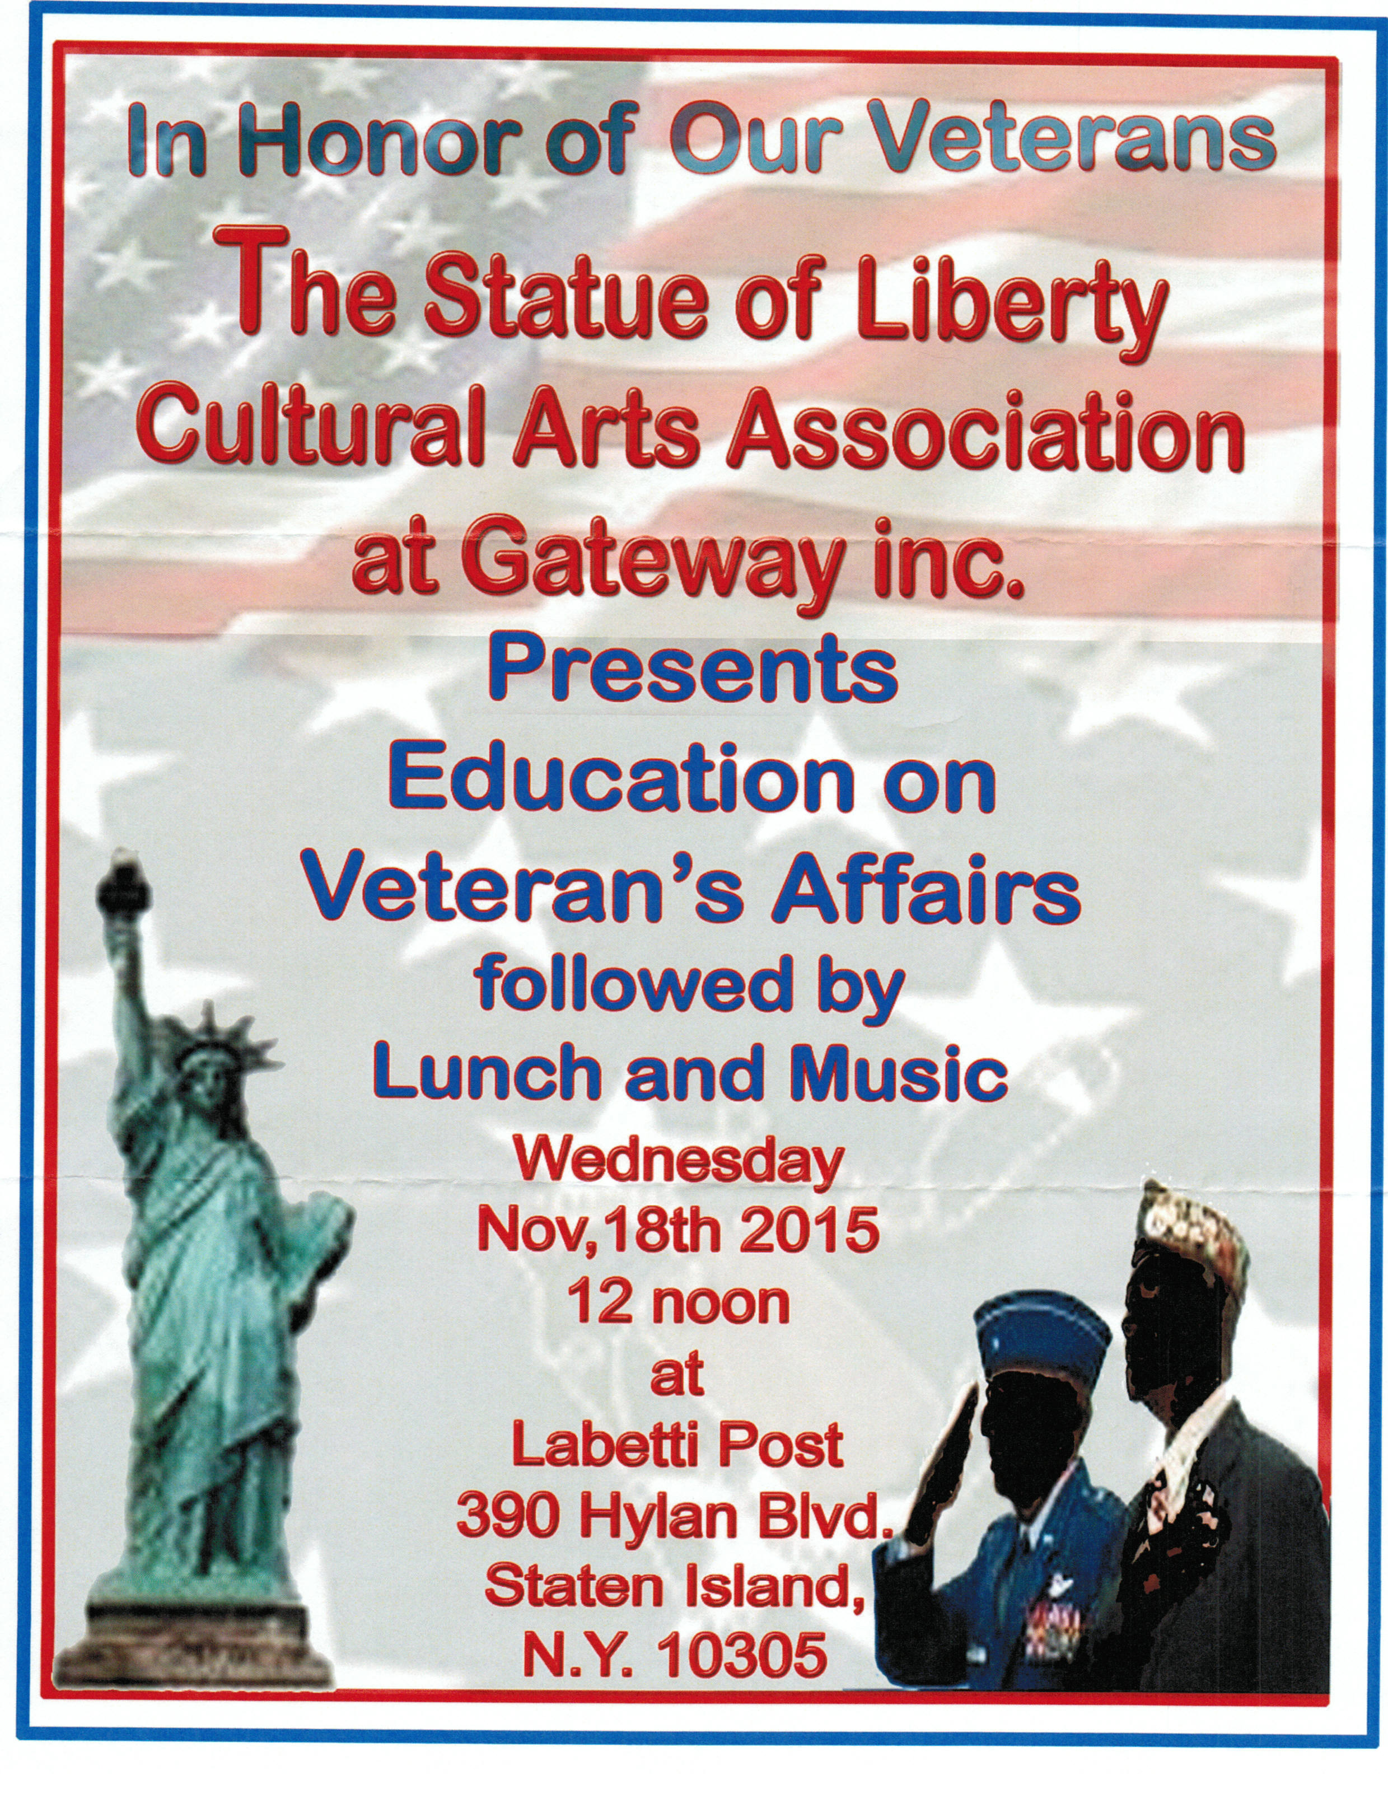

Membership

1. Consider Life Membership. You save money over the long run and eliminate the need to renew yearly. Below are the membership rates for Life membership and Installment Plan Life Membership.
Age attained Payment in Full Installment Plan Option
on Dec. 31st Total: Initial Fee: 11 payments of:
Through Age 30 $425.00 $45.00 $38.64
31-40 $410.00 $45.00 $37.27
41-50 $375.00 $45.00 $34.09
51-60 $335.00 $45.00 $30.45
61-70 $290.00 $45.00 $26.36
71-80 $225.00 $45.00 $20.45
81 and over $170.00 $45.00 $15.45

2. MAJ Adam Scher, one of our members, has returned from Iraq and has started teaching again at West Point. He thanks everyone for their support.

3. Dues Renewal Reminder:

Member Name | Paid Thru | Days Remaining
Antoniello, Anthony R | 12/31/2015 | 87
Buttermark, Paul J | 12/31/2015 | 87
Curry, Albert | 12/31/2015 | 87
Delsante Sr, Joseph | 12/31/2015 | 87
Griffo, Arnold P | 12/31/2015 | 87
Guerra, Eugene D | 12/31/2015 | 87
Khoury, Theodore | 12/31/2015 | 87
Manna, Michael L | 12/31/2015 | 87
Osowiecki, Alphonse | 12/31/2015 | 87
Palmieri, Mario A | 12/31/2015 | 87
Ramirez, Elvin | 12/31/2015 | 87AutoPay
Scher, Adam A | 12/31/2015 | 87
Sjursen, Daniel A | 12/31/2015 | 87
Smith, Gerald F | 12/31/2015 | 87
Sogomonyan, Fianna | 12/31/2015 | 87
Squicciarini, John | 12/31/2015 | 87
Treadaway, Ann M | 12/31/2015 | 87
Vail, Michael S | 12/31/2015 | 87

Service Officer

1. Veterans are encouraged to enroll in the VA health care so they are on record should they ever need it. No cost to apply. Apply on line at www.va.gov/healtheligibility/vfw or call 1-877-222-8387.

2. Tri-Care Dental. Tri-Care dental isn't free. You must enroll to be covered. Tri-Care dental web site, www.trdp.org
Delta Dental Tel #. 888-838-8737. The Tri-Care number for NY, is 1-877-874-2273.

3. DD Form 214 website. http://vetrecs.archives.gov. If you need assistance, contact the post service officer, Paul Dietrich.

4. Survivor Outreach Services. The website has a lot of information for those left behind when a service member or veteran passes. http://www.sos.army.mil/ or http://www.westpointmwr.com/acs/survivor_outreach_services.html

5. The Department of Veterans Affairs (VA) is working to make filing claims and appeals as fast and easy as possible. Beginning Tuesday, March 24, 2015, claims and appeals must be filed using the appropriate form. Standardizing forms will ease frustration among claimants, make claims processing more efficient and help VA reach more accurate decisions.
There are three major actions that will require a specific form or standardized process: Intent to File, claims applications, and Notice of Disagreement. When filing a formal claim, the following forms should be completed and submitted to VA either electronically via eBenefits (ebenefits.va.gov) or the Stakeholder Enterprise Portal (sep.va.gov), or by mailing the completed paper form to VA:
a.. For disability benefits, applicants must now use VA Form 21-526EZ, Application for Disability Compensation and Related Compensation Benefits.
b.. To apply for needs-based pension, use VA Form 21-527EZ, Application for Pension. To file a claim for dependency and indemnity compensation (DIC), survivor's pension, and accrued benefits, claimants should complete VA Form 21-534EZ, Application for DIC, Death Pension, and/or Accrued Benefits .

Applicants who are not ready to file a claim for disability, but wish to preserve a date of claim while gathering evidence and completing the necessary application form should use one of the following three methods to communicate an intent to file a claim to VA:
a.. 1) electronically via eBenefits (ebenefits.va.gov) or the Stakeholder Enterprise Portal (sep.va.gov),
b.. 2) mailing VA Form 21-0966, Intent to File a Claim for Compensation and/or Pension, or Survivors Pension and/or DIC, or
c.. 3) over the phone with a VA call center representative.
Finally, Veterans filing a Notice of Disagreement with a compensation decision should use VA Form 21-0958, Notice of Disagreement. Veterans and their representatives currently use the form on an optional basis. However, beginning March 24, 2015, Veterans must use this form when VA provides the form with a decision notice letter. Veterans and survivors will not be required to use a standardized notice of disagreement form for other types of claims (i.e., pension or survivors benefits) at this time. If you are unable to download these forms from va.gov/vaforms/, call
800-827-1000 to have the correct form sent to your home. Requiring standard forms will help VA more quickly identify what the applicant is claiming and gather the evidence required to process the claim or appeal. Standardized forms are a key component of VA's transformation, which will help achieve the Department's goal to eliminate the backlog in 2015. Contact data for VSO on website. Do not file with VSO review.

6. All paid up members of Post 1574 were enrolled in Group Accidental Death and Dismemberment insurance paid for by the post. Coverage is for $1000 and is with the Lockton Affinity LLC, PO box 87-9610 of Kansas City MO 64187-9610. Please keep information on this policy with your family important documents for your relatives and heirs.

7. To someone going through a difficult time, one simple act has the power to make a difference. Reach out to veterans and service members in your life today – let them know they’re not alone. Find out how you can make a difference http://www.veteranscrisisline.net/ThePowerof1.aspx.

Employment and Education

1. Looking for a job? Need quality employees? USE VETJOBS! www.vetjobs.com

2. Vets looking for jobs, the website: 100000jobsmission.com. Go there to apply and search for available jobs specifically held for veterans.

3. New initiative called the We can't wait program plan helps ex GIs get civilian credentials/licenses for skills learned in the military. For info: http://www.whitehouse.gov/sites/default/files/docs/veterans_report_5-31-2012.pdf

4. Veterans Head Back to Boot Camp to Learn Business Skills. Boots to Business: Reboot is a two-day entrepreneurship workshop presented by the U.S. Small Business Administration and the Institute for Veterans and Military Families (IVMF) available to transitioning service members as a part of the Defense Department’s Transition Assistance Program. Learn
more about the program http://www.military1.com/veterans/article/538543-veterans-head-back-to-boot-camp-to-learn-business-skills.

Bottom of Form

5. VFW’s Help A Hero Program is Accepting Applications. Eligible service members and veterans are encouraged to apply for spring 2016 scholarships. Enacted in 2013, the VFW’s “Sport Clips Help A Hero Scholarship” program has

awarded more than $1.2 million in scholarship funds to nearly 300 service members and veterans. Applications are now being accepted and the deadline to apply is Nov.15. Get the details http://www.vfw.org/scholarship/.

6. Job info. Seeking Video grapher / Editor. Experience required. Working knowledge of Panasonic AG-HMC 150 Camera. Proficient in use of Final Cut Pro editing. Must have a vehicle. Forward contact info and resume to SIVidher@Aol.com.
7. First Place wins $30,000! Do you know a high school student who could use some help paying for college?
Let them know about the VFW's Voice of Democracy Scholarship competition! This Year's Topic: My Vision for America. ENTRY DEADLINE: November 1, 2015. All students in grades 9-12 can apply. We want to reach as many patriotic students as possible to compete for the grand prize: $30,000 paid directly to the American college, university or vocational/technical school of their choice! Download the application.
Pass the word on to:
- High School Students
- Teachers
- Counselors
- Youth Groups
- Parent-Teacher Associations
- School Boards
General

1. Staten Island University Hospital's Military Appreciation Program. This program entitles active duty members and veterans free parking 12 times per year at the SIUH parking lot. Call 718-226-4325 for an application.

2. The Defense POW/MIA Office announced the identification of remains belonging to the following personnel. Returned
home are:

* Marine Corps 1st Lt. Alexander "Sandy" Bonnyman, 33, Company F, 2nd Battalion, 18th Marines Regiment, 2nd Marine Division, who would be posthumously awarded the Medal of Honor for his heroic actions fighting on the Tarawa Atoll in the Gilbert Islands, Nov. 11, 1943.
* Navy Lt. j.g. Neil B. Taylor, 26, will be buried in his hometown with full military honors on Sept. 14, exactly 50 years after the A-4C Skyhawk he was piloting crashed while on a bombing mission over Bac Lieu Province, Vietnam, on Sept. 14, 1965.
* Marine Corps Pfc. James P. Reilly and Cpl. James D. Otto, who were both killed in action on Nov. 20, 1943, while fighting on the Pacific island of Tarawa. They were assigned to Company L, 3rd Battalion, 8th Marines, 2nd Marine Division.
* Army Cpl. Robert E. Meyers, Company A, 2nd Engineer Combat Battalion, 2nd Infantry Division, when he died fighting in North Korea on Dec. 1, 1950.
* Army Cpl. George H. Mason, 2nd Reconnaissance Company, 2nd Infantry Division, died while fighting in North Korea on Feb. 14, 1951.
* Army Cpl. Martin A. King, Company E, 2nd Battalion, 8th Cavalry Regiment, 1st Cavalry Division, declared missing in action while fighting in North Korea on Nov. 2, 1950.
* Army Cpl. Robert V. Witt, 20, 1st Battalion, 32nd Infantry Regiment, 7th Infantry Division, captured while fighting in North Korea on Dec. 2, 1950. He reportedly died in a North Korean prisoner of war camp on Jan. 31, 1951.
* Army Pfc. Frank Worley, 21, County, N.C., Battery A, 503rd Field Artillery Battalion, 2nd Infantry Division.
was declared missing in North Korea on Feb. 12, 1951. It was later learned he had been captured, but died in captivity.
* Army Cpl. Robert P. Graham, Company A, 13th Engineer Combat Battalion, 7th Infantry Division, was declared missing in North Korea on Feb. 13, 1951. It was later learned he had been captured, but died in captivity.

3. The Defense POW/MIA Accounting Agency is seeking the public’s help to find and encourage more MIA families to donate a DNA sample to help speed the identification process of recovered remains. Currently, 89 percent of the Korean War’s 7,800 MIAs have a family reference sample on file, 84 percent for the Cold War’s 126 MIAs, and 81 percent of the Vietnam War’s 1,600 missing. But for World War II, it’s a dismal 4 percent of the 73,500 who are still missing. Each military service and the State Department has a service casualty office that can explain how to donate.

Army: 800-892-2490 | Navy: 800-443-9298 | State Department: 202-485-6106
Marine Corps: 800-847-1597 | Air Force: 800-531-5501

4. Free parking for veterans at Richmond County Medical Center. Veterans can park for free in the visitors parking lot where tokens are normally required. Stop at the main reception desk or security post, show proof you are a veteran (drivers license with vet on it, retired ID card, VA card or similar) and they will give you a free token for the parking lot. Get it on the way in as the reception/info desk is not manned all night. Use the token to exit the lot. Saves you $4 per visit.

5. Philip Napoli, Associate Professor at Brooklyn College and author of Bringing It All Back Home: An Oral History of New York City's Vietnam Veterans. He is also an associate member of VVA Chapter 72. This semester he is
teaching a course on the history of the Vietnam War. As part of the course, he requires that his students interview people with significant memories of the Vietnam era. On the basis of two interviews, the students will write an essay. If interviewees agree, the recordings of the conversation will be archived and made publicly available. Many of his students want to interview men and women who served in Vietnam. If you are willing to be interviewed by a Brooklyn College student about your experiences in Vietnam, please contact him at pnapoli@brooklyn.cuny.edu. He will pass your contact
information to a student, and they will be in touch with you directly, to set up a meeting or telephone conversation. Thank you for considering this! Philip F. Napoli Richie Chan Treasurer Membership Chairman Website and Newsletter Editor Vietnam Veterans of America Chapter 72, Brooklyn, NY www.vvachapter72.com

6. 'Farcing' scam targets social media users and their friends lists. According to the Better Business Bureau, “farcing” involves a criminal “friending” a victim through a phony social media account to steal their identity. The victim is then fooled into giving up personal information. From there, other people on the victim’s friends list can be lured into "friending" the same criminal and the scam continues. The BBB said those using farcing can learn a great deal about individuals and their friends depending on what the victims share through their social media accounts. The info they snatch can include names, academic histories, hometowns, employment records, relatives’ names, pets and so forth. From there, it’s not that hard to obtain telephone numbers, home addresses and salary information. As a result, the BBB said the victim’s identity could be stolen. The BBB said it has seen this activity take place over Twitter, Facebook, LinkedIn and Google Plus. Officials said users should be selective over who they accept on friends lists. Users are also recommended to tighten their privacy settings and limit the amount of information that they share on profiles. It also warned that some of the information posted on people’s profiles can be used in password-reset questions. Hometowns and pet names are popular choices for questions that can be guessed with information posted to profiles.

Items of Interest
The Service Flag

The Service Flag (also known as the Blue Star Flag or the Service Star Flag) is a banner authorized by the Department of Defense for display during wartime by families with members serving in the armed forces. The rectangular flag, which has a white field with a red border, holds one blue star (symbolizing hope and pride) for each immediate family member in the armed forces. A blue star is covered with a gold star (symbolizing sacrifice to the cause of freedom) when a family member is killed or dies while serving in the armed forces. The tradition of the Service Flag dates to World War I, when Captain Robert L. Queissner of the 5th Ohio Infantry designed the banner to honor two sons serving on the front lines. On September 24, 1917, Ohio congressman Ivory Emerson introduced the flag to Congress, explaining that it was a tribute to those families who gave to this great cause of liberty . . . the dearest thing in all the world to a father and mother are their children. Banners began to appear in the windows of homes across the country, to symbolize loved ones in service. The Service Flag saw widespread use during World War II but was less popular by the time of the Vietnam War. The tradition began to revive during the 1990 Persian Gulf War and the War on Terror. Organizations such as businesses, churches, and schools may also honor members fighting in the armed forces by displaying Service Flags.

