VETERANS OF FOREIGN WARS BLAZING STAR POST #1574
17 CANNON AVENUE
STATEN ISLAND, NY 10314
Website. http://blazingstarvfwpost1574.org/wp

November 2015

BLAZING STAR POST 1574 CONTACT NUMBERS
Al Porto, Commander - 718-578-1242, albert.porto38@gmail.com
Paul Dietrich, Quartermaster - 718-698-5269, paul@the-dietrichs.com
William Alcock, Adjutant - 718-698-1923

IN MEMORIUM

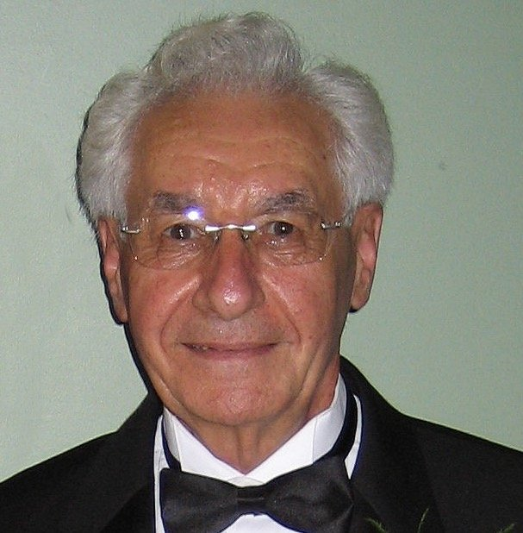
Rocco (Rocky) Speranza, 87, of Port Richmond, a loving husband and father who was active in several veterans' organizations, died Friday in Richmond University Medical Center. Born in Manhattan, Mr. Speranza had lived in Port Richmond since infancy. A graduate of McKee Vocational High School and served in Korea with the U.S. Army, attaining the rank of corporal. Rocco was awarded a presidential citation and three Battle Stars. A longtime employee of the city Department of Transportation, Rocco rose to the position of supervisor of auto mechanics at the West Brighton location during his 32 years with the agency. He retired in 1990. Rocco was an avid gardener and a handyman. Through the years, he traveled the world and the U.S. with his wife. He was a member of the Corporal Allan F. Kivlehan Chapter, Korean War Veterans Association and the Gold Star Post of the American Legion. He was also the Chaplain of the Blazing Star Post of the Veterans of Foreign Wars. He was a parishioner of St. Roch's R.C. Church, Port Richmond. He is survived by his wife of 59 years, Joan; his sons, Frank and Rocco; his daughter, Janet Speranza; his brothers, Vincent and Albert, and his sisters, Connie Beer and Rosemarie Rich.

Calendar Events

Calendar of Events for 2015:

Date | Event | Location | Time | Remarks
4 November | Blazing Star Post Meeting | Gold Star Post | 1300
5 November | Veterans Day Breakfast | St Adalbert's School | 0800 | 718-442-2020
6 November | Poppy Distribution | SI Ferry | 0700 | Volunteers Needed
6 November | Poppy Distribution | Phillips Refinery | 1100
7 November | Poppy Distribution | Stop & Shop | 0900
8 November | Poppy Distribution | Stop & Shop | 0900 | Volunteers Needed
11 November | Veterans Day Ceremony | Travis War Memorial | 0900
11 November | Veterans Assistance Table | Applebee's Richmond Av | 1600
12 November | Richmond County Council Meeting | Ollis Post | 1100
12 November | Veterans Information Seminar | Old Bermuda Inn | 1000 | 718-356-2867
14 November | Poppy Distribution | Shop-Rite | 0900
2 December | Blazing Star Post Meeting | Gold Star Post | 1300
10 December | Richmond County Council Meeting | North Shore Post | 1100

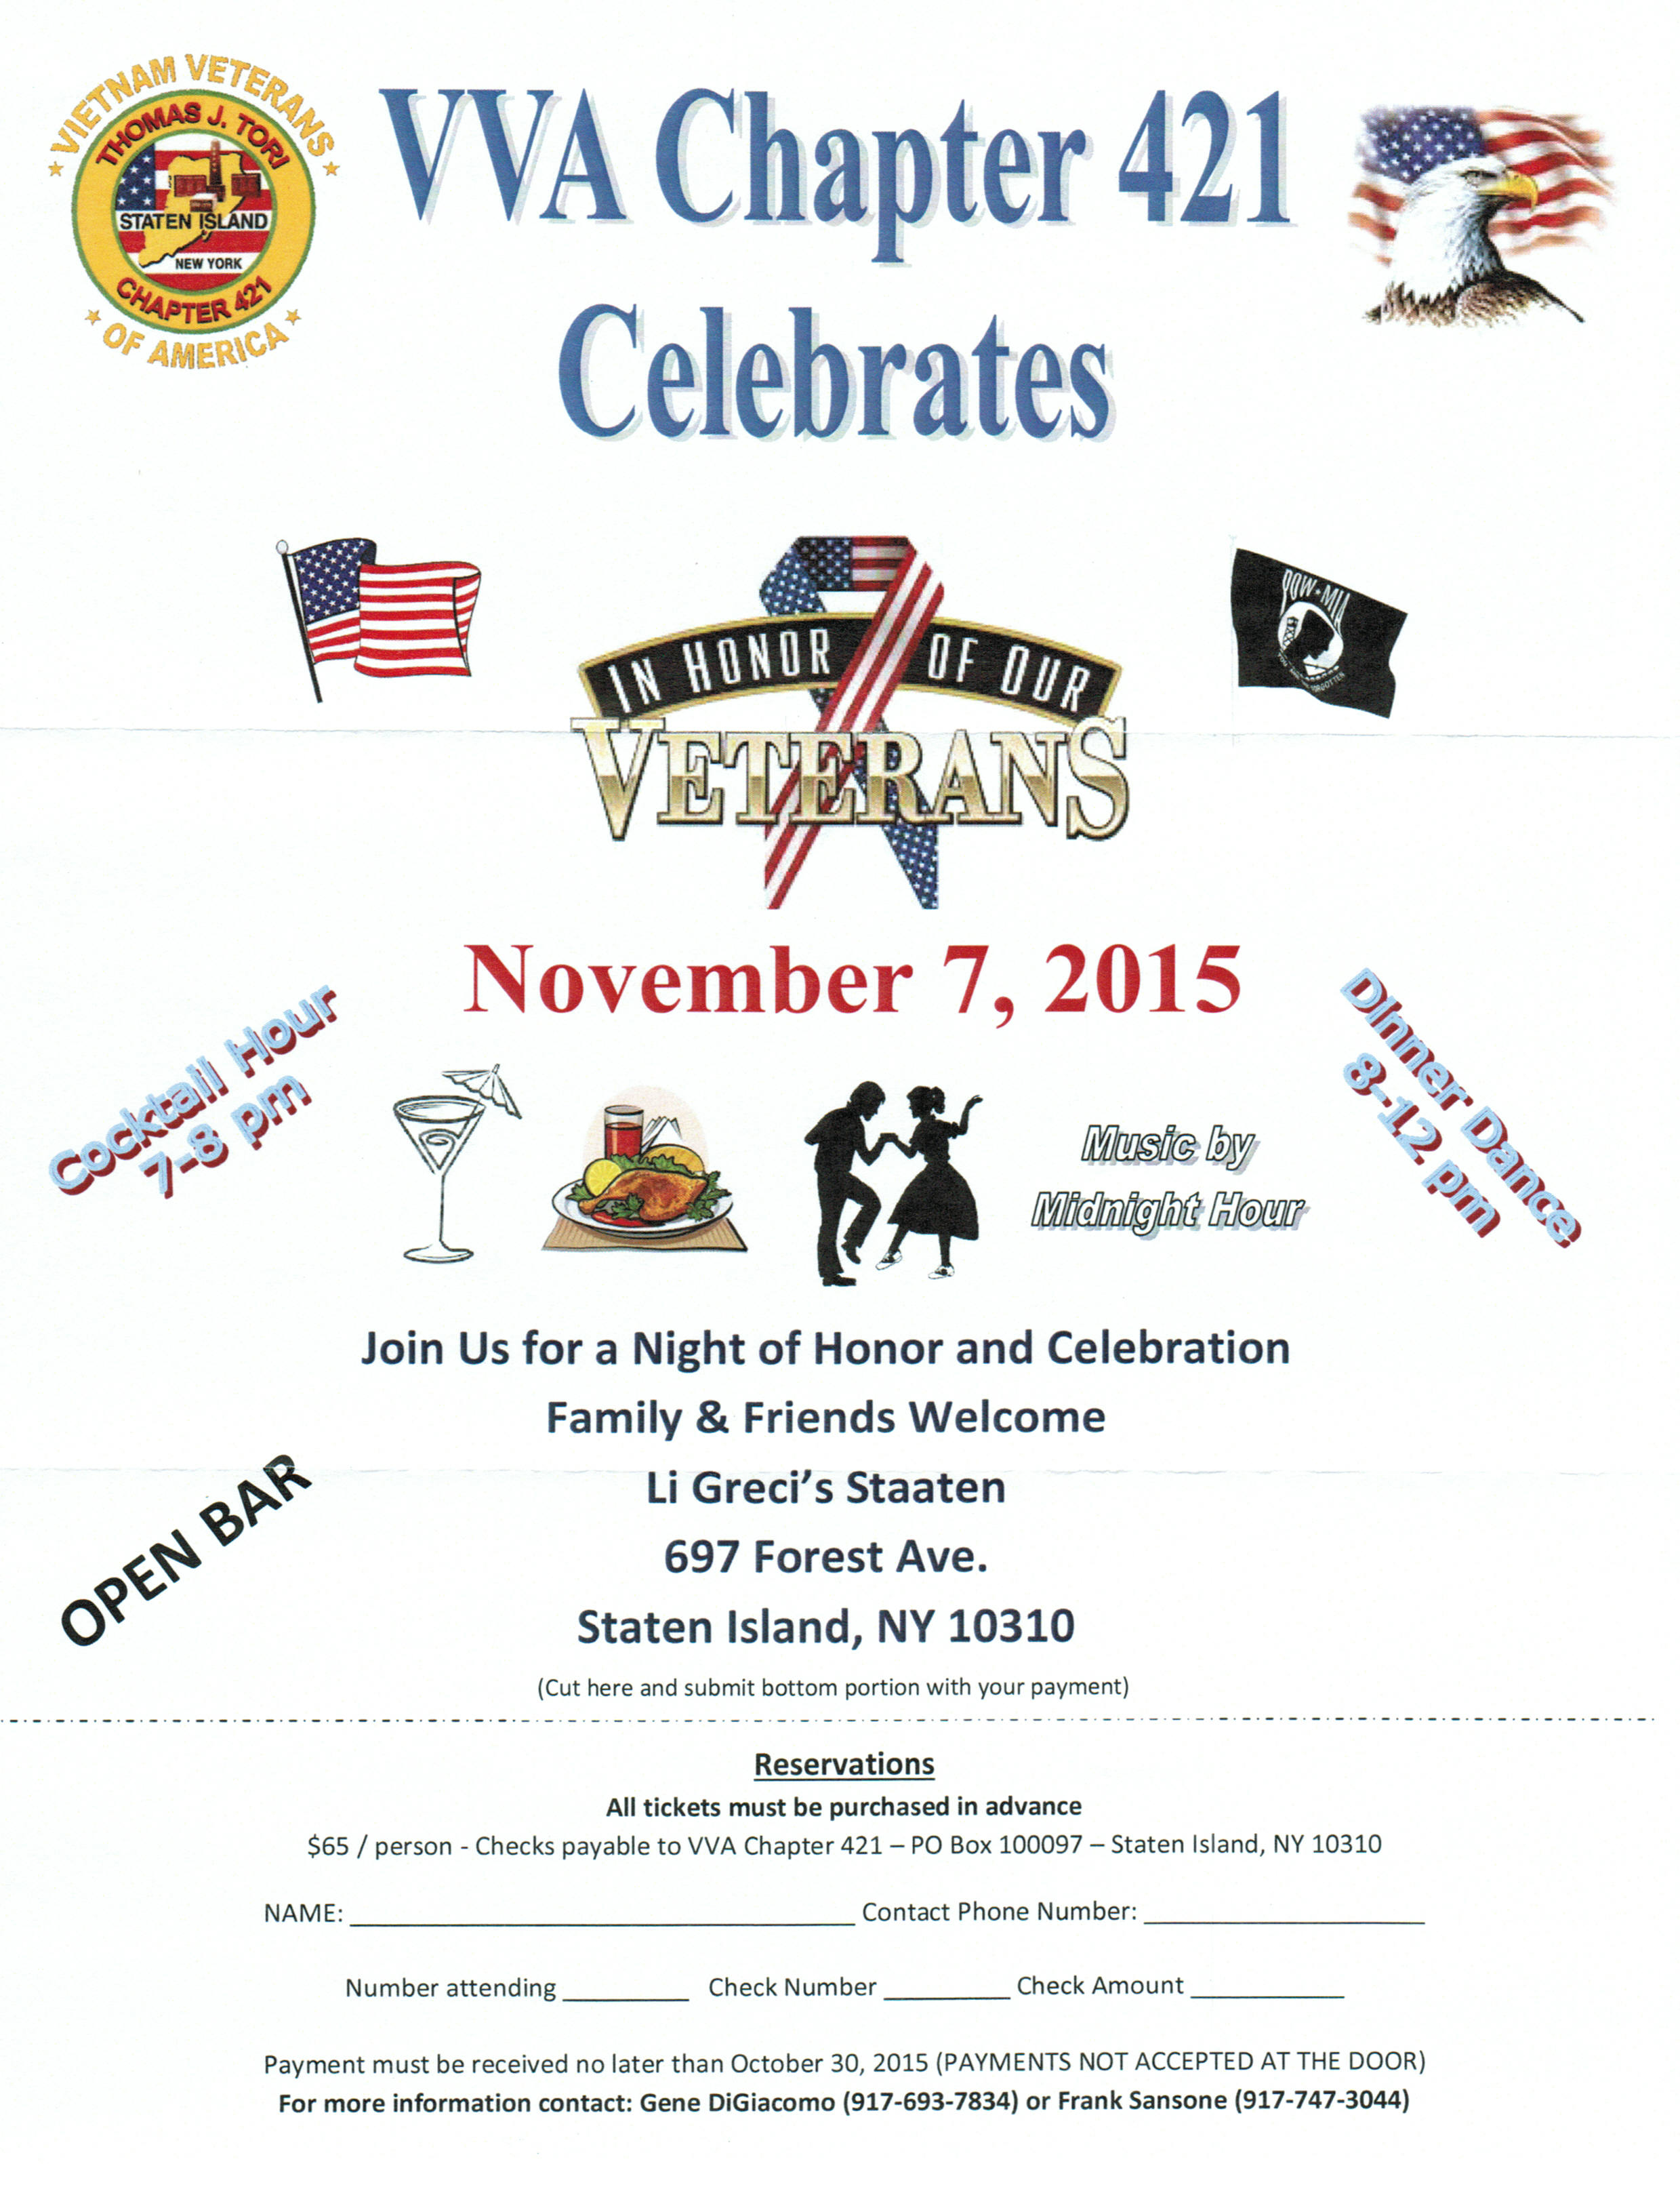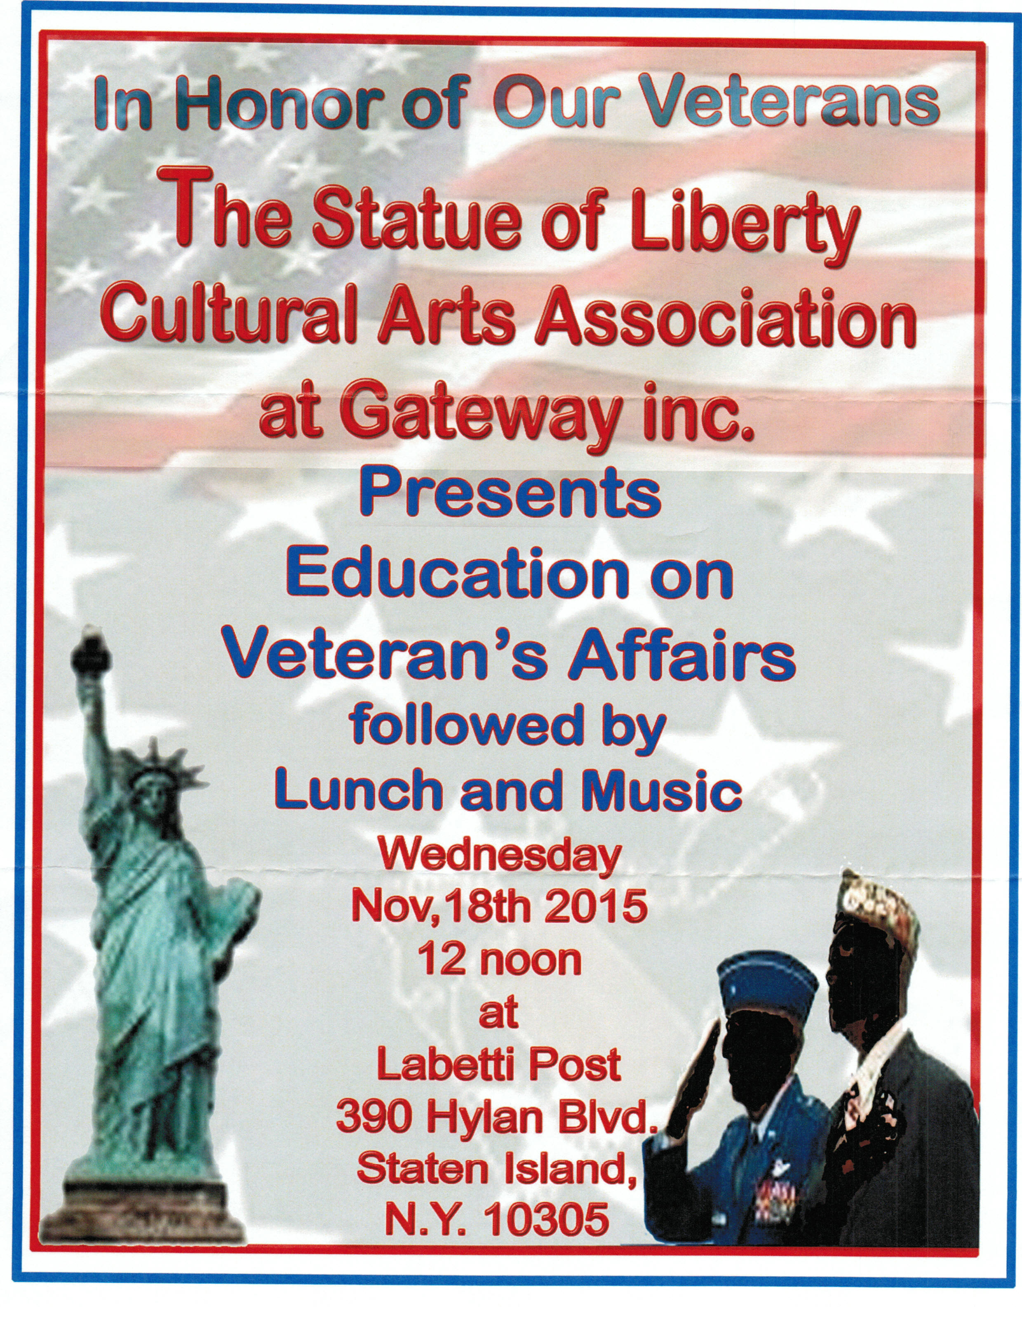

The Port Richmond High School Army JROTC Raider Battalion requests the pleasure of your company at the
“Honor Our Country’s Veterans Ceremony” Friday, the Sixth of November 2015 at 1100 hrs Port Richmond High School
85 St. Joseph’s Avenue, Staten Island, NY 10302. RSVP COL John Friedlander, Senior Army Instructor
908- 456-3977.
V.I.P. Reception Uniform of the day:
Coffee and pastry 1000hrs, Military, ACUs or duty uniform
Lunch served following the ceremony 1215hrs Civilian, Business Casual

Membership

1. Consider Life Membership. You save money over the long run and eliminate the need to renew yearly. Below are the membership rates for Life membership and Installment Plan Life Membership.
Age attained Payment in Full Installment Plan Option
on Dec. 31st Total: Initial Fee: 11 payments of:
Through Age 30 $425.00 $45.00 $38.64
31-40 $410.00 $45.00 $37.27
41-50 $375.00 $45.00 $34.09
51-60 $335.00 $45.00 $30.45
61-70 $290.00 $45.00 $26.36
71-80 $225.00 $45.00 $20.45
81 and over $170.00 $45.00 $15.45

2. Dues Renewal Reminder:

Member Name | Paid Thru | Days Remaining
Buttermark, Paul J | 12/31/2015 | 63
Delsante Sr, Joseph | 12/31/2015 | 63
Griffo, Arnold P | 12/31/2015 | 63
Guerra, Eugene D | 12/31/2015 | 63
Osowiecki, Alphonse | 12/31/2015 | 63
Palmieri, Mario A | 12/31/2015 | 63
Ramirez, Elvin | 12/31/2015 | 63AutoPay
Smith, Gerald F | 12/31/2015 | 63
Squicciarini, John | 12/31/2015 | 63
Treadaway, Ann M | 12/31/2015 | 63
Vail, Michael S | 12/31/2015 | 63

Service Officer

1. Veterans are encouraged to enroll in the VA health care so they are on record should they ever need it. No cost to apply. Apply on line at www.va.gov/healtheligibility/vfw or call 1-877-222-8387.

2. Tri-Care Dental. Tri-Care dental isn't free. You must enroll to be covered. Tri-Care dental web site, www.trdp.org
Delta Dental Tel #. 888-838-8737. The Tri-Care number for NY, is 1-877-874-2273.

3. DD Form 214 website. http://vetrecs.archives.gov. If you need assistance, contact the post service officer, Paul Dietrich.

4. Survivor Outreach Services. The website has a lot of information for those left behind when a service member or veteran passes. http://www.sos.army.mil/ or http://www.westpointmwr.com/acs/survivor_outreach_services.html

5. The Department of Veterans Affairs (VA) is working to make filing claims and appeals as fast and easy as possible. Beginning Tuesday, March 24, 2015, claims and appeals must be filed using the appropriate form. Standardizing forms will ease frustration among claimants, make claims processing more efficient and help VA reach more accurate decisions.
There are three major actions that will require a specific form or standardized process: Intent to File, claims applications, and Notice of Disagreement. When filing a formal claim, the following forms should be completed and submitted to VA either electronically via eBenefits (ebenefits.va.gov) or the Stakeholder Enterprise Portal (sep.va.gov), or by mailing the completed paper form to VA:
a.. For disability benefits, applicants must now use VA Form 21-526EZ, Application for Disability Compensation and Related Compensation Benefits.
b.. To apply for needs-based pension, use VA Form 21-527EZ, Application for Pension. To file a claim for dependency and indemnity compensation (DIC), survivor's pension, and accrued benefits, claimants should complete VA Form 21-534EZ, Application for DIC, Death Pension, and/or Accrued Benefits .

Applicants who are not ready to file a claim for disability, but wish to preserve a date of claim while gathering evidence and completing the necessary application form should use one of the following three methods to communicate an intent to file a claim to VA:
a.. 1) electronically via eBenefits (ebenefits.va.gov) or the Stakeholder Enterprise Portal (sep.va.gov),
b.. 2) mailing VA Form 21-0966, Intent to File a Claim for Compensation and/or Pension, or Survivors Pension and/or DIC, or
c.. 3) over the phone with a VA call center representative.
Finally, Veterans filing a Notice of Disagreement with a compensation decision should use VA Form 21-0958, Notice of Disagreement. Veterans and their representatives currently use the form on an optional basis. However, beginning March 24, 2015, Veterans must use this form when VA provides the form with a decision notice letter. Veterans and survivors will not be required to use a standardized notice of disagreement form for other types of claims (i.e., pension or survivors benefits) at this time. If you are unable to download these forms from va.gov/vaforms/, call
800-827-1000 to have the correct form sent to your home. Requiring standard forms will help VA more quickly identify what the applicant is claiming and gather the evidence required to process the claim or appeal. Standardized forms are a key component of VA's transformation, which will help achieve the Department's goal to eliminate the backlog in 2015. Contact data for VSO on website. Do not file with VSO review.

6. All paid up members of Post 1574 were enrolled in Group Accidental Death and Dismemberment insurance paid for by the post. Coverage is for $1000 and is with the Lockton Affinity LLC, PO box 87-9610 of Kansas City MO 64187-9610. Please keep information on this policy with your family important documents for your relatives and heirs.

7. To someone going through a difficult time, one simple act has the power to make a difference. Reach out to veterans and service members in your life today – let them know they’re not alone. Find out how you can make a difference http://www.veteranscrisisline.net/ThePowerof1.aspx.

Employment and Education

1. Looking for a job? Need quality employees? USE VETJOBS! www.vetjobs.com

2. Vets looking for jobs, the website: 100000jobsmission.com. Go there to apply and search for available jobs specifically held for veterans.

3. New initiative called the We can't wait program plan helps ex GIs get civilian credentials/licenses for skills learned in the military. For info: http://www.whitehouse.gov/sites/default/files/docs/veterans_report_5-31-2012.pdf

4. Veterans Head Back to Boot Camp to Learn Business Skills. Boots to Business: Reboot is a two-day entrepreneurship workshop presented by the U.S. Small Business Administration and the Institute for Veterans and Military Families (IVMF) available to transitioning service members as a part of the Defense Department’s Transition Assistance Program. Learn
more about the program http://www.military1.com/veterans/article/538543-veterans-head-back-to-boot-camp-to-learn-business-skills.

Bottom of Form

5. VFW’s Help A Hero Program is Accepting Applications. Eligible service members and veterans are encouraged to apply for spring 2016 scholarships. Enacted in 2013, the VFW’s “Sport Clips Help A Hero Scholarship” program has

awarded more than $1.2 million in scholarship funds to nearly 300 service members and veterans. Applications are now being accepted and the deadline to apply is Nov.15. Get the details http://www.vfw.org/scholarship/.

6. Job info. Seeking Video grapher / Editor. Experience required. Working knowledge of Panasonic AG-HMC 150 Camera. Proficient in use of Final Cut Pro editing. Must have a vehicle. Forward contact info and resume to SIVidher@Aol.com.
7. First Place wins $30,000! Do you know a high school student who could use some help paying for college?
Let them know about the VFW's Voice of Democracy Scholarship competition! This Year's Topic: My Vision for America. ENTRY DEADLINE: November 1, 2015. All students in grades 9-12 can apply. We want to reach as many patriotic students as possible to compete for the grand prize: $30,000 paid directly to the American college, university or

vocational/technical school of their choice! Download the application.
Pass the word on to:

High School Students | Counselors | Parent-Teacher Associations
Teachers | Youth Groups | School Boards

General

1. Staten Island University Hospital's Military Appreciation Program. This program entitles active duty members and veterans free parking 12 times per year at the SIUH parking lot. Call 718-226-4325 for an application.

2. The Defense POW/MIA Office announced the identification of remains belonging to the following personnel. Returned
home are:
* Marine Corps Cpl. Roger K. Nielson, Company E, 2nd Battalion, 8th Marine Regiment, 2nd Marine Division, KIA on Tarawa, Nov. 20, 1943.
* Army Cpl. Grant H. Ewing, 28, Battery C, 38th Field Artillery Battalion, 2nd Infantry Division, which was deployed north and east of the town of Kunu-ri, North Korea. On Nov. 25, 1950, his division was attacked by Chinese forces, which forced them to withdraw south through a series of Chinese roadblocks known as “the Gauntlet.” Ewing was reported missing in action. It would be later learned he was captured by Chinese forces, but died in a POW camp in February 1951.
* Army Cpl. George H. Mason, 19, 2nd Reconnaissance Company, 2nd Infantry Division, which was deployed near Chuam-ni, South Korea, when their defensive line was attacked by Chinese forces and forced to withdraw south to a more defensible position. Mason was reported as missing in action on Feb. 14, 1951.
* Army Cpl. Robert V. Witt, 20, 1st Battalion, 32nd Infantry Regiment, 31st Regimental Combat Team, 7th Infantry Division. The 31st RCT, historically known as Task Force Faith, was deployed east of the Chosin Reservoir in North Korea when it was attacked by overwhelming numbers of Chinese forces. Witt was reported as missing in action on Dec. 2, 1950. It was later learned he had been captured, but died in a North Korean prisoner of war camp on Jan. 31, 1951.
* Army Cpl. Robert E. Meyers, 21, Company A, 2nd Engineer Combat Battalion, 2nd Infantry Division, was declared missing on Dec. 1, 1950, after his unit was involved in combat operations in the vicinity of Sonchu, North Korea.
* Army Pvt. John H. Klopp, 25, 126th Infantry Regiment, 32nd Infantry Division, declared missing while fighting on Papua New Guinea on Dec. 5, 1942.
* Army Sgt. 1st Class Dean D. Chaney, Company K, 3rd Battalion, 35th Infantry Regiment, 25th Infantry Division.
Declared missing while fighting in North Korea on Nov. 28, 1950. It would be later learned he had been captured, but died in a POW camp.

3. The Defense POW/MIA Accounting Agency is seeking the public’s help to find and encourage more MIA families to donate a DNA sample to help speed the identification process of recovered remains. Currently, 89 percent of the Korean War’s 7,800 MIAs have a family reference sample on file, 84 percent for the Cold War’s 126 MIAs, and 81 percent of the Vietnam War’s 1,600 missing. But for World War II, it’s a dismal 4 percent of the 73,500 who are still missing. Each military service and the State Department has a service casualty office that can explain how to donate.

Army: 800-892-2490 | Navy: 800-443-9298 | State Department: 202-485-6106
Marine Corps: 800-847-1597 | Air Force: 800-531-5501

4. Free parking for veterans at Richmond County Medical Center. Veterans can park for free in the visitors parking lot where tokens are normally required. Stop at the main reception desk or security post, show proof you are a veteran (drivers license with vet on it, retired ID card, VA card or similar) and they will give you a free token for the parking lot. Get it on the way in as the reception/info desk is not manned all night. Use the token to exit the lot. Saves you $4 per visit.

Items of Interest

THANK YOU TO ALL OUR VETERANS AND THEIR FAMILIES!

Thanks to my fellow veterans:

I remember the day I found out I got into West Point. My mom actually showed up in the hallway of my high school and waited for me to get out of class. She was bawling her eyes out and apologizing that she had opened up my admission letter. She wasn't crying because it had been her dream for me to go there. She was crying because she knew how hard I'd worked to get in, how much I wanted to attend, and how much I wanted to be an infantry officer.- I was going to get that opportunity. That same day two of my teachers took me aside and essentially told me the following: "David, you're a smart guy. You don't have to join the military. You should go to college, instead." I could easily write a theme defending West Point and the military as I did that day, explaining that USMA is an elite institution, that separate from that it is actually statistically much harder to enlist in the military than it is to get admitted to college, that serving the nation is a challenge that all able-bodied men should at least consider for a host of reasons, but I won't.

What I will say is that when a 16 year-old kid is being told that attending West Point is going to be bad for his future then there is a dangerous disconnect in America, and entirely too many Americans have no idea what kind of burdens our military is bearing.
- In World War II, 11.2% of the nation served in four (4) years.
- During the Vietnam era, 4.3% served in twelve (12) years.
- Since 2001, only 0.45% of our population has served in the Global War on Terror.

These are unbelievable statistics. Over time, fewer and fewer people have shouldered more and more of the burden and it is only getting worse. Our troops were sent to war in Iraq by a Congress consisting of 10% veterans with only one person having a child in the military. Taxes did not increase to pay for the war. War bonds were not sold. Gas was not regulated. In fact, the average citizen was asked to sacrifice nothing, and has sacrificed nothing unless they have chosen to out of the goodness of their hearts. The only people who have sacrificed are the veterans and their families. The volunteers. The people who swore an oath to defend this nation. You stand there, deployment after deployment and fight on. You've lost relationships, spent years of your lives in extreme conditions, years apart from kids you'll never get back, and beaten your body in a way that even professional athletes don't understand.
Then you come home to a nation that doesn't understand. They don't understand suffering. They don't understand sacrifice. They don't understand why we fight for them. They don't understand that bad people exist. They look at you like you're a machine - like something is wrong with you. You are the misguided one - not them. When you get out, you sit in the college classrooms with political science teachers that discount your opinions on Iraq and Afghanistan because YOU WERE THERE and can't understand the macro issues they gathered from books, because of your bias.

You watch TV shows where every vet has PTSD and the violent strain at that. Your Congress is debating your benefits, your retirement, and your pay, while they ask you to do more. But the amazing thing about you is that you all know this. You know your country will never pay back what you've given up. You know that the populace at large will never truly understand or appreciate what you have done for them. Hell, you know that in some circles, you will be thought as less than normal for having worn the uniform. But you do it anyway.

You do what the greatest men and women of this country have done since 1775. YOU SERVED. Just that decision alone makes you part of an elite group.

"Never in the field of human conflict has so much been owed by so many to so few." -Winston Churchill- Thank you to the 11.2% and 4.3% who have served and thanks to the 0.45% who continue to serve our Nation.

General David Petraeus
West Point Class 1974

"Some people spend an entire lifetime wondering if they made a difference in the world. But the U.S. ARMED FORCES don't have that problem." R. Reagan

