VETERANS OF FOREIGN WARS BLAZING STAR POST #1574
17 CANNON AVENUE
STATEN ISLAND, NY 10314
Website. http://blazingstarvfwpost1574.org/wp

December 2015

BLAZING STAR POST 1574 CONTACT NUMBERS
Al Porto, Commander - 718-578-1242, albert.porto38@gmail.com
Paul Dietrich, Quartermaster - 718-698-5269, paul@the-dietrichs.com
William Alcock, Adjutant - 718-698-1923

IN MEMORIUM

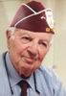

Theodore (Ted) Khoury, 95, of Sunnyside, a retired textile business owner, World War II veteran and family man, died 31 October 2015. Born and raised in Brooklyn, he went to school there. He lived in Dycker Heights until moving to Sunnyside about a year and a half ago. Ted served in the U.S. Army during World War II, from 1942 to 1945, assigned to the 2nd Battalion, 114th Infantry Regiment, 44th Infantry Division. He saw combat in Normandy and Alsace-Lorraine, where he was the only member of his unit to survive after a battle in November 1944 and was captured and held prisoner of war by the Germans until he was freed in May 1945. He owned a Brooklyn textile factory that made quilts, retiring about 30 years ago.
Ted was an avid reader. He delighted in riding in the country with his sweetheart, the former Evelyn Sabbat. He also had a passion for photography. He had a real appreciation for gratitude, love of country and family, and the "little things in life," his family said. "He was a man of deep integrity and we are proud to call him husband, father, grandfather and friend. He was a true American patriot and a hero to all of us," they added. Ted was a parishioner of St. Ann's R.C. Church, Dongan Hills. Surviving, along with Evelyn, his wife of 67 years, are his daughters, Barbara Vele and Joanne LaBella, and three grandchildren.

Calendar Events

Calendar of Events for 2016:

Date | Event | Location | Time | Remarks
2 December | Blazing Star Post Meeting | Gold Star Post | 1300
6 December | Unit Holiday Party | HQ, 8th Medical Brigade | 1200
10 December | Richmond County Council Meeting | North Shore Post | 1100
6 January | Blazing Star Post Meeting | Gold Star Post | 1300
3 February | Blazing Star Post Meeting | Gold Star Post | 1300
3 March | Blazing Star Post Meeting | Gold Star Post | 1300
6 April | Blazing Star Post Meeting | Gold Star Post | 1300
7 May | Blazing Star Post Meeting | Gold Star Post | 1000
4 June | Blazing Star Post Meeting | Gold Star Post | 1000
9 July | Blazing Star Post Meeting | Gold Star Post | 1000
6 August | Blazing Star Post Meeting | Gold Star Post | 1000
7 September | Blazing Star Post Meeting | Gold Star Post | 1300
5 October | Blazing Star Post Meeting | Gold Star Post | 1300
2 November | Blazing Star Post Meeting | Gold Star Post | 1300
7 December | Blazing Star Post Meeting | Gold Star Post | 1300

Membership

1. Consider Life Membership. You save money over the long run and eliminate the need to renew yearly. Below are the membership rates for Life membership and Installment Plan Life Membership.
Age attained Payment in Full Installment Plan Option
on Dec. 31st Total: Initial Fee: 11 payments of:
Through Age 30 $425.00 $45.00 $38.64
31-40 $410.00 $45.00 $37.27
41-50 $375.00 $45.00 $34.09
51-60 $335.00 $45.00 $30.45
61-70 $290.00 $45.00 $26.36
71-80 $225.00 $45.00 $20.45
81 and over $170.00 $45.00 $15.45

2. Dues Renewal Reminder:

Member Name | Paid Thru | Days Remaining
Buttermark, Paul J | 12/31/2015 | 63
Delsante Sr, Joseph | 12/31/2015 | 63
Osowiecki, Alphonse | 12/31/2015 | 63
Palmieri, Mario A | 12/31/2015 | 63
Ramirez, Elvin | 12/31/2015 | 63AutoPay
Smith, Gerald F | 12/31/2015 | 63
Squicciarini, John | 12/31/2015 | 63
Treadaway, Ann M | 12/31/2015 | 63
Vail, Michael S | 12/31/2015 | 63

3. Poppy Platoon. Many thanks to Blazing Star Members who participated in distributing Veterans Day Buddy Poppies!

William Alcock | Gene Guerra
John Byrnes | Charlie Malone
Ben Cirigliano | Keith Mollett
Paul Dietrich | Frank Zielinski

4. Welcome New Members! Kevin M. Gaudreau and Chris E. Gordon

Service Officer

1. Veterans are encouraged to enroll in the VA health care so they are on record should they ever need it. No cost to apply. Apply on line at www.va.gov/healtheligibility/vfw or call 1-877-222-8387.

2. Tri-Care Dental. Tri-Care dental isn't free. You must enroll to be covered. Tri-Care dental web site, www.trdp.org
Delta Dental Tel #. 888-838-8737. The Tri-Care number for NY, is 1-877-874-2273.

3. DD Form 214 website. http://vetrecs.archives.gov. If you need assistance, contact the post service officer, Paul Dietrich.

4. Survivor Outreach Services. The website has a lot of information for those left behind when a service member or veteran passes. http://www.sos.army.mil/ or http://www.westpointmwr.com/acs/survivor_outreach_services.html

5. The Department of Veterans Affairs (VA) is working to make filing claims and appeals as fast and easy as possible. Beginning Tuesday, March 24, 2015, claims and appeals must be filed using the appropriate form. Standardizing forms will ease frustration among claimants, make claims processing more efficient and help VA reach more accurate decisions.
There are three major actions that will require a specific form or standardized process: Intent to File, claims applications, and Notice of Disagreement. When filing a formal claim, the following forms should be completed and submitted to VA either electronically via eBenefits (ebenefits.va.gov) or the Stakeholder Enterprise Portal (sep.va.gov), or by mailing the completed paper form to VA:
a.. For disability benefits, applicants must now use VA Form 21-526EZ, Application for Disability Compensation and Related Compensation Benefits.
b.. To apply for needs-based pension, use VA Form 21-527EZ, Application for Pension. To file a claim for dependency and indemnity compensation (DIC), survivor's pension, and accrued benefits, claimants should complete VA Form 21-534EZ, Application for DIC, Death Pension, and/or Accrued Benefits .

Applicants who are not ready to file a claim for disability, but wish to preserve a date of claim while gathering evidence and completing the necessary application form should use one of the following three methods to communicate an intent to file a claim to VA:
a.. 1) electronically via eBenefits (ebenefits.va.gov) or the Stakeholder Enterprise Portal (sep.va.gov),
b.. 2) mailing VA Form 21-0966, Intent to File a Claim for Compensation and/or Pension, or Survivors Pension and/or DIC, or
c.. 3) over the phone with a VA call center representative.
Finally, Veterans filing a Notice of Disagreement with a compensation decision should use VA Form 21-0958, Notice of Disagreement. Veterans and their representatives currently use the form on an optional basis. However, beginning March 24, 2015, Veterans must use this form when VA provides the form with a decision notice letter. Veterans and survivors will not be required to use a standardized notice of disagreement form for other types of claims (i.e., pension or survivors benefits) at this time. If you are unable to download these forms from va.gov/vaforms/, call
800-827-1000 to have the correct form sent to your home. Requiring standard forms will help VA more quickly identify what the applicant is claiming and gather the evidence required to process the claim or appeal. Standardized forms are a key component of VA's transformation, which will help achieve the Department's goal to eliminate the backlog in 2015. Contact data for VSO on website. Do not file with VSO review.

6. All paid up members of Post 1574 were enrolled in Group Accidental Death and Dismemberment insurance paid for by the post. Coverage is for $1000 and is with the Lockton Affinity LLC, PO box 87-9610 of Kansas City

MO 64187-9610. Please keep information on this policy with your family important documents for your relatives and heirs.

7. To someone going through a difficult time, one simple act has the power to make a difference. Reach out to veterans and service members in your life today – let them know they’re not alone. Find out how you can make a difference http://www.veteranscrisisline.net/ThePowerof1.aspx.

Employment and Education

1. Looking for a job? Need quality employees? USE VETJOBS! www.vetjobs.com

2. Vets looking for jobs, the website: 100000jobsmission.com. Go there to apply and search for available jobs specifically held for veterans.

3. New initiative called the We can't wait program plan helps ex GIs get civilian credentials/licenses for skills learned in the military. For info: http://www.whitehouse.gov/sites/default/files/docs/veterans_report_5-31-2012.pdf

4. Veterans Head Back to Boot Camp to Learn Business Skills. Boots to Business: Reboot is a two-day entrepreneurship workshop presented by the U.S. Small Business Administration and the Institute for Veterans and Military Families (IVMF) available to transitioning service members as a part of the Defense Department’s Transition Assistance Program. Learn
more about the program http://www.military1.com/veterans/article/538543-veterans-head-back-to-boot-camp-to-learn-business-skills.

Bottom of Form

5. VFW’s Help A Hero Program is Accepting Applications. Eligible service members and veterans are encouraged to apply for spring 2016 scholarships. Enacted in 2013, the VFW’s “Sport Clips Help A Hero Scholarship” program has
awarded more than $1.2 million in scholarship funds to nearly 300 service members and veterans. Applications are now being accepted and the deadline to apply is Nov.15. Get the details http://www.vfw.org/scholarship/.

6. Job info. Seeking Video grapher / Editor. Experience required. Working knowledge of Panasonic AG-HMC 150 Camera. Proficient in use of Final Cut Pro editing. Must have a vehicle. Forward contact info and resume to SIVidher@Aol.com.
General

1. Staten Island University Hospital's Military Appreciation Program. This program entitles active duty members and veterans free parking 12 times per year at the SIUH parking lot. Call 718-226-4325 for an application.

2. The Defense POW/MIA Office announced the identification of remains belonging to the following personnel. Returned
home are:
- Army Pfc. Frank Worley, 21. On Feb. 11, 1951, Worley and elements of Battery A, 503rd Field Artillery Battalion, 2nd Infantry Division, were occupying a position in the vicinity of Hoengsong, South Korea, when their unit was overwhelmed by Chinese forces. Worley was reported missing after the attack.
- Marine Pfc. James P. Reilly, 20. In November 1943, Reilly was assigned to Company L, 3rd Battalion, 8th Marines Regiment, 2nd Marine Division, which landed against stiff Japanese resistance on the small island of Betio in the Tarawa Atoll. Approximately 1,000 Marines were killed over several days of intense fighting, to include Reilly on the first day of battle, Nov. 20, 1943.
- Army Cpl. Martin A. King, 18. In early November 1950, King was assigned to Company E, 2nd Battalion, 8th Cavalry Regiment, 1st Cavalry Division, when his unit was attacked by Chinese forces while occupying a position along the Nammyon River, near Unsan, North Korea. King was reported missing on Nov. 2, 1950. It would be later learned that he had been captured, but died of malnutrition in a POW camp.
- Army Air Forces 1st Lt. William O. Pile, 24. On Dec. 23, 1944, Pile was assigned to the 559th Bombardment Squadron, 387th Bombardment Group, 9th Air Force. Pile was the pilot of a B-26C Marauder which crashed after being struck by enemy fire near Philippsweiler, Germany. Pile and his co-pilot, 2nd Lt. Robert Ward, were reported killed in action. Seven crewmen survived the crash by parachuting to safety. One crewman, however, was captured and later died in captivity.
- Marine Corps Cpl. Roger K. Nielson, 22. Nielson was assigned to Company E, 2nd Battalion, 8th Marine Regiment, 2nd Marine Division, when he was killed in action fighting on the Pacific island of Tarawa on Nov. 20, 1943.
- Army Staff Sgt. Kenneth L. Cunningham, 21. On Oct. 3, 1969, then Private 1st Class Cunningham was an observer in an OV-1C Mohawk aircraft on a surveillance mission over the tri-border area of Cambodia, Laos and South Vietnam. Contact was lost and the aircraft was found two days later on top of a 7,000 foot peak in a mountain range north of Kontum. His remains were not recovered. He was assigned to the 225th Aviation Company, 223rd Aviation Battalion, 17th Aviation Group, 1st Aviation Brigade.
3. The Defense POW/MIA Accounting Agency is seeking the public’s help to find and encourage more MIA families to donate a DNA sample to help speed the identification process of recovered remains. Currently, 89 percent of the Korean War’s 7,800 MIAs have a family reference sample on file, 84 percent for the Cold War’s 126 MIAs, and 81 percent of the Vietnam War’s 1,600 missing. But for World War II, it’s a dismal 4 percent of the 73,500 who are still missing. Each military service and the State Department has a service casualty office that can explain how to donate.

Army: 800-892-2490 | Navy: 800-443-9298 | State Department: 202-485-6106
Marine Corps: 800-847-1597 | Air Force: 800-531-5501

4. Free parking for veterans at Richmond County Medical Center. Veterans can park for free in the visitors parking lot where tokens are normally required. Stop at the main reception desk or security post, show proof you are a veteran (drivers license with vet on it, retired ID card, VA card or similar) and they will give you a free token for the parking lot. Get it on the way in as the reception/info desk is not manned all night. Use the token to exit the lot. Saves you $4 per visit.

5. Update with regards to National Guard and Reserve. House, Senate Pass Vet-status Bills. All retired National Guardsmen will likely soon be able to legally call themselves veterans. The Senate passed legislation last week that would grant veteran status to any Guardsman or Reservist who has served 20 years. The House approved a similar provision Monday. Sen. John Boozman, R-Ark., a member of the Senate Veteran's Affairs Committee, championed the legislation in the Senate; Rep. Tim Walz, D-Minn., pushed the matter in the House. Current law requires Guardsmen and Reservists to serve at least 179 days on federal active duty for other than training to be considered a veteran, regardless of how many years they have in uniform. "It's a travesty that Guardsmen and Reservists who have served this country honorably for 20 years or more cannot legally call themselves veterans," said retired Maj. Gen. Gus Hargett, the NGAUS president. "They are in my eyes. They are in most Americans' eyes. And we have never been closer to making that true in the eyes of the law."

6. WASHINGTON — Nearly 30,000 post-9/11 combat veterans – some of whom have been waiting for years – are still without Department of Veterans Affairs health benefits due to a technicality more than three months after a whistleblower brought the issue to light. VA officials apologized but say they do not have the authority to automatically enroll the veterans, even though they filled out the proper paperwork and are guaranteed at least five years of enhanced care by law. At issue is an optional means test, which the veterans in question did not fill out. The free care they are guaranteed by a 2008 law does not require them to fill out the means test, but without that information, their applications are automatically placed into “pending” status. When VA program specialist Scott Davis first reported the issue in August, 35,000 combat veterans were on the pending list, half of whom had waited five years or more to be enrolled. The VA did not start reaching out to the veterans until Davis publically reported the problem, and now says there are about 29,000 Iraq and Afghanistan veterans in pending status. Benita Miller, director of the VA’s Health Eligibility Center, said the VA had enrolled 9,000 servicemembers since August. (Roughly 3,000 new veterans applied in that time.) Miller said her office is continuing to reach out to veterans by telephone and by mail. The department has apologized for the problem but also said the system is working as designed and that the vets need to specifically opt out of the means test to move forward, to show that they accept the potential of co-pays. VA Secretary Bob McDonald has repeated the assertion that he does not have the authority to change a veterans enrollment status. Davis, who handles the enrollment applications, refutes the VA claim that the department cannot automatically enroll the veterans and says they have in fact done just that in the past. “Those combat veterans are clearly applying for health care; we have always just enrolled the people without

asking questions,” he said. McDonald “has a moral, legal and ethical responsibility to enroll these veterans.” When asked by a Stars and Stripes reporter whether VA lawyers had specifically given guidance that the department could not enroll the veterans, Miller demurred. “We didn’t have the guidance to make an agreement to enroll them in VA health care,” she said in a phone interview with Stars and Stripes. The House Committee on Veterans Affairs requested that the VA provide information by Friday about the combat veterans on the pending list, including the list of veterans who may have died while their enrollments were still pending, but they did not receive the information, according to a committee official.
“The law hasn’t required a means test from recent combat veterans since 2008, yet VA still hasn’t come up with an efficient way to enroll these veterans in its health care system without one,” committee Chairman Rep. Jeff Miller said in a statement. “This is either blatant incompetence or cold-hearted indifference.” Benita Miller said her team was still compiling the data and did not have statistics on the number of veterans who may have died while awaiting enrollment.
Davis said VA’s reluctance to automatically enroll the veterans could be about potentially being responsible for tens of millions of dollars in compensation owed to veterans for the delayed benefits. VA officials would not comment on what kind of compensation, if any, veterans might be owed. If you believe you might be one of the combat veterans affected, you can call 877-222-8387 or visit the VA's Health Benefits page

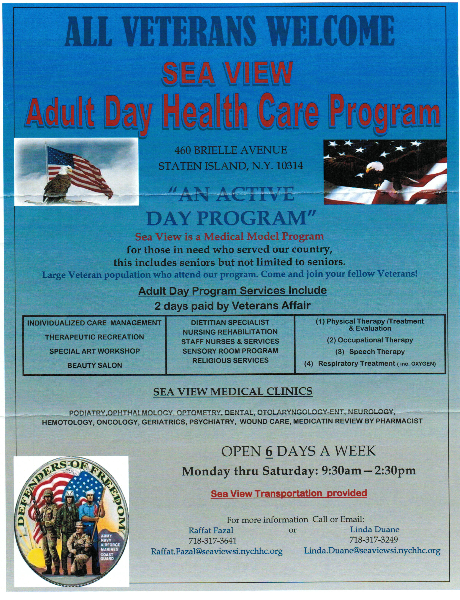

Items of Interest

24 December 1944
Merry Christmas!
HEADQUARTERS, 101ST AIRBORNE DIVISION
Office of the Division Commander

What’s merry about all this, you ask? We’re fighting – it’s cold – we aren’t home. All true, but what has the proud Eagle Division accomplished with its worthy comrades of the 10th Armored Division, the 705th Tank Destroyer Battalion and all the rest? Just this: We have stopped cold everything that has been thrown at us from the North, East, South, and West. We have identifications from four German Panzer Divisions, two German Infantry Divisions and one German Parachute Division. These units, spearheading the last desperate German lunge, were headed straight west for key points when the Eagle Division was hurriedly ordered to stem the advance. How effectively this was done will be written in history; not alone in our Division’s glorious history but in world history. The Germans actually did surround us, their radios blared our doom. Their Commander demanded our surrender in the following impudent arrogance:

December 22d 1944

“To the U.S.A. Commander of the encircled town of Bastogne: “The fortune of war is changing. This time the U.S.A. forces in and near Bastogne have been encircled by strong German armored units. More German armored units have crossed the river Ourthe near Ortheuville, have taken Marche and reached St. Hubert by passing through HompreSibret-Tillet. Libramont is in German hands. “There is only one possibility to save the encircled U.S.A. troops from total annihilation: that is the honorable surrender of the encircled town. In order to think it over a term of two hours will be granted beginning with the presentation of this note. “If this proposal should be rejected one German Artillery Corps and six heavy A. A. Battalions are ready to annihilate the U.S.A. troops in and near Bastogne. The order for firing will be given immediately after this two hours’ term. “All the serious civilian losses caused by this artillery fire would not correspond with the well-known American humanity.

The German Commander”
The German Commander received the following reply:

22 December 1944
“To the German Commander:

N U T S !

The American Commander”

Allied Troops are counterattacking in force. We continue to hold Bastogne. By holding Bastogne we assure the success of the Allied Armies. We know that our Division Commander, General Taylor, will say: “Well Done!” We are giving our country and our loved ones at home a worthy Christmas present and being privileged to take part in this gallant feat of arms are truly making for ourselves a Merry Christmas.

A. C. McAuliffe Commanding

