VETERANS OF FOREIGN WARS BLAZING STAR POST #1574
17 CANNON AVENUE
STATEN ISLAND, NY 10314
Website. http://blazingstarvfwpost1574.org/wp

October 2016

BLAZING STAR POST 1574 CONTACT NUMBERS
Al Porto, Commander - 718-578-1242, albert.porto38@gmail.com
Paul Dietrich, Quartermaster - 718-698-5269, paul@the-dietrichs.com
William Alcock, Adjutant - 718-698-1923

Calendar Events

Calendar of Events for 2016:

Date | Event | Location | Time | Remarks
5 October Wednesday | Blazing Star Post Meeting | Gold Star Post | 1300
29 October | Poppy Distribution | Shop-Rite | 0900-1500
2 November Wednesday | Blazing Star Post Meeting | Gold Star Post | 1300
3 November | Poppy Distribution | Staten Island Ferry | 0700-1000
3 November | Poppy Distribution | Refinery | 1100-1300
5 November | Poppy Distribution | Stop & Shop | 0900-1500
6 November | Poppy Distribution | Stop & Shop | 0900-1500
7 November | VA Medical Screening | CSI
11 November | Veterans Day Ceremony | Gold Star Post | 0900-1100
7 December Wednesday | Blazing Star Post Meeting | Gold Star Post | 1300

Membership

1. Consider Life Membership. You save money over the long run and eliminate the need to renew yearly. Below are the membership rates for Life membership and Installment Plan Life Membership.
Age attained Payment in Full Installment Plan Option
on Dec. 31st Total: Initial Fee: 11 payments of:
Through Age 30 $425.00 $45.00 $38.64
31-40 $410.00 $45.00 $37.27
41-50 $375.00 $45.00 $34.09
51-60 $335.00 $45.00 $30.45
61-70 $290.00 $45.00 $26.36
71-80 $225.00 $45.00 $20.45
81 and over $170.00 $45.00 $15.45

2. Welcome New Member! Laura A Scazzafavo

3. Dues Renewal Reminder:

Leunes, Peter | Current Until | 6/17/2016

Service Officer

1. Veterans are encouraged to enroll in the VA health care so they are on record should they ever need it. No cost to apply. Apply on line at www.va.gov/healtheligibility/vfw or call 1-877-222-8387.

2. Tri-Care Dental. Tri-Care dental isn't free. You must enroll to be covered. Tri-Care dental web site, www.trdp.org
Delta Dental Tel #. 888-838-8737. The Tri-Care number for NY, is 1-877-874-2273.

3. DD Form 214 website. http://vetrecs.archives.gov. If you need assistance, contact the post service officer, Paul Dietrich.

4. Survivor Outreach Services. The website has a lot of information for those left behind when a service member or veteran passes. http://www.sos.army.mil/ or http://www.westpointmwr.com/acs/survivor_outreach_services.html

5. To someone going through a difficult time, one simple act has the power to make a difference. Reach out to veterans and service members in your life today – let them know they’re not alone. Find out how you can make a difference http://www.veteranscrisisline.net/ThePowerof1.aspx.

6. NY State Creates Mobile App for Veterans to Access Services. There's a new mobile app designed to help New York's veterans access state and federal services. Gov. Andrew Cuomo announced the creation of the application Thursday. It's compatible with Apple and Android products and has help for veterans looking for information on health care, jobs and benefits. The program also locates the closest state veterans' affairs office. Cuomo says the app is an example of how technology can be used to improve the delivery of state services and programs. The program was developed by the state's Division of Veterans' Affairs.

7. Online Health Care Application. Providing health care to our Nation’s Veterans is a vital service of the Department of Veterans Affairs (VA), one that must persistently improve. Through the MyVA transformation, VA is rebuilding trust with Veterans and the American people; modernizing service delivery; and setting the course for long-term, VA excellence, all
while continuing to expand access to high-quality care. Through improvement efforts, many of the steps Veterans must take to receive health care were reviewed and found that enhancements were necessary in the initial application to better the Veteran experience by removing barriers that hinder access. The VA will soon launch a new online health care application onwww.vets.gov. Previously, Veterans could apply for health care online, but the user experience was often frustrating. Beginning June 30, 2016, Veterans applying for health care will be directed to the health care application on www.vets.gov. Veterans and other stakeholders will still have access to VA Form 10-10EZ, which was originally available through the Veterans On-line Application; however, going forward, those applying for health care eligibility will use the online application or call 877-222-VETS (8387). Please take a moment to review the new online form, and, as of June 30, 2016, begin referring Veterans interested in applying for health care eligibility to the new site. To learn more about applying for health benefits, please visit VA’s Health Benefits webpage.

8. On November 7th at the College of Staten Island Bldg 1C, the VA will have the VA Mobile Medical Unit and Vet Center Mobile Van to conduct Medical Screenings and Free flu shots.

Employment and Education

1. Looking for a job? Need quality employees? USE VETJOBS! www.vetjobs.com

2. Vets looking for jobs, the website: 100000jobsmission.com. Go there to apply and search for available jobs specifically held for veterans.

3. RECRUITMILITARY NYC HIRING EVENT FOR VETERANS.

New York Hilton Midtown, 1335 Avenue of the Americas, New York, NY 10019
New York All Veterans Job Fair
September 15, 201611:00 AM – September 15, 2016 3:00 PM
For more information on how to register for the event please have them visit this link:
https://events.recruitmilitary.com/events/new-york-all-veterans-job-fair-september-15-2016#registration

4. Great opportunity to get in with National Grid!!
Call Center Representatives - Hours offered are 30-40 hours $12/hr
Helpers - Hours offered are 30-40 hours $ 13-$15/hr
Testing is only open for candidates that apply for union jobs on the National Grid website, https://careers.nationalgridus.com/
Candidates create a profile on the National Grid website, upload their resume and cover letters and fill out an application for job of choice.

5. JOBS AVAILABLE IN NYC AREA

Superintendent Wanted
w/Exp & Tools. Bilingual a plus
Interviews Thurs, Oct 6 9am-1pm
@ 175 - A Boerum St. Brooklyn, 11206 For directions
call 718-782-7703 Fax resume to 516-466-0643

CONSTRUCTION EQUIPMENT OPERATORS FOR SNOW REMOVAL
Experienced Only!
P/L, BOBCAT Operators/ Mechanics/Supervisors
JFK ,LGA, & EWR AIRPORTS
Work Storm hours only,
Time and a half after 40 hours.
Clean Criminal Background.
SNOWLIFT 516-239-2123

Metro One LPSG is having open house interviews for
SECURITY OFFICERS throughout the five boroughs.
M-F 9-5 and Wed until 7
90 John St Rm 401 NY, NY;
850 Bronx River Rd Ste 103 Bronxville;
& 116-16 Queens Blvd Forest Hills.

IRON WORKERS WANTED
Fast growing structural steel and miscellaneous shop looking for
motivated individuals who have experience in fabrication of stairs, rails, fences and all types of structural steel. Also looking for an estimator/ project manager with experience in bidding on project, estimating and reading blue prints.
Please reply to trinchesemt@gmail.com if interested or call the office at 347-442-1133.

Call Center Manager - Branch Manager
XCEL Federal Credit Union is seeking an experienced Branch Manager/Call Center Manager to assume the responsibility of efficient, effective and accurate performance of duties. Candidate must possess working knowledge and a proven track record in the management of
frontline banking operations, as well as extensive Banking Call Center management experience. Three to five years of management experience required. Flexibility required
to work in our NJ branch if the need arises. Submit resume and letter of interest with salary requirements to hr@xcelfcu.org EOE.

Inspector/Ass’t Manager Wanted
Property Mngmt Company looking for an inspector for several
Subsidized Housing complexes in Brooklyn. Must have experience in electrical, plumbing & lock repairs. Certifications a plus. Bilingual. Salary based on exp.
Fax Resume to 516-466-0643

Bottom of Form
General

1. Staten Island University Hospital's Military Appreciation Program. This program entitles active duty members and veterans free parking 12 times per year at the SIUH parking lot. Call 718-226-4325 for an application.

2. The Defense POW/MIA Office announced the identification of remains belonging to the following personnel. Returned
home are:

- Marine Pvt. Frank F. Penna, 24, Company E, 2nd Battalion, 8th Marine Regiment, 2nd Marine Division, which
landed against stiff Japanese resistance on the small island of Betio in the Tarawa Atoll of the Gilbert Islands. Penna died on the first day of battle, Nov. 20, 1943.
- Army Cpl. Larry M. Dunn, 18, On Dec. 1, 1950, Dunn was a member of Company B, 2nd Engineer Combat
Battalion, 2nd Infantry Division, when his unit was fighting through a roadblock that was heavily defended by enemy forces near Sonchu, North Korea. He was declared missing after the battle.
- Air Force Maj. Dean A. Klenda, 25, On Sept. 17, 1965, Klenda was piloting an F-105D Thunderchief when it was
shot down by enemy fire while on an attack mission west of Hanoi in Son La Province, Vietnam. He reportedly was able to eject from the aircraft, but failed to separate himself from the ejection seat. He was assigned to the 67th Tactical Fighter Squadron, 6234th Tactical Fighter Wing.
- Marine Pfc. Nicholas J. Cancilla, of Blair, Pa., was assigned to Company B, 1st Battalion, 2nd Marines, 2nd
Marine Division, which landed against stiff Japanese resistance on the small island of Betio in the Tarawa Atoll of the Gilbert Islands. Cancilla died on the first day of battle, Nov. 20, 1943.
- Marine Pfc. James S. Smith, Company C, 2nd Amphibious Tractor Battalion, 2nd Marine Division, which landed
against stiff Japanese resistance on the small island of Betio in the Tarawa Atoll of the Gilbert Islands. Smith died on the first day of battle, Nov. 20, 1943.
- Army Cpl. Vernon D. Presswood, 20, Heavy Mortar Company, 32nd Infantry Regiment, 7th Infantry Division, as
one of approximately 2,500 American and 700 South Korean soldiers assembled into the 31st Regimental Combat Team, which was attacked by an overwhelming Chinese force east of the Chosin Reservoir in North Korea. Presswood would be reported missing on Dec. 2, 1950.
- Marine Pfc. John W. MacDonald, Company F, 2nd Battalion, 8th Marine Regiment, 2nd Marine Division, which
landed against stiff Japanese resistance on the small island of Betio in the Tarawa Atoll of the Gilbert Islands. MacDonald died on the first day of battle, Nov. 20, 1943.
- Marine Sgt. James J. Hubert, Company H, 2nd Battalion, 8th Marines, 2nd Marine Division, which landed
against stiff Japanese resistance on the small island of Betio in the Tarawa Atoll of the Gilbert Islands. Hubert died on the second day of battle, Nov. 21, 1943.
- Marine Pfc. Ben H. Gore, 20, Special Weapons Group, 2nd Defense Battalion, Fleet Marine Force, which landed
against stiff Japanese resistance on the small island of Betio in the Tarawa Atoll of the Gilbert Islands. Gore died of his wounds on Nov. 25, 1943.
- Marine Pvt. Emmett L. Kines, 24, Company F, 2nd Battalion, 8th Marines, 2nd Marine Division, which landed
against stiff Japanese resistance on the small island of Betio in the Tarawa Atoll of the Gilbert Islands. Kines died sometime during the first day of the battle, Nov. 20, 1943.
- Army Cpl. Wayne Minard, Company C, 1st Battalion, 9th Infantry Regiment, 2nd Infantry Division, fighting a
delaying action south to Kunu-ri, North Korea. He would be reported missing in action on Nov. 26, 1950.
- Army Cpl. David T. Nordin Jr., Company K, 3rd Battalion, 35th Infantry Regiment, 25th Infantry Division, moving
northward toward Unsan, North Korea, when forced to withdraw. Nordin was reported missing in action on Nov. 28, 1950. It would be later learned he had been captured but died in a North Korean POW camp.
- Army Sgt. 1st Class Louis M. Baxter, Headquarters Battery, 57th Field Artillery Battalion, 31st
Regimental Combat Team, 7th Infantry Division, on the east side of the Chosin Reservoir in North Korea, when his unit was forced into a fighting withdrawal southward. He would be declared missing in action on Dec. 6, 1950.
- Army Cpl. Joseph Trepasso, 20, Company L, 3rd Battalion, 31st Infantry Regiment, 7th Infantry Division, on the
east side of the Chosin Reservoir in North Korea, when his unit was forced into a fighting withdrawal southward. He would be declared missing in action on Dec. 12, 1950.
- Army Pfc. Kenneth Miller was a member of Company K, 3rd Battalion 19th Infantry Regiment, 24th Infantry
Division, when his unit was forced to withdraw from their position on April 23, 1951.
- Army Air Forces 2nd Lt. Robert W. Ward, 22, On Dec. 23, 1944, Ward was co-piloting a B-26C Marauder with
eight other crew members when it was shot down by enemy fire while on a bombing mission near Philippsweiler, Germany. Ward and one other were reported killed in action. He was assigned to the 559th Bombardment Squadron, 387th Bombardment Group, 9th Air Force.
- Army Cpl. William H. Smith Company E, 2nd Battalion, 35th Infantry Regiment, 25th Infantry Division, which
was forced into a fighting withdrawal from Unsan, North Korea. He would be reported missing in action on Nov. 28, 1950..
- Army Air Forces 1st Lt. Ben B. Barnes On Dec. 5, 1944, Barnes was piloting a P-51D Mustang on a bomber
escort mission to Germany when he was shot down by enemy fighters northeast of Berlin. He was a member of the 361st Fighter Squadron, 356th Fighter Group.
- Army Cpl. Donald R. Hendrickson, Headquarters Battery, 57th Field Artillery Battalion, 31st Regimental Combat
Team, 7th Infantry Division, when it was forced into a fighting withdrawal from east of the Chosin Reservoir in North Korea. He would be reported missing in action on Dec. 6, 1950.
- Army Pfc. William V. Giovanniello Company F, 2nd Battalion, 35th Infantry Regiment, 25th Infantry Division,
when on April 25, 1951, he would be declared missing in action after his unit was forced into a fighting withdrawal from Chorwon, South Korea.
- Army Pfc. Everett E. Johnson, Company F, 2nd Battalion, 8th Cavalry Regiment, 1st Cavalry Division, when on
Sept. 3, 1950, he was killed by enemy fire as his company was forced into a fighting withdrawal from Taegu, South Korea.
- Army Cpl. Roy C. Fink, 20, from New York, was assigned to Company B, 1st Battalion, 32nd Infantry Regiment,
7th Infantry Division, deployed east of the Chosin Reservoir, North Korea, when his unit was forced into a fighting withdrawal. Fink would be reported missing in action on Dec. 2, 1950.
- Marine Sgt. Fae V. Moore, 23, Company E, 2nd Battalion, 8th Marines, 2nd Marine Division, which landed
against stiff Japanese resistance on the small island of Betio in the Tarawa Atoll of the Gilbert Islands. Moore died sometime on the first day of battle, Nov. 20, 1943.
- Army Cpl. William H. Smith, 18, Company E, 2nd Battalion, 35th Infantry Regiment, 25th Infantry Division, when
his unit was forced into a fighting withdrawal from their positions near Unsan, South Korea. Smith was reported missing in action as of Nov. 28, 1950.
- Marine Pfc. Ronald W. Vosmer, 22, Company E, 2nd Battalion, 8th Marine Regiment, 2nd Marine Division,
when it landed Nov. 20, 1943, against stiff Japanese resistance on the small island of Betio in the Tarawa Atoll of the Gilbert Islands.
- Army Sgt. 1st Class Louis M. Baxter, 22, Headquarters Battery, 57th Field Artillery Battalion, 31st Regimental
Combat Team, 7th Infantry Division, on the east side of the Chosin Reservoir in North Korea, when his unit was forced into a fighting withdrawal southward. He would be declared missing in action on Dec. 6, 1950.
- Navy Seaman 2nd Class Lewis L. Wagoner, 20, was stationed aboard the battleship USS Oklahoma when it
capsized after sustaining multiple torpedo hits as it was moored off Ford Island in Pearl Harbor, Hawaii. The attack on the ship resulted in 429 casualties, second most only to the USS Arizona that day.
- Navy Lt. j.g. Aloysius H. Schmitt, 32, was stationed aboard the battleship USS Oklahoma when it capsized after
sustaining multiple torpedo hits as it was moored off Ford Island in Pearl Harbor, Hawaii. The attack on the ship resulted in 429 casualties, second most only to the USS Arizona that day.
- Army W. Pfc. William Cowan, Company M, 3rd Battalion, 38th Infantry Regiment, 2nd Infantry
Division, he was reported missing in action after his unit attacked an enemy roadblock near Hoengsong, South Korea, on Feb. 12, 1951. It would be later learned he died in captivity in North Korea.

3. The Defense POW/MIA Accounting Agency is seeking the public’s help to find and encourage more MIA families to donate a DNA sample to help speed the identification process of recovered remains. Currently, 89 percent of the Korean War’s 7,800 MIAs have a family reference sample on file, 84 percent for the Cold War’s 126 MIAs, and 81 percent of the Vietnam War’s 1,600 missing. But for World War II, it’s a dismal 4 percent of the 73,500 who are still missing. Each military service and the State Department has a service casualty office that can explain how to donate.

Army: 800-892-2490 | Navy: 800-443-9298 | State Department: 202-485-6106
Marine Corps: 800-847-1597 | Air Force: 800-531-5501

4. Free parking for veterans at Richmond County Medical Center. Veterans can park for free in the visitors parking lot where tokens are required. Stop at the main reception desk or security post, show proof you are a veteran (drivers license with vet on it, retired ID card, VA card or similar) and they will give you a free token for the parking lot. Get it on the way in as the reception/info desk is not manned all night. Use the token to exit the lot. Saves you $4 per visit.

6. VFW essay contest themes for 2016-2017 are as follows:
Voice of Democracy - “MY RESPONSIBILITY TO AMERICA”
Patriot’s Pen - “THE AMERICA I BELIEVE IN”
The student entry deadline for 2016-2017 will be November 1, 2016 for both contests.

7. Many of you know our sister post Gold Star Post of the American Legion #1365. We have a special relationship with Gold Star as they support us by providing meeting space and a “home”. Gold Star Post is celebrating their 70th anniversary this year and have scheduled a celebration dinner on 9 October 2015 from 1500 to 2000 hours or 3 pm to 8PM at the Crystal Room on the South shore of Staten Island. There will be entertainment, a cocktail hour, open bar and a sit down dinner. The cost is a modest $50 per person. If anyone is interested in supporting our sister post Gold Star and having a good night out, please contact me with the information on how many tickets you would like. Paul Dietrich

8. Combat Wounded Veterans of America and the NY Islanders NHL Hockey Team Wants to Honor Your Service.
NY Islanders would like to honor those that served this country in the military or those that are currently serving in the United States Military and or First Responders. For this opportunity, the honoree will receive a total of 2 VIP tickets at Barclays Center Brooklyn, NY (620 Atlantic Ave. Brooklyn New York, 11217) to see the Islanders play.
During the game you will be recognized. You will be notified how the recognition will take place prior to the game.
In order to be considered for this opportunity, please send (2) pictures of yourself in military uniform. Also the picture should just have you in at least one of them. As that will be the one that is used in the Jumbotron . IT MUST BE A JPEG PHOTO. Also email your military biography and information requested below to Tony Ntellas, CWVA Lead Volunteer/Event Coordinator, at tntellas@combatwoundedveteransofamerica.org
The pictures must be high resolution and, if possible, taken during your time in the military. JPEG ONLY
please note: This is for veterans from any era.
ANY ACTIVE DUTY MEMBER OR VETERAN WHO SERVED IN THE MILITARY (AND WAS DISCHARGED HONORABLY) IS ELIGIBLE TO BE HONORED BY THE NY ISLANDERS.
Children cannot sit on your lap TWO TICKETS ONLY.
YOU ARE NOT ELIGILBLE FOR THIS HONOR IF YOU HAVE PREVIOUSLY PARTICIPATED IN THIS NY YORK ISLANDERS OPPORTUNITY. HOWEVER, YOU COULD GO AS A GUEST OF THE HONOREE.
Please remember your military biography must include the following information:
What type of veteran are you----------- (Operation Iraq Freedom/Operation Enduring Freedom/ Peace Time/Desert Storm Veteran/ Operation Deliberate Force (Bosnia Veteran)/ Cold War Era/ Vietnam Veteran/ Korean War Veteran/ World War II----
Please list any COMBAT AWARDS only such as Purple Heart, combat action ribbon, combat infantry badge, or V device, Silver Star etc.----
Mailing Address-
City-
State-
Zip-
Veterans Name-
Pronunciation –
Email-
Cell-
Branch: (Spell it out)
Rank :( Spell it out) Also give E-?
Veteran’s home number-
Significant Others Name-
Significant others email-
Significant others cell-
Home Phone # if different-
Date of entry in service:
Date of Birth:
Date you were discharged:
Do you have an honorable discharge?
Are you a NY Islanders fan?
What is your VA Disability Compensation %? (if any)
NO PARKING IS AVAILABLE
Have you been honored by the NY Islanders in the past?
Will you be bringing a service dog?-
What are your top three choices of games you would like to attend?
Do you understand you will receive a total of 2 tickets one for honoree and 1 for guests-?
CHOICE ONE DATE, TIME, OPPONENT
CHOICE TWO DATE, DAY, TIME, OPPONENT
CHOICE THREE DATE, DAY, TIME, OPPONENT

9. Donations needed for deployed unit care packages such as coffee, small health and beauty items, nuts, dried fruit, hard candy etc.
1LT Daisy Chambers or SFC Jenna Polk
691st FST
AOB-South/Camp Brown
APO AE 09355

Items of Interest

These ax murders along the DMZ almost started another Korean War
It must have seemed like a relatively harmless work detail, in the way that any detail in the world’s most heavily armed border area can be harmless. When Captain Arthur Bonifas and Lieutenant Mark Barrett reported for duty to chop down a tree in the Korean DMZ, they probably never thought they’d be hacked to death by North Korean soldiers. The two officers were leading a South Korean work detail with a South Korean officer on August 18, 1976. A 100-foot tall poplar tree blocked the view between the U.N. observation post and U.N. Command Post No. 3. North Korean soldiers were known to drag unsuspecting U.N. personnel across the North-South Korean border in this area. Bonifas himself once defused a tense situation at CP No. 3, after several Americans were held at gunpoint by Northern troops. Bonifas was one of 19 people assigned to help take down the tree that afternoon. He led Lt. Barrett, the South Korean officer, five workers, and 11 enlisted personnel into the joint security area to trim the tree. They did not wear sidearms, as regulations restricted the number of armed people that could be in the area at one time. The workers brought axes to trim the tree.
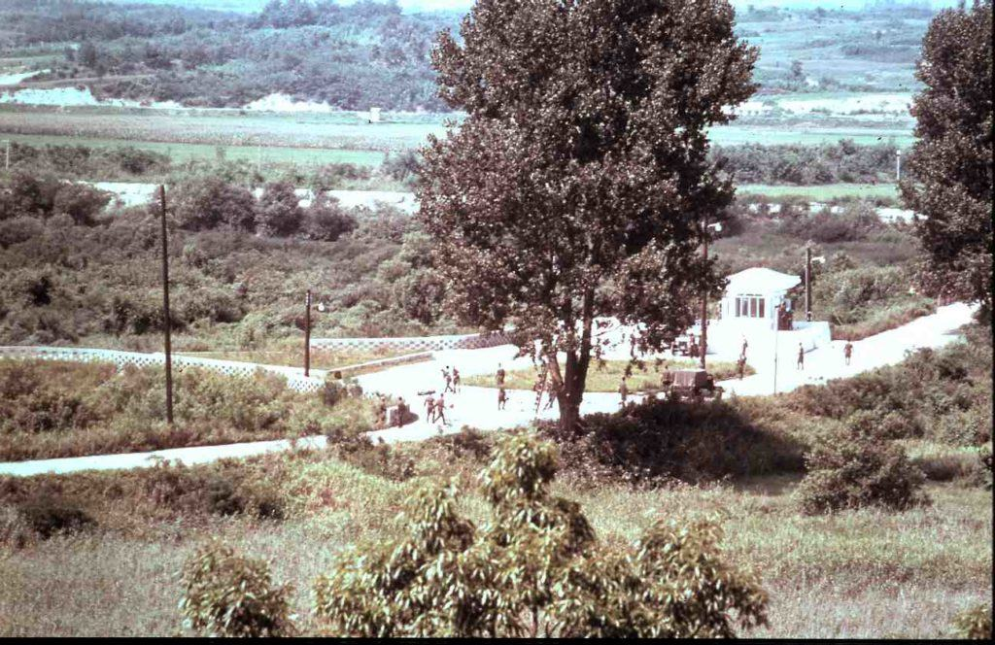
As soon as work began, 15 North Korean soldiers appeared, led by a Northern officer, Lt. Pak Chul, who was known for being confrontational. The North Koreans watch the crew work for roughly 15 minutes before demanding they stop because North Korean President Kim Il-Sung had supposedly planted the tree. Capt. Bonifas ordered the work to continue and then turned his back on the North Koreans. That gesture set Lt. Pak “The Bulldog” Chul over the edge. He sent a runner to get 20 more North Korean soldiers, who came carrying clubs and crowbars in the bed of a truck. He then ordered his men to “kill the bastards.” The Communists picked up the axes dropped by the work party and beat Capt. Bonifas to death on the spot.
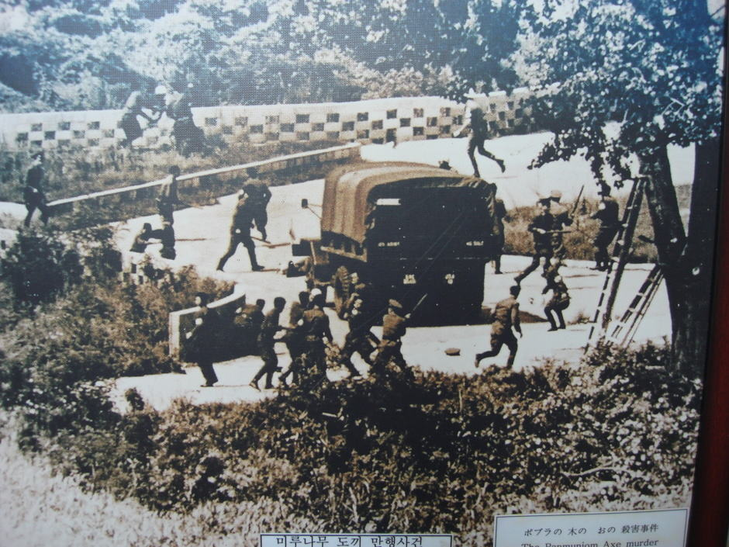
Lt. Barrett jumped over a wall and fell into a ravine across the road. Everyone else was wounded. The U.N. Observation Post could not see where Barrett was but only that North Korean guards were taking turns going into the ravine with an axe. This continued for 90 minutes.
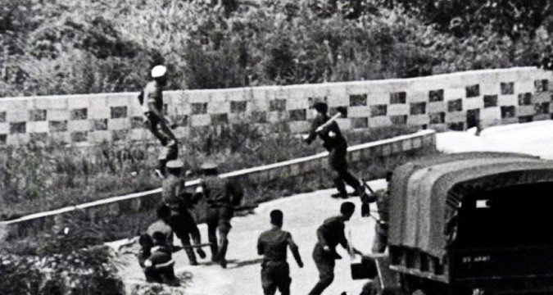
A search team was dispatched. They found Barrett still alive but badly hacked with the axes. He died on the way to a hospital in Seoul. The entire incident was recorded on film. Kim Jong-Il, speaking at a conference of Non-Aligned Nations in Sri Lanka denounced the attack as North Korean troops defending themselves from U.S. aggression. Around 10:45 a.m. today, the American imperialist aggressors sent in 14 hoodlums with axes into the Joint Security Area to cut the trees on their own accord, although such a work should be mutually consented beforehand. Four persons from our side went to the spot to warn them not to continue the work without our consent. Against our persuasion, they attacked our guards en masse and committed a serious provocative act of beating our men, wielding murderous weapons and depending on the fact that they outnumbered us. Our guards could not but resort to self-defense measures under the circumstances of this reckless provocation. Meanwhile, U.S. troops went to DEFCON 3 as a military response was weighed by the Pentagon and South Korean President Park Chung-Hee.
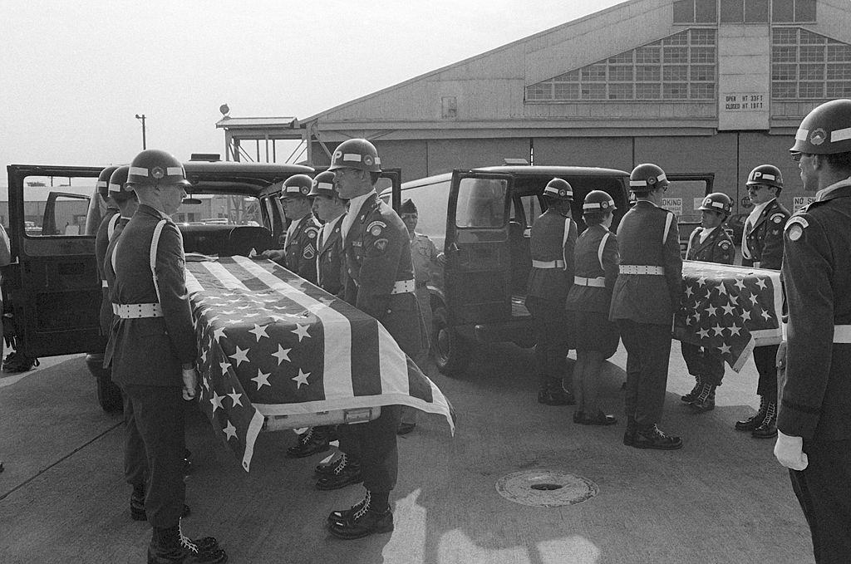
The repatriated American officers. Instead of an assault, the U.S. launched Operation Paul Bunyan. Three days after the killing, 23 American and South Korean vehicles drove into the Joint Security Area without alerting the North. They then dispatched 8 two-man teams of engineers with chainsaws to take out the tree. Two platoons of 30 men each came armed with clubs and were accompanied by South Korean Special Forces with axe handles. The South Koreans had Claymore Mines strapped to their chests, detonators in hand, as they walked across the bridge of no return that separated the two countries. They yelled at the North Korean soldiers, daring the Northerners to cross the bridge and meet them in combat.
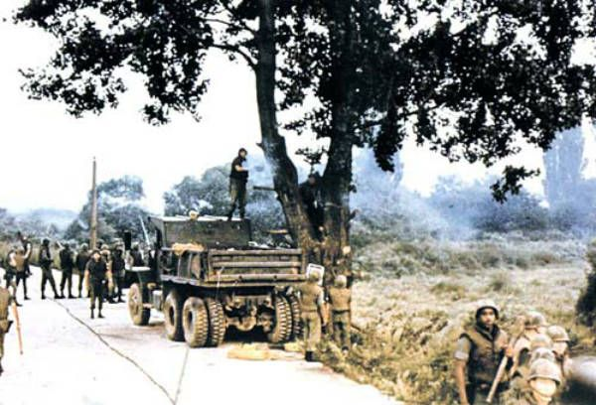
Meanwhile, the massive show of force operation, also had 20 helicopters in the air in the area, as well as B-52 Stratofortress Bombers flying overhead. The bombers were accompanied by F-4 Phantom IIs, South Korean F-5s and F-86s, and a number of F-111 bombers. The USS Midway Task Force was also just offshore.
North Korea deployed 200 troops to meet the force of more than 800 the U.S. and South Korea fielded. The Northerners watched the allied forces vandalize their guard posts from some buses. They eventually filed out and set up fire positions, but by then the Americans were on their way out of the JSA.
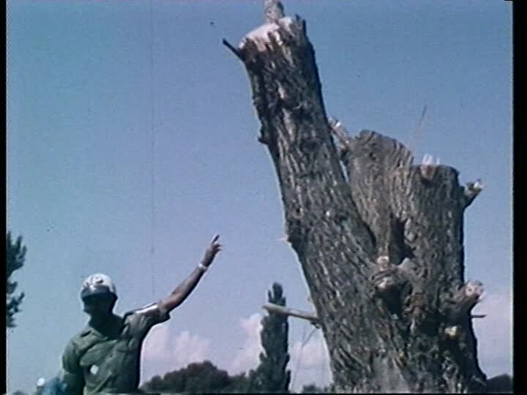
The tree was gone in 42 minutes. While North Korean President Kim Il-Sung sent a message of regret over the incident, he never took responsibility. The ax used to kill Bonifas and Barrett is now in the North Korean Peace Museum. In the South, the JSA’s advance camp was renamed Camp Bonifas for the fallen officer. General William Livsey, who commanded the 8th Army at the time, fashioned a “swagger stick” carved from the poplar tree’s wood. He passed it on to his successor.

