VETERANS OF FOREIGN WARS BLAZING STAR POST #1574
17 CANNON AVENUE
STATEN ISLAND, NY 10314
Website. http://blazingstarvfwpost1574.org/wp

April 2020

BLAZING STAR POST 1574 CONTACT NUMBERS
Al Porto, Commander - 718-578-1242, albert.porto38@gmail.com
Paul Dietrich, Quartermaster - 718-698-5269, paul@the-dietrichs.com
William Alcock, Adjutant - 718-698-1923

IN MEMORIAM

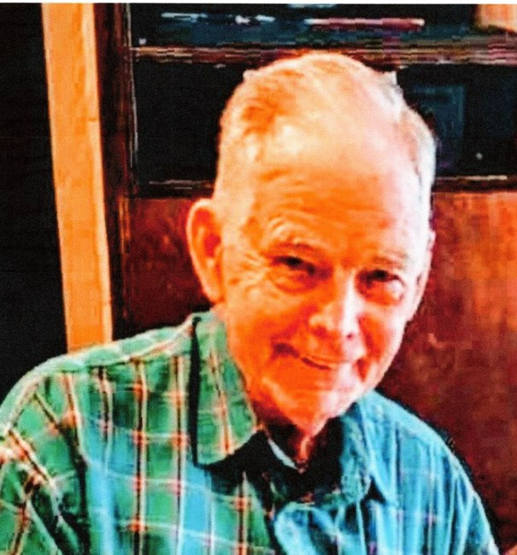

Charles A. Malone

August 26, 1930 – February 10, 2020

Charles A. Malone, long-time member of Blazing Star Post, passed away on February 10, 2020 at his winter home in Florida. Charlie, as we all called him, was an Army veteran who served in the 33rd Infantry Regiment during the Korean War. He later went on to become a Firefighter with the FDNY. Charlie was also very active with the Kivlehan Chapter of Korean War Veterans Association.

Calendar Events

Date | Event | Location | Time | Remarks
4 April 2020 | Blazing Star Post Meeting | Gold Star Post | 1000 | Cancelled
2 May 2020 | Blazing Star Post Meeting | Gold Star Post | 1000 | To Be Determined
9 May 2020 | Poppy Distribution | Shop Rite | 0900-1500 | To Be Determined
15 May 2020 | Poppy Distribution | Staten Island Ferry | 0700-1000 | To Be Determined
15 May 2020 | Poppy Distribution | Bayway Refinery | 1100-1300 | To Be Determined
16 May 2020 | Poppy Distribution | Stop & Shop | 0900-1500 | To Be Determined
17 May 2020 | Poppy Distribution | Stop & Shop | 0900-1500 | To Be Determined
23 May 2020 | Memorial Day Ceremony | Oceanview Cemetery | 1300 | To Be Determined
30 May 2020 | SI Tuna Club Bass Tournament | Great Kills Marina | TBA | To Be Determined
6 June 2020 | Blazing Star Post Meeting | Gold Star Post | 1000 | To Be Determined
11 July 2020 | Blazing Star Post Meeting | Gold Star Post | 1000 | To Be Determined
1 August 2020 | Blazing Star Post Meeting | Gold Star Post | 1000 | Saturday
2 September 2020 | Blazing Star Post Meeting | Gold Star Post | 1300 | Wednesday
7 October 2020 | Blazing Star Post Meeting | Gold Star Post | 1300 | Wednesday
4 November 2020 | Blazing Star Post Meeting | Gold Star Post | 1300 | Wednesday
2 December 2020 | Blazing Star Post Meeting | Gold Star Post | 1300 | Wednesday

College of Staten Island BLOOD DRIVE
Monday, April 27, 2020 11:30am – 5:30pm
Tuesday, April 28, 2020 8:30am – 2:30pm
Green Dolphin Room
Remember to eat, drink and bring your donor ID or ID with name and photo
Eligibility Information: https://www.nybc.org/donate/become-donor/can-i-donate-blood/

Coronavirus/COVID-19 Update

1. The response is as follows: If your Post County Council, District and Department cannot be elected Officers as required by the COVID-19 Virus the Current Officers shall remain in their current Position until new officer can be elected. In essence if you are an Officer in the Post County Council, District and Department you will stay in place until a proper election in compliance with the National By-Laws can be held or further order from National Headquarters.
2. Effective Thursday morning, March 19th Fort Hamilton will move to Health Protection Condition Charlie. (HPCON Charlie) The measures include curtailing/closure of certain services, telework considerations & limited access to the installation. Installation access will be limited to those who live and work on Fort Hamilton, mail and package delivery, contractors & mission-essential services. There will be 100 % ID check. This measure is being implemented to reduce the number of personnel on the installation to mitigate the spread of the virus. For the duration of this temporary protective measure, the following personnel will have not have access to the base: Veterans under the expanded patronage act and retirees, nor members of the Fort Hamilton Community Club that do not live or work on Fort Hamilton. We understand the impact & do not take it lightly. We recognize that this is a very dynamic situation and conditions will continue to change. We will continue to make risk-based decisions which are fully informed by health experts, senior leaders and government leaders from local to National level. We will remain transparent as possible and actively communicate those decisions to you. It's important that we take precautionary measures to protect the health of the force and maintain operational readiness in the midst of the COVID19 pandemic.

3. Scam Reminder Scammers now exploiting coronavirus fears KANSAS CITY, Mo. (March 19, 2020) – As a new wave of scams surface in an attempt to exploit coronavirus fears, the VFW would like to remind all of its members to exercise extreme caution in providing personal information during any unsolicited call. Most recently, a VFW member reported receiving a call from an individual identifying himself as a VFW representative and was asked to provide credit card information in exchange for a $100 gift card. This is a scam. If you do receive a call from an individual claiming to be a VFW representative who is requesting personally identifiable information, ask that they confirm your VFW membership number. If they’re unable to do so, hang up.

4. The Veterans Benefits Administration (VBA) Regional Offices will be closed to the public starting March 19.
Regional offices will remain open, but will no longer accept walk-ins for claims assistance, scheduled appointments, counseling and other in-person services. This decision protects our older Veterans and those with underlying conditions as well as our employees. Veterans can continue to get information about benefits or file a claim for benefits by visiting our website at www.va.gov. Veterans with claims specific or other questions may request information via Inquiry Routing & Information System (IRIS) or telephone at 1-800-827-1000. VBA benefits and services provided to Veterans, families, and survivors will continue to be delivered throughout the duration of COVID-19 impacts.

5. DMV NY. All Licenses, Non Driver ID's, and Registrations with an expiration date of March 1, 2020 or later will be extended. All DMV Offices are closed and road tests are suspended until further notice. All reservations have been cancelled. You can still do most transactions online. As DMV responds to the impact of COVID-19, the processing of some transactions and the provision of some services may be delayed. Thank you for your understanding.

6. The most up-to-date information on the novel coronavirus:
Governor Cuomo’s Guidance on Essential Services during the outbreak of COVID-19: https://www.governor.ny.gov/news/governor-cuomo-issues-guidance-essential-services-under-new-york-state-pause-executive-order
Virtual Resource Center: https://www1.nyc.gov/site/em/resources/covid-19-services-resources.page
Latest information from Department of Health: https://www1.nyc.gov/site/doh/covid/covid-19-main.page
Department of Education Learn at home resources: https://www.schools.nyc.gov/learn-at-home
Information about free meals: https://www.schools.nyc.gov/school-life/food/free-meals
Remote learning device request: https://www.schools.nyc.gov/school-life/health-and-wellness/coronavirus-update
Remote learning portal: https://www.schools.nyc.gov/learn-at-home/technical-tools-and-support/remote-learning-portal
Guidance from NYCHA: https://mailchi.mp/04dbfe42be85/nycha-intergov-organizational-changes-4085050?e=79da5d28fa

7. Update from the FCC: COVID-19
Scammers are constantly adapting and the recent COVID-19 national emergency is no exception. The FCC has learned of a number of ways fraudsters are seeking to take advantage of consumers.
From fake testing kits and unproven cures to government imposter scams and work from home schemes, robocall scams are being updated to reflect the current crisis. These scams prey on our most vulnerable community members and result in financial loss or worse, the use of potentially dangerous “treatments”. The FCC has developed a COVID-19 scams page (https://www.fcc.gov/covid-scams ) that includes tips to assist consumers with protecting themselves and their loved ones. The guide includes scam audio and a sample text hoax that was circulating. We will continue to update the page as we learn about new COVID-19 scams. We must work together to spread the word about these pernicious scams. Please share this link with your network or contact us to discuss a joint email message. For additional consumer information or to schedule additional partnership opportunities (informational webinars, etc.) please email outreach@fcc.gov
8. Comrades, it’s terrifying to learn that an illness such as coronavirus (COVID-19) is spreading across the globe. The early stages of a pandemic can be especially anxiety-provoking. During this time, you don’t know how widespread or deadly the illness is going to end up being. Feelings of fear, anxiety, sadness, and uncertainty are normal during a pandemic. Fortunately, being proactive about your mental health can help to keep both your mind and body stronger.
Ways to take care of yourself include:
- Reading the news from reliable sources (and take breaks from the news)
- Recognizing the things you can control, like having good hygiene
- Taking measures only if recommended by the CDC
- Practicing self-care
- Seeking professional help from a licensed mental health professional if necessary
- If you are feeling lonely or have anxiety so are many others, Pleasse take the time to check on your Posts, auxiliary, members, the elderly and friends to make sure they are ok and don’t need anything? I am sure they would like to hear from someone other that the TV or Radio.
Take care, stay healthy and remember we must all take care of ourselves and each other.

Membership

Service for John Byrnes

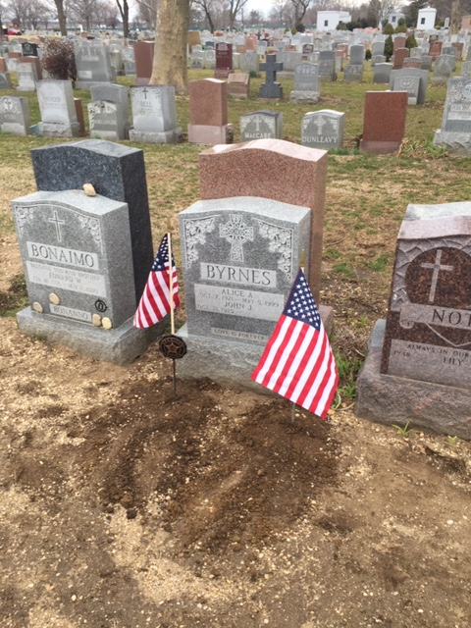

On March 6, 2020 A joint delegation from Blazing Star Post and Gold Star Post (American Legion) traveled to Long Island to pay our final respects to past member John Byrnes. We held a grave side service and installed VFW and American Legion grave markers with flags. Thanks to Gene Guerra for driving. Also in attendance were Paul Dietrich, Denny Pizzini, Mark Kelly and myself. Al Porto, Commander

1. Consider Life Membership. You save money over the long run and eliminate the need to renew yearly. Below are the membership rates for Life membership and Installment Plan Life Membership.
Age on 31 Dec Payment in Full Installment Plan Option
Total: Initial Fee: 11 payments of:
Through Age 30 $425.00 $45.00 $38.64
31-40 $410.00 $45.00 $37.27
41-50 $375.00 $45.00 $34.09
51-60 $335.00 $45.00 $30.45
61-70 $290.00 $45.00 $26.36
71-80 $225.00 $45.00 $20.45
81 and over $170.00 $45.00 $15.45

2. Dues Renewal Reminder:

 | Eans, Ernest | UnPaid | 6/30/2019 | EXPIRED
 | Gomes, Dannyel | UnPaid | 6/30/2019 | EXPIRED
 | Nelson, Eric | UnPaid | 5/31/2019 | EXPIRED
 | Santiago, Luis A | UnPaid | 4/30/2019 | EXPIRED

Service Officer

1. Veterans are encouraged to enroll in the VA health care so they are on record should they ever need it. No cost to apply. Apply on line at www.va.gov/healtheligibility/vfw or call 1-877-222-8387.

2. DD Form 214 website. http://vetrecs.archives.gov. If you need assistance, contact the post service officer, Doug Encarcion.

3. Survivor Outreach Services. The website has a lot of information for those left behind when a service member or veteran passes. http://www.sos.army.mil/ or http://www.westpointmwr.com/acs/survivor_outreach_services.html

4. To someone going through a difficult time, one simple act has the power to make a difference. Reach out to veterans and service members in your life today – http://www.veteranscrisisline.net/ThePowerof1.aspx.

5. Online Health Care Application. www.vets.gov. or call 877-222-VETS (8387).

6. Veterans Representative on Staten Island. Monique L. Rada Engagement and Community Services Coordinator
NYC Department of Veterans’ Services 1 Centre Street, Suite 2208 New York, NY 10007 917-628-8487 mrada@veterans.nyc.gov

7. Vets.gov Connects Veterans to Services.

8. John Bartow, Assistant VSO, Veterans of Foreign Wars 518-626-5687.

9. The following web site is the medical providers close to your house who have accepted the VA Choice program and are registered to do so. Quite a few here on SI. It gives a map where you can see them in relation to where you live or work. You can also get contact information to reach out to them. https://www.va.gov/opa/apps/locator/

10. A VBA Representative at the Staten Island Vet Center every Wednesday. There are no walk-ins everyone must call (718)816-4499 to set up an appointment. All services are free. Samuel B. Cottes, Jr., Veterans Outreach
Specialist, Staten Island Veterans Center, US Department of Veterans Affairs; Readjustment Counseling Services, 60 Bay Street, Staten Island, NY 10301 Tel: (718) 816-4499 x 7747 Cell: (929) 359-2449 Fax: (718) 816-6899

11. Discharge Upgrade Online Tool.
http://www.ourveterans.nyc/discharge_upgrade_online_tool?utm_campaign=180129&utm_medium=email&utm_source=nycveteransalliance

Employment and Education

1. Looking for a job? Need quality employees? USE VETJOBS! www.vetjobs.com

2. Vets looking for jobs, the website: 100000jobsmission.com. Go there to apply and search for available jobs specifically held for veterans.

Bottom of Form
General

1. Staten Island University Hospital's Military Appreciation Program. This program entitles active duty members and veterans free parking 12 times per year at the SIUH parking lot. Go to the Security Office with proof of military/veteran status. You will be given 12 parking stamps. Place them on parking ticket and no fee.

2. Free parking for veterans at Richmond County Medical Center. Veterans can park for free in the visitors parking lot where tokens are required. Stop at the main reception desk or security post, show proof you are a veteran (driver’s license with vet on it, retired ID card, VA card or similar) and they will give you a free token for the parking lot. Get it on the way in as the reception/info desk is not manned all night. Use the token to exit the lot. Saves you $4 per visit.

3. The Defense POW/MIA Office announced the identification of remains belonging to the following personnel. Returned
home are:
Army Air Forces 2nd Lt. Earl W. Smith, 22, 8th Fighter Group, Papua New Guinea Aug. 20, 1943.
Army Air Forces 2nd Lt. Earl F. Ferguson, 26, 93rd Bombardment Group (Heavy), Ploiesti, Romania, Aug. 1, 1943.
Army Maj. Harvey H. Storms, 34, HQ Co, 3rd Bn, 31st Infantry Regt, Chosin Reservoir, North Korea, Dec. 1, 1950.
Army Cpl. Ralph L. Cale, 19, Co B, 1st Bn, 32nd Infantry Regt, Chosin Reservoir, North Korea, Dec. 2, 1950.
U.S. Army Air Forces 2nd Lt. George M. Johnson, 23, 30th Bombardment Group, Tarawa Atoll, Gilbert Islands.
Navy Seaman 1st Class Orval A. Tranbarger, 20, USS Oklahoma, Pearl Harbor, Dec. 7, 1941.
Army Air Forces 2nd Lt. George M. Johnson, 23, 30th Bombardment Group, Tarawa Atoll, Gilbert Islands.
Navy Fireman 3rd Class Herbert B. Jacobson, 21, USS Oklahoma, Pearl Harbor, Dec. 7, 1941.
Marine Corps Sgt. Jerome B. Morris, 22, Co B, 1st Bn, 6th Marine Regt, Tarawa Atoll, Nov. 22, 1943.

4. The Defense POW/MIA Accounting Agency is seeking the public’s help to find and encourage more MIA families to donate a DNA sample to help speed the identification process of recovered remains. Each military service and the State Department has a service casualty office that can explain how to donate.

Army: 800-892-2490 | Navy: 800-443-9298 | State Department: 202-485-6106
Marine Corps: 800-847-1597 | Air Force: 800-531-5501

5. Staten Island Community TV: Veterans TV Shows are available 24 hours a day via Youtube. To view, google "Youtube, Ed Salek, In Honor of" or go to Youtube.com and search for Ed Salek, In Honor of.

Items of Interest

33rd Infantry Regiment

Distinctive Unit Insignia

The 33rd Infantry was activated on 6 July 1916 in accordance with War Department General Orders Number 22 dated 30 June 1916. Formed in the Canal Zone July 6, 1916 from personnel drawn from the 5th and 10th infantry stationed at Camps Empire and Otis. During the construction days both camps were occupied by troops after being vacated by civilians. Headquarters, machine gun, supply companies, and companies A,B,C,D,E, and F were organized at Camp Empire. Companies G,H,I,J,K,L, and M were organized at Camp Otis. The band section was organized at Fort Jay, N.Y. During the first four years of its existence, the 33rd Infantry was distributed by battalions, and detachments, throughout the canal zone and the Republic of Panama. During World War I, it guarded Gatun Locks, the dam and spillway, the Monte Lirio and Mindi Bridges, the Chagres River Bridge at Gamboa, the Pedro Miguel and Miraflores locks, pier 18 and the dry dock at Balboa. During the period from 1916 to 1920, the regiment was engaged in exploring and charting the jungles of Panama. In November, 1920, the 33rd Infantry Regiment assembled as a unit for the first time at Fort Clayton Canal Zone. In 1941 the regiment was transferred from the Panama Canal Department to the Caribbean Defense Command. On 6 September 1941, the 1st Battalion was sent to Trinidad, with elements of the 1st Battalion later transferring to Surinam to guard bauxite mines, protect the Dutch government in exile, and watch the border of Vichy French Guiana. The 2d and 3d Battalions later arrived at Fort Read in Trinidad. The 1st Battalion was withdrawn from Surinam in June 1943 and moved to Aruba. In March 1944 the regiment departed Trinidad arriving in New York in 1944, the first time the regimental colors arrived on Continental American soil. The regiment was assigned to Camp Claiborne Louisiana and assigned to the Fourth United States Army. Many of the regiment volunteered for Merrill's Marauders and were sent to Burma as the 2d Battalion 5307th Composite Unit (Provisional). The regiment was inactivated on 26 June 1944. The 33d Infantry was reactivated at Fort Clayton on February 1946, inactivated again on September 1948 at Fort Gulick, then reactivated at Fort Kobbe, Canal Zone. During the Korean War the 3d Battalion of the 33d was transferred to the 65th Infantry Regiment for war service. The 33d Infantry became part of the Americal Division in the Canal Zone on 2 December 1954, with the regiment being inactivated again on 26 May 1956, the assets of the unit being used to reactivate the 20th Infantry Regiment.

Notable member: Charles A. Malone

