VETERANS OF FOREIGN WARS BLAZING STAR POST #1574
17 CANNON AVENUE
STATEN ISLAND, NY 10314
718-578-1242
albert.porto38@gmail.com

March 2015

BLAZING STAR POST 1574 CONTACT NUMBERS IN CASE OF DEATH, ILLNESS OR IN NEED OF ASSISTANCE
Al Porto, Commander - 718-578-1242, albert.porto38@gmail.com
Paul Dietrich, Quartermaster - 718-698-5269, paul@the-dietrichs.com
William Alcock, Adjutant - 718-698-1923

Calendar Events
Calendar of Events for 2015:

Date | Event | Location | Time | Remarks
4 March | Blazing Star Post Meeting | Gold Star Post | 1300
29 March | District 2 VFW Meeting | New Paltz, NY | 1300 | Input needed
1 April | Blazing Star Post Meeting | Gold Star Post | 1300 | Post Elections
19 April | A/L Children in Youth Breakfast | Staaten | 0830 | $30.00
26 April | SSG Ollis Memorial Poker Run | Ollis VFW Post | 1100 | Details below
6 May | Blazing Star Post Meeting | Gold Star Post | 1300
15 May | KWVA Annual Dinner Dance | Staaten | 1930
16 May | Poppy Distribution | Shoprite | 0900
22 May | Poppy Distribution | SI Ferry | 0700
22 May | Poppy Distribution | Phillips Refinery | 1100
23 May | Poppy Distribution | Stop & Shop | 0900
24 May | Poppy Distribution | Stop & Shop | 0900
25 May | Memorial Day Ceremony | Travis War Memorial | 0900
25 May | Richmond County VFW Ceremony | Oceanview Cemetery | 1100
30 May | Frank Peters Homecoming Dinner | Staaten | TBA
6 June | Blazing Star Post Meeting | Gold Star Post | 1000
4 July | Travis 4th of July Parade | Showcase Bowling | 1030
11 July | Blazing Star Post Meeting | Gold Star Post | 1000
1 August | Blazing Star Post Meeting | Gold Star Post | 1000
2 September | Blazing Star Post Meeting | Gold Star Post | 1300
7 October | Blazing Star Post Meeting | Gold Star Post | 1300
4 November | Blazing Star Post Meeting | Gold Star Post | 1300
2 December | Blazing Star Post Meeting | Gold Star Post | 1300

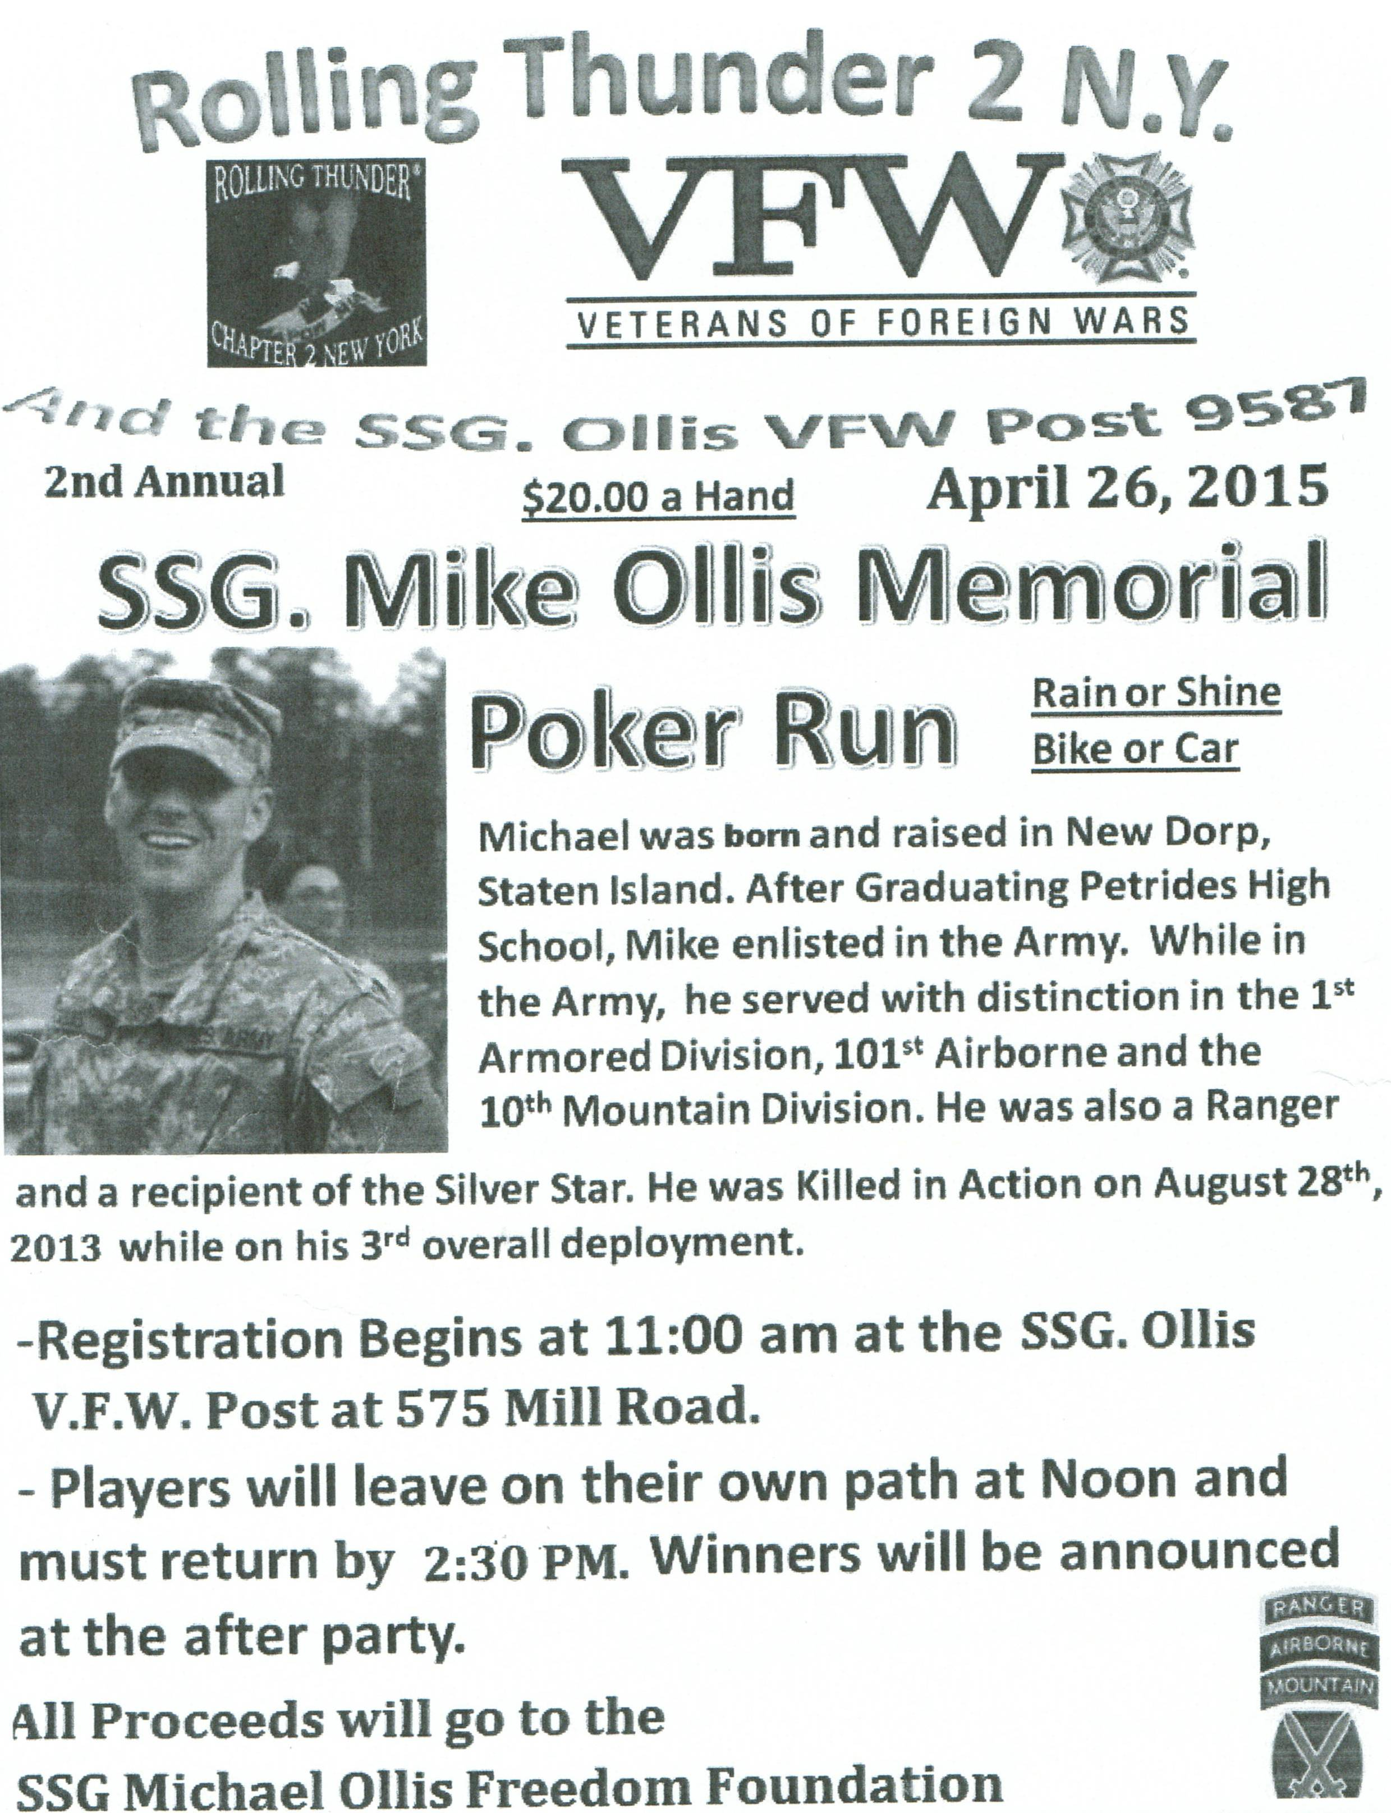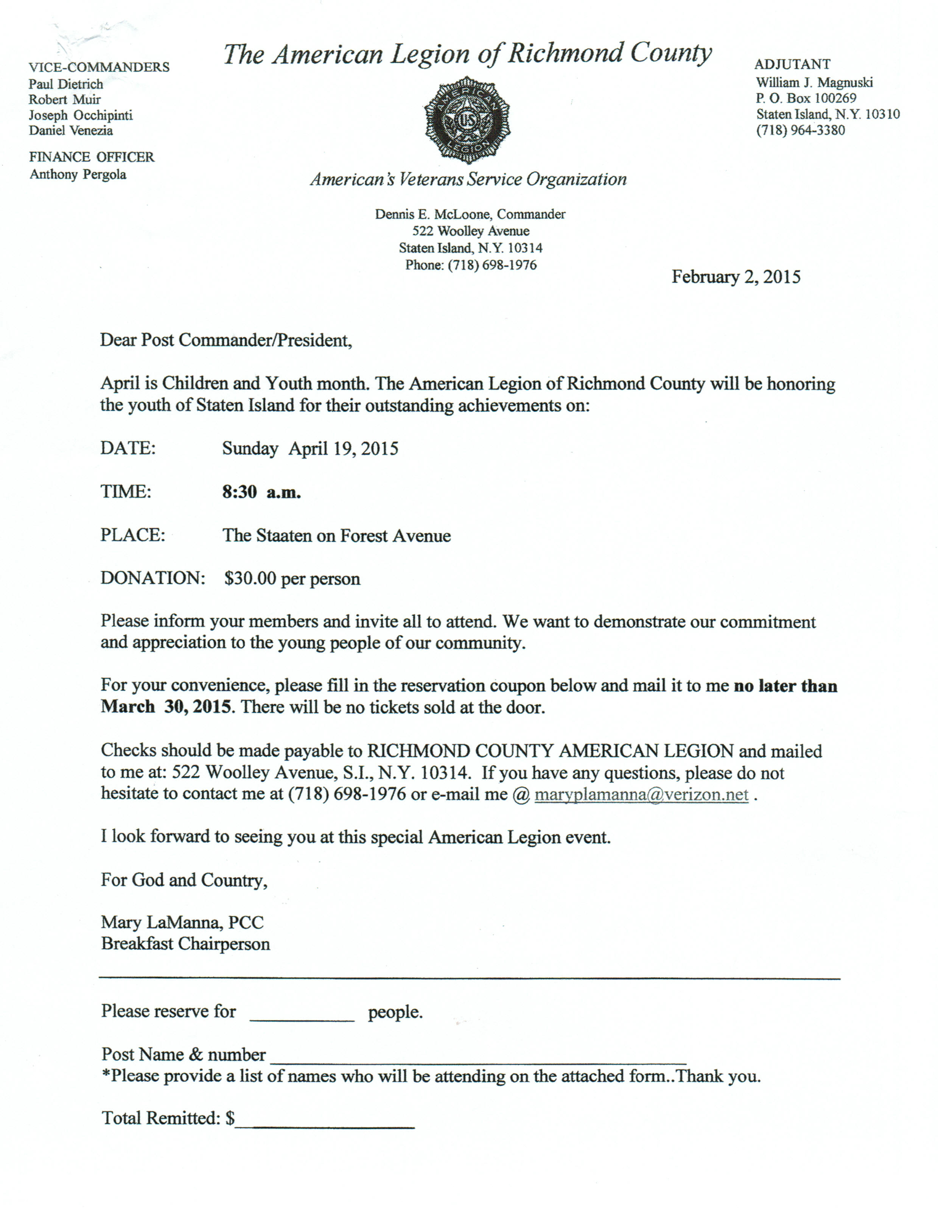

Membership

1. The new dues rate for annual members is $35 per year. Note that dues change was done at the national level. Below are the membership rates for Life membership and Installment Plan Life Membership. Recommend that all members consider installment Life membership when their renewal is due as you save over the long run and eliminate the need to renew yearly.

Age attained on Dec 31 Payment in Full Installment Plan Initial Fee 11 payments of:
Through Age 30 $425.00 $45.00 $38.64
31-40 $410.00 $45.00 $37.27
41-50 $375.00 $45.00 $34.09
51-60 $335.00 $45.00 $30.45
61-70 $290.00 $45.00 $26.36
71-80 $225.00 $45.00 $20.45
81 and over $170.00 $45.00 $15.45

2. Post elections will be held during the April meeting. I urge all members to attend that meeting to participate in the election process and vote. One of the trustee positions is vacant and we need a candidate.

Service Officer

1. Veterans are encouraged to enroll in the VA health care so they are on record should they ever need it. No cost to apply. Apply on line at www.va.gov/healtheligibility/vfw or call 1-877-222-8387.

2. Tri-Care Dental. Tri-Care dental isn't free. You must enroll to be covered. Tri-Care dental web site, www.trdp.org
Delta Dental Tel #. 888-838-8737. The Tri-Care number for NY, is 1-877-874-2273.

3. DD Form 214 website. http://vetrecs.archives.gov. If you need assistance, contact the post service officer, Paul Dietrich.

4. Survivor Outreach Services. The website has a lot of information for those left behind when a service member or veteran passes. http://www.sos.army.mil/ or http://www.westpointmwr.com/acs/survivor_outreach_services.html

5. VA Choice Program Rollout. The Veterans Access, Choice and Accountability Act required VA to start implementation of the Choice Program by November 5, 2014. Starting this week, veterans who live 40 or more miles away from a VA medical facility will have the opportunity to choose whether to receive their health care at VA or in their community, through non-VA doctors. Veterans who live within 40 miles of a VA medical facility, but are currently waiting longer than 30 days for VA care will begin receiving their cards later this month. VA expects that all veterans who were enrolled in the VA health care system on August 1, 2014, will receive their cards by January 2015. However, receiving a Veterans Choice Card does not instantly authorize you to start receiving health care from non-VA doctors. All care received through the Choice Program must be pre-authorized and coordinated by VA.

Employment and Education

1. Looking for a job? Need quality employees? USE VETJOBS! www.vetjobs.com

2. Vets looking for jobs, the website: 100000jobsmission.com. Go there to apply and search for available jobs specifically held for veterans.

3. New initiative called the We can't wait program plan helps ex GIs get civilian credentials/licenses for skills learned in the military. For info: http://www.whitehouse.gov/sites/default/files/docs/veterans_report_5-31-2012.pdf

4. Veterans Head Back to Boot Camp to Learn Business Skills. Boots to Business: Reboot is a two-day entrepreneurship workshop presented by the U.S. Small Business Administration and the Institute for Veterans and Military Families (IVMF) available to transitioning service members as a part of the Defense Department’s Transition Assistance Program. Learn more about the program http://www.military1.com/veterans/article/538543-veterans-head-back-to-boot-camp-to-learn-business-skills.

Bottom of Form
General

1. Staten Island University Hospital's Military Appreciation Program. This program entitles active duty members and veterans free parking 12 times per year at the SIUH parking lot. Call 718-226-4325 for an application.

2. The Defense POW/MIA Office announced the identification of remains belonging to the following personnel. Returned home are:
* Air Force Capt. Richard D. Chorlins, 24, of University City, Mo., who was piloting an A-1 Skyraider aircraft on a night strike mission over the Mu Gia Pass in Laos when his aircraft was shot down by enemy ground fire on Jan. 11, 1970. He was assigned to the 602nd Special Operations Squadron, 34th Tactical Group.
* U.S. Army Air Forces 1st Lt. James F. Gatlin, 25, of Jacksonville, Fla. On Dec. 23, 1944, Gatlin was copiloting a B-26C Marauder that was shot down while on a bombing mission near Ahrweiler, Germany. Gatlin and four other crew members were reported killed in action. He was assigned to the 575th Bombardment Squadron, 391st Bombardment Group, 9th Air Force.
* Army Sgt. Gilberto L. Sanchez, 19, of New Braunfels, Texas. Sanchez was assigned to Medical Company, 32nd Infantry Regiment, 31st Regimental Combat Team. His unit was deployed east of the Chosin Reservoir in North Korea when it was attacked by overwhelming numbers of Chinese forces. On Dec. 1, 1950, remnants of the 31st RCT, known historically as Task Force Faith, began a fighting withdrawal to more defensible positions south of the reservoir. Sanchez was reported as missing in action on Dec. 2.
* Army Cpl. C.G. Bolden, 24, of Van Buren, Ark. Bolden was assigned to Company C, 1st Battalion, 38th Infantry Regiment, 2nd Infantry Division. He was captured by enemy forces on Jan. 5, 1951, and reportedly died in a North Korean POW Camp on April 30, 1951.

3. Devil's Brigade to Receive Congressional Gold Medal. The U.S.-Canadian 1st Special Service Force, known as the "Devil's Brigade," was presented with the Congressional Gold Medal in a February 3 ceremony inside the U.S.
Capitol. The Devil's Brigade is the predecessor of today's Green Berets. They operated primarily in Italy and southern France, and were responsible for 12,000 German casualties and capturing 7,000 prisoners. The Congressional Gold Medal is the nation's highest award for distinguished achievement. Recent military recipients have included the Tuskegee Airmen, Native American Code Talkers, Women Air Service Pilots, the Japanese-American WWII units 100th Infantry Battalion, 442nd Regimental Combat Team and Military Intelligence Service, Montford Point Marines, the 65th Infantry Regiment "Borinqueneers" and the Doolittle Raiders.

4. Teen from New York in the running to win a $30,000 scholarship from the VFW. High school students across the country recorded audio-essays on "Why Veterans Are Important to Our Nation's History and Future." We've selected one lucky winner from each state to qualify for the grand prize, a $30,000 scholarship to the college or trade school of their choice.

Hear the winning essays.
http://heroes.vfw.org/site/R?i=Xi1AxStbrSCBiNJj2J53wA

It's all part of the VFW's Voice of Democracy competition, in which high school students compete for more than $2.2 million in scholarships and incentives.

Hear Your State Winner's Essay Clip
http://heroes.vfw.org/site/R?i=HvUIyW3K3s7rQ3IpdRhCpA

The grand-prize winner will be announced on Monday, March 2, at the VFW Legislative Conference in Washington, D.C. Tune in at 6 p.m. (ET) for a live stream of the Parade of Winners at vfw.org/legislativeconference.

Share the Audio Clip
http://heroes.vfw.org/site/R?i=LSg1fyPY5J7oczdAXl_ykw

5. Identity Theft Protection. Identity theft happens when someone steals your personal information, such as your Social Security number, address, phone number or financial account information, and uses it to open up lines of credit
IN YOUR NAME.

What you can do to protect yourself?
* Protect your personal information. Do not give out information such as your social security number, and important passwords to your accounts.
* Never carry your social security card, memorize the number. If you must give the number for verification over the phone, the last 4 digits should suffice. Institutions should never ask you to provide your full social security number.
* Do not give personal information over the phone; the caller on the other side may not be who they purport to be.
* Use a secured mailbox.
* Check your credit history and score regularly. Subscribe to a reputable credit monitoring service. It may cost you a fee but peace of mind is priceless.
* Shred all documents containing important information before disposing of them.

Items of Interest

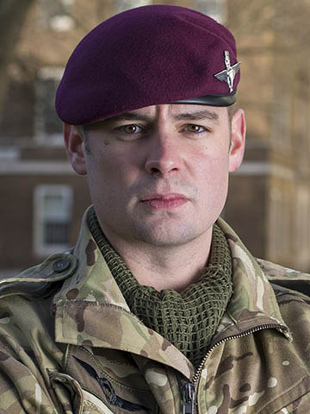

Joshua Mark Leakey, VC is a British soldier who is currently serving in the Parachute Regiment. He was awarded the Victoria Cross, the highest military decoration for valor in the British and Commonwealth armed forces, for his involvement in a joint UK-USA raid in Helmand Province, Afghanistan, on 22 August 2013. He is the first living British soldier to be awarded the Victoria Cross for the War in Afghanistan. He is the second member of his family to be awarded the Victoria Cross. His second cousin twice removed, Nigel Leakey, was posthumously awarded the medal during the Second World War. He is also related to David Leakey, the current Black Rod and a former senior British Army officer.
Leakey joined the British Army in 2007 and was subsequently posted to the 1st Battalion, Parachute Regiment. He served three tours of duty in Afghanistan during Operation Herrick: in 2009, 2011 and 2013. The actions for which Leakey was awarded the Victoria Cross occurred on 22 August 2013 in Helmand Province, Afghanistan. A routine joint patrol composed of British paratroopers, US Marines and Afghan soldiers had targeted a village to search for illegal weapons. Having been flown into the area in Chinook helicopters, the patrol was attacked by machine gun fire and rocket-propelled grenades soon after dismounting. Leakey's helicopter had landed on a hill near the village and he, with three other paratroopers and an Afghan soldier, was to provide fire support for the main segment of the patrol. From their vantage point, his section could see the attack and heard over their radio that someone had been injured. Leakey ran up the hill to assess the seriousness of the attack and came to the conclusion that urgent action was needed. Though he was only a lance corporal, he took control of the situation and led his section down to the group under attack. Having reached the group under attack, he gave first aid to the wounded US Marine Corps captain and began the process of evacuating him from the battlefield. While under fire, he returned to the machine guns that his section had left at the top of the hill. He moved one to a better position to fire at the attacking Taliban even though he was under constant, accurate fire (bullets were ricocheting off the weapon he was carrying). His actions inspired other soldiers to join in the fightback. While he was manning the machine gun, he was also shouting updates of the situation into his radio. Having realized that more than one machine gun would be needed to effectively fight back the insurgents, he allowed his gun to be taken over by another soldier. He then ran once more through heavy fire to retrieve a second machine gun, position it in a suitable site, and then manned it to fire at the Taliban. The skirmish lasted approximately 45 minutes during which eleven insurgents were killed and four wounded. It was only when air support arrived that fighting ceased. When it did, he handed the second machine gun over to another soldier. He then returned to the injured American officer and oversaw his medical evacuation.

The Ministry of Defense summarized the reasons for awarding Leakey the Victoria Cross as follows:
Under fire yet undeterred by the very clear and present danger, Lance Corporal Leakey ran across the exposed slope of the hill three times to initiate casualty evacuation, re-site machine guns and return fire. His actions proved the turning point, inspiring his comrades to fight back with renewed ferocity. Displaying gritty leadership well above that expected of his rank, Lance Corporal Leakey's actions singlehandedly regained the initiative and prevented considerable loss of life.
Announcing Leakey's medal, General Sir Nicholas Carter, broke with tradition to hug Leakey. Leakey will be presented with the medal in a ceremony at Buckingham Palace.

