VETERANS OF FOREIGN WARS BLAZING STAR POST #1574
17 CANNON AVENUE
STATEN ISLAND, NY 10314
Website. http://blazingstarvfwpost1574.org/wp

April 2019

BLAZING STAR POST 1574 CONTACT NUMBERS
Al Porto, Commander - 718-578-1242, albert.porto38@gmail.com
Paul Dietrich, Quartermaster - 718-698-5269, paul@the-dietrichs.com
William Alcock, Adjutant - 718-698-1923

Calendar Events

Date | Event | Location | Time | Remarks
6 April | Blazing Star Post Meeting | Gold Star Post | 1000 | Saturday
6 April | Vietnam Veterans’ Day Ceremony | Tottenville High School | 1400
16 April | CSI Blood Drive – Campus Center (1C) | Green Dolphin Lounge | 1130-1730
17 April | CSI Blood Drive – Campus Center (1C) | Green Dolphin Lounge | 0830-1430
4 May | Blazing Star Post Meeting | Gold Star Post | 1000 | Saturday
17 May | Poppy Distribution | SI Ferry & Refinery | 0700-1300
18 May | Poppy Distribution | Stop & Shop | 0900-1500
19 May | Poppy Distribution | Stop & Shop | 0900-1500
25 May | Poppy Distribution | ShopRite | 0900-1500
27 May | Memorial Day Ceremony | Oceanview Cemetery | 1100
1 June | Blazing Star Post Meeting | Gold Star Post | 1000 | Saturday
13 July | Blazing Star Post Meeting | Gold Star Post | 1000 | Saturday
3 August | Blazing Star Post Meeting | Gold Star Post | 1000 | Saturday
4 September | Blazing Star Post Meeting | Gold Star Post | 1300 | Wednesday
2 October | Blazing Star Post Meeting | Gold Star Post | 1300 | Wednesday
6 November | Blazing Star Post Meeting | Gold Star Post | 1300 | Wednesday
4 December | Blazing Star Post Meeting | Gold Star Post | 1300 | Wednesday
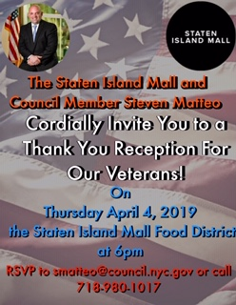

Membership

1. Consider Life Membership. You save money over the long run and eliminate the need to renew yearly. Below are the membership rates for Life membership and Installment Plan Life Membership.
Age on 31 Dec Payment in Full Installment Plan Option
Total: Initial Fee: 11 payments of:
Through Age 30 $425.00 $45.00 $38.64
31-40 $410.00 $45.00 $37.27
41-50 $375.00 $45.00 $34.09
51-60 $335.00 $45.00 $30.45
61-70 $290.00 $45.00 $26.36
71-80 $225.00 $45.00 $20.45
81 and over $170.00 $45.00 $15.45

2. We are collecting items such as snacks, microwave popcorn, jiffy pop and hard candies, etc. for fellow post member Adam Scher who is deployed to Afghanistan.

3. Dues Renewal Reminder:
Balistreri, Sal | 2/28/2019 | EXPIRED
Curry, Albert | 12/31/2017 | EXPIRED
DiPietrantonio, Rosa | 1/31/2019 | EXPIRED
Garriga, Jose A | 12/31/2018 | EXPIRED
Griffo, Arnold P | 1/31/2019 | EXPIRED
Hayes, Matthew T | 5/9/2018 | EXPIRED
Johnson, Khadijah L | 5/2/2018 | EXPIRED
Krigel, Adam C | 10/31/2018 | EXPIRED
Krishna, Ash | 6/18/2018 | EXPIRED
Maloney, Brian T | 12/31/2017 | EXPIRED
Moore, Thomas | 12/31/2018 | EXPIRED
Ruggiero, Blenda C | 6/29/2018 | EXPIRED
Sheinwald, Abe | 3/30/2018 | EXPIRED

Service Officer

1. Veterans are encouraged to enroll in the VA health care so they are on record should they ever need it. No cost to apply. Apply on line at www.va.gov/healtheligibility/vfw or call 1-877-222-8387.

2. DD Form 214 website. http://vetrecs.archives.gov. If you need assistance, contact the post service officer, Doug Encarcion.

3. Survivor Outreach Services. The website has a lot of information for those left behind when a service member or veteran passes. http://www.sos.army.mil/ or http://www.westpointmwr.com/acs/survivor_outreach_services.html

4. To someone going through a difficult time, one simple act has the power to make a difference. Reach out to veterans and service members in your life today – http://www.veteranscrisisline.net/ThePowerof1.aspx.

5. Online Health Care Application. www.vets.gov. or call 877-222-VETS (8387).

6. Veterans Representative on Staten Island. Monique L. Rada Engagement and Community Services Coordinator
NYC Department of Veterans’ Services 1 Centre Street, Suite 2208 New York, NY 10007 917-628-8487 mrada@veterans.nyc.gov

7. Vets.gov Connects Veterans to Services.

8. John Bartow, Assistant VSO, Veterans of Foreign Wars 518-626-5687.

9. The following web site is the medical providers close to your house who have accepted the VA Choice program and are registered to do so. Quite a few here on SI. It gives a map where you can see them in relation to where you live or work. You can also get contact information to reach out to them. https://www.va.gov/opa/apps/locator/

10. A VBA Representative at the Staten Island Vet Center every Wednesday. There are no walk-ins everyone must call (718)816-4499 to set up an appointment. All services are free. Samuel B. Cottes, Jr., Veterans Outreach

Specialist, Staten Island Veterans Center, US Department of Veterans Affairs; Readjustment Counseling Services, 60 Bay Street, Staten Island, NY 10301 Tel: (718) 816-4499 x 7747 Cell: (929) 359-2449 Fax: (718) 816-6899

11. Discharge Upgrade Online Tool.
http://www.ourveterans.nyc/discharge_upgrade_online_tool?utm_campaign=180129&utm_medium=email&utm_source=nycveteransalliance

Employment and Education

1. Looking for a job? Need quality employees? USE VETJOBS! www.vetjobs.com

2. Vets looking for jobs, the website: 100000jobsmission.com. Go there to apply and search for available jobs specifically held for veterans.

Bottom of Form
General

1. Staten Island University Hospital's Military Appreciation Program. This program entitles active duty members and veterans free parking 12 times per year at the SIUH parking lot. Go to the Security Office with proof of military/veteran status. You will be given 12 parking stamps. Place them on parking ticket and no fee.

2. Free parking for veterans at Richmond County Medical Center. Veterans can park for free in the visitors parking lot where tokens are required. Stop at the main reception desk or security post, show proof you are a veteran (drivers license with vet on it, retired ID card, VA card or similar) and they will give you a free token for the parking lot. Get it on the way in as the reception/info desk is not manned all night. Use the token to exit the lot. Saves you $4 per visit.

3. The Defense POW/MIA Office announced the identification of remains belonging to the following personnel. Returned
home are:
The Defense POW/MIA Accounting Agency did not announce any identifications or recovery updates this month.

4. The Defense POW/MIA Accounting Agency is seeking the public’s help to find and encourage more MIA families to donate a DNA sample to help speed the identification process of recovered remains. Each military service and the State Department has a service casualty office that can explain how to donate.

Army: 800-892-2490 | Navy: 800-443-9298 | State Department: 202-485-6106
Marine Corps: 800-847-1597 | Air Force: 800-531-5501

5. Staten Island Community TV: Veterans TV Shows are available 24 hours a day via Youtube. To view, google "Youtube, Ed Salek, In Honor of" or go to Youtube.com and search for Ed Salek, In Honor of.

6. Here is what your Post has done for our deployed troops. Packages from home are always special.

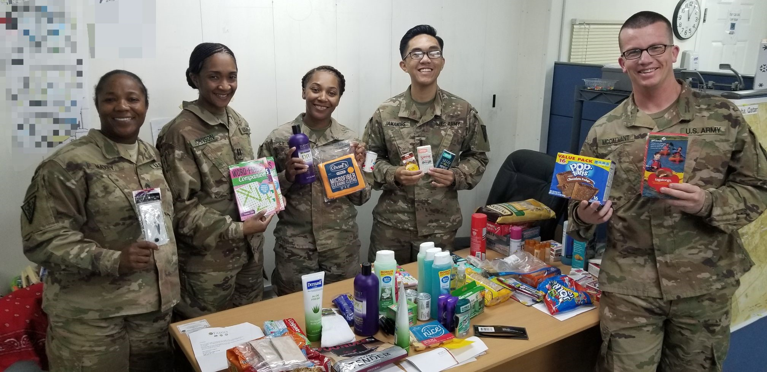

Items of Interest

Subject: The Whole Class Failed
A brief lesson regarding Socialism.
Teacher Fails Entire Class and explains why Socialism won't work, and always fails. This teacher is a GENIUS!

An economics professor at a local college made a statement that he had never failed a single student before, but had recently failed an entire class. That class had insisted that socialism worked and that no one would be poor and no one would be rich, a great equalizer.

The professor then said, "OK, we will have an experiment in this class on this plan". All grades will be averaged and everyone will receive the same grade so no one will fail and no one will receive an A.... (substituting grades for dollars - something closer to home and more readily understood by all).

After the first test, the grades were averaged and everyone got a B. The students who studied hard were upset and the students who studied little were happy. As the second test rolled around, the students who studied little had studied even less and the ones who studied hard decided they wanted a free ride too so they studied little.

The second test average was a D! No one was happy. When the 3rd test rolled around, the average was an F.
As the tests proceeded, the scores never increased as bickering, blame and name-calling all resulted in hard feelings and no one would study for the benefit of anyone else.

To their great surprise, ALL FAILED and the professor told them that socialism would also ultimately fail because when the reward is great, the effort to succeed is great, but when government takes all the reward away, no one will try or want to succeed.

These are possibly the 5 best sentences you'll ever read and all applicable to this experiment:

1. You cannot legislate the poor into prosperity by legislating the wealthy out of prosperity.

2. What one person receives without working for, another person must work for without receiving.

3. The government cannot give to anybody anything that the government does not first take from somebody else

4. You cannot multiply wealth by dividing it!

5. When half of the people get the idea that they do not have to work because the other half is going to take care of them, and when the other half gets the idea that it does no good to work because somebody else is going to get what they work for, that is the beginning of the end of any nation.

