**VETERANS OF FOREIGN WARS BLAZING STAR POST #1574**

**17 CANNON AVENUE**

**STATEN ISLAND, NY 10314**

**Website. http://blazingstarvfwpost1574.org/wp**

**July 2019**

|  |
| --- |
| BLAZING STAR POST 1574 CONTACT NUMBERS  Al Porto, Commander - 718-578-1242, albert.porto38@gmail.com  Paul Dietrich, Quartermaster - 718-698-5269, paul@the-dietrichs.com  William Alcock, Adjutant - 718-698-1923 |

**Calendar Events**

|  |  |  |  |  |
| --- | --- | --- | --- | --- |
| Date | Event | Location | Time | Remarks |
| 13 July | Blazing Star Post Meeting | Gold Star Post | 1000 | Saturday |
| 3 August | Blazing Star Post Meeting | Gold Star Post | 1000 | Saturday |
| 4 September | Blazing Star Post Meeting | Gold Star Post | 1300 | Wednesday |
| 2 October | Blazing Star Post Meeting | Gold Star Post | 1300 | Wednesday |
| 22-23 October | Blood Drive | College of Staten Island | TBA |  |
| 6 November | Blazing Star Post Meeting | Gold Star Post | 1300 | Wednesday |
| 4 December | Blazing Star Post Meeting | Gold Star Post | 1300 | Wednesday |

**Membership**

1. Consider Life Membership. You save money over the long run and eliminate the need to renew yearly. Below are the membership rates for Life membership and Installment Plan Life Membership.

**Age on 31 Dec             Payment in Full             Installment Plan Option                               
                         Total:                   Initial Fee:        11 payments of:**

Through Age 30               $425.00                $45.00                $38.64

31-40                                  $410.00                $45.00                $37.27

41-50                                  $375.00                $45.00                $34.09

51-60                                  $335.00                $45.00                $30.45

61-70                                  $290.00                $45.00                $26.36

71-80                                  $225.00                $45.00                $20.45

81 and over                        $170.00                $45.00                $15.45

2. We are still collecting items such as snacks, microwave popcorn, jiffy pop and hard candies, etc. for fellow post member Adam Scher who is deployed to Afghanistan.

4. Dues Renewal Reminder:

|  |  |  |  |  |  |  |  |  |  |
| --- | --- | --- | --- | --- | --- | --- | --- | --- | --- |
|  | **DiPietrantonio, Rosa** |  |  | **UnPaid** | | ***1/31/2019*** | | **EXPIRED** | |
|  | **Eans, Ernest** | **UnPaid** | | | ***6/30/2019*** | | **EXPIRED** | |
|  | **Garriga, Jose A** | **UnPaid** | | | ***12/31/2018*** | | **EXPIRED** | |
|  | **Gomes, Dannyel** | **UnPaid** | | | ***6/30/2019*** | | **EXPIRED** | |
|  | **Griffo, Arnold P** | **UnPaid** | | | ***1/31/2019*** | | **EXPIRED** | |
|  | **Ivan, Peter C** | **UnPaid** | | | ***4/30/2019*** | | **EXPIRED** | |
|  | **Krigel, Adam C** | **UnPaid** | | | ***10/31/2018*** | | **EXPIRED** | |
|  | **Moore, Thomas** | **UnPaid** | | | ***12/31/2018*** | | **EXPIRED** | |
|  | **Nelson, Eric** | **UnPaid** | | | ***5/31/2019*** | | **EXPIRED** | |
|  | **Santiago, Luis A** | **UnPaid** | | | ***4/30/2019*** | | **EXPIRED** | |

**Service Officer**

1. Veterans are encouraged to enroll in the VA health care so they are on record should they ever need it.  No cost to apply.  Apply on line at www.va.gov/healtheligibility/vfw or call 1-877-222-8387.

2. DD Form 214 website. http://vetrecs.archives.gov. If you need assistance, contact the post service officer, Doug Encarcion.

3. Survivor Outreach Services. The website has a lot of information for those left behind when a service member or veteran passes. <http://www.sos.army.mil/> or <http://www.westpointmwr.com/acs/survivor_outreach_services.html>

4. To someone going through a difficult time, one simple act has the power to make a difference. Reach out to veterans and service members in your life today – <http://www.veteranscrisisline.net/ThePowerof1.aspx>.

5. Online Health Care Application.[www.vets.gov](https://www.vets.gov/).  or call 877-222-VETS (8387).

6. Veterans Representative on Staten Island. Monique L. Rada Engagement and Community Services Coordinator

NYC Department of Veterans’ Services [1 Centre Street, Suite 2208](x-apple-data-detectors://1/0) [New York, NY 10007](x-apple-data-detectors://1/0) [917-628-8487](tel:917-628-8487) [mrada@veterans.nyc.gov](mailto:mrada@veterans.nyc.gov)

7. [Vets.gov](http://vets.gov/) Connects Veterans to Services.

8. John Bartow, Assistant VSO, Veterans of Foreign Wars 518-626-5687.

9. The following web site is the medical providers close to your house who have accepted the VA Choice program and are registered to do so.  Quite a few here on SI.  It gives a map where you can see them in relation to where you live or work.  You can also get contact information to reach out to them. <https://www.va.gov/opa/apps/locator/>

10. A VBA Representative at the Staten Island Vet Center every Wednesday.  **There are no walk-ins everyone must call  (718)816-4499 to set up an appointment.**  All services are free. Samuel B. Cottes, Jr., Veterans Outreach

Specialist, Staten Island Veterans Center, US Department of Veterans Affairs; Readjustment Counseling Services, 60 Bay Street, Staten Island, NY 10301 Tel: (718) 816-4499 x 7747 Cell: (929) 359-2449 Fax:  (718) 816-6899

11. Discharge Upgrade Online Tool.

<http://www.ourveterans.nyc/discharge_upgrade_online_tool?utm_campaign=180129&utm_medium=email&utm_source=nycveteransalliance>

**Employment and Education**

1. Looking for a job? Need quality employees? USE VETJOBS! [www.vetjobs.com](http://svarialce.vfwemail.org:81/CT00004002MzA1OTA1NDk=.HTML?D=2011-08-26)

2. Vets looking for jobs, the website: 100000jobsmission.com. Go there to apply and search for available jobs specifically held for veterans.

Bottom of Form

General

1. Staten Island University Hospital's Military Appreciation Program. This program entitles active duty members and veterans free parking 12 times per year at the SIUH parking lot. Go to the Security Office with proof of military/veteran status. You will be given 12 parking stamps. Place them on parking ticket and no fee.

2. Free parking for veterans at Richmond County Medical Center. Veterans can park for free in the visitors parking lot where tokens are required. Stop at the main reception desk or security post, show proof you are a veteran (drivers license with vet on it, retired ID card, VA card or similar) and they will give you a free token for the parking lot. Get it on the way in as the reception/info desk is not manned all night. Use the token to exit the lot. Saves you $4 per visit.

3. The Defense POW/MIA Office announced the identification of remains belonging to the following personnel. Returned

home are:

**Army Pfc. David C. Wilkes,** Co D, 1st Bn 32nd Inf Regt, 7th Inf Division, Chosin Reservoir, North Korea, Dec. 2, 1950.

**USMCR Pfc. Kenneth W. Likens,** Co B, 1st B, 6th Marine Regt, 2nd Marine Division, Tarawa Atoll, Nov. 22, 1943.

4. The Defense POW/MIA Accounting Agency is seeking the public’s help to find and encourage more MIA families to donate a DNA sample to help speed the identification process of recovered remains. Each military service and the State Department has a service casualty office that can explain how to donate.

|  |  |  |
| --- | --- | --- |
| Army: 800-892-2490 | Navy: 800-443-9298 | State Department: 202-485-6106 |
| Marine Corps: 800-847-1597 | Air Force: 800-531-5501 |  |

5. Staten Island Community TV: Veterans TV Shows are available 24 hours a day via Youtube. To view, google "Youtube, Ed Salek, In Honor of" or go to Youtube.com and search for Ed Salek, In Honor of.

6. Staten Island Vet Center Open House. All veterans and veteran’s family are welcome June 20 2019

10:00 AM – 3:00 PM, Celebration Luncheon 12:00 PM – 1:00 PM, 60 Bay Street, Staten Island, NY 10301

7. A Special Thank You from TF 8th Medical Brigade deployed to Afghanistan.

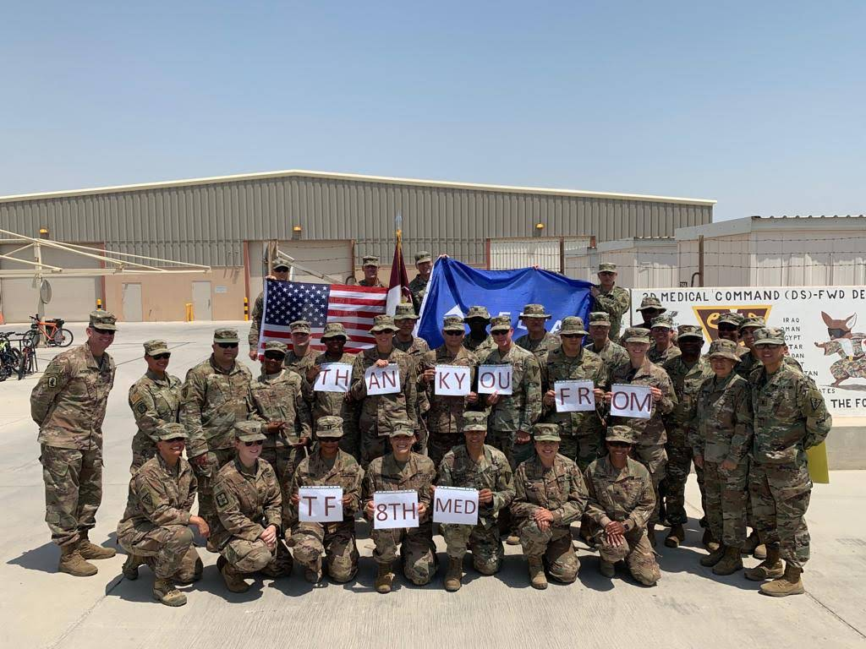

8. Beware of Scammers.

Watch out: Scammers are out there pretending to be from Con Edison. Don’t be a victim. Beware of these common scams.

Smart Meter Scams The latest scams involve smart meters.

* We DO NOT require deposits for installation of a smart meter.
* We also do not accept Bitcoin as payment for products and services.

Website and Email Scams

Always check the url. You can only pay your Con Edison bills through two sites.

* conEd.com – bank account (checking or savings).
* webpayments.billmatrix.com/ConEdResidential – credit or debit card

Phone Scams

In one of the most prevalent phone scams, a caller may:

* Pretend to be from Con Edison. They may even manipulate your caller ID to display Con Edison’s name.
* Threaten to turn off your power or gas within an hour.
* Demand immediate payment—often by prepaid debit card.

Door-to-Door Scams

When someone comes to your door claiming to be from Con Edison, ask for credentials. It’s not rude, it’s safe.

How to Recognize Our Employees

Here’s how to tell a real Con Edison employee from a fake one.

* An employee will readily prove their identity. An imposter won’t.
* An employee will wear a photo ID with their name and employee number.
* An employee will gladly give you their supervisor’s name, the unique “ticket” number assigned to your job, and ask you to call 1-800-75-CONED ([1-800-752-6633](tel:+18007526633)) to verify their identity.

Con Edison employee:

We wear different uniforms depending on the season and the kind of work we do, but we always have ID.

Suspect a Scammer?

Call the police or 1-800-75-CONED ([**1-800-752-6633**](tel:+18007526633)).

Keep others safe. Share these tips with your neighbors, family members, and the elderly.

**Items of Interest**

New York State Senate 2019 Veterans’ Hall of Fame Honoree Profile

John Diana, US Army, Corporal

John Diana of Staten Island is a decorated U.S. Army Korean War veteran who served from 1952 through 1954, most notably with the 204th Field Artillery in Korea. The 204th’s orders were to provide artillery support to various battles, including Pork Chop Hill. While regrouping, Mr. Diana’s unit came under surprise artillery attack and he was literally blown off his tank. Mr. Diana suffered severe burns and damage to his legs and lost over 60% of his hearing. Subsequent to being released from the Army hospital in Seoul, he was reassigned to the duty of battalion commander’s driver. These duties included driving personnel carriers and visiting forward areas to pick up the dead and wounded for transport to hospital and morgue locations. The experience of dealing with death and dismemberment on a daily basis still haunts Mr. Diana’s memory. After discharge, it was discovered that the cartilage in both legs had been severely damaged and not repaired properly. Mr. Diana underwent extensive surgery to alleviate the pain and moderate the effects of the damage. Mr. Diana is a most modest and unassuming veteran. For his valor, he received the Purple Heart, three Bronze Stars and various United Nations and Presidential service medals and citations – seven in all. Understandably, Mr. Diana rarely talks about his experiences and contributions to his country, nor does he mention his medals and awards. Mr. Diana is proud of his service to his country and to the family he loves. He is truly one of the walking wounded who has dealt with the horrors of the battlefield on a daily basis and who cannot forget those images and experiences. It is the contribution of soldiers like John Diana that we must not forget.