VETERANS OF FOREIGN WARS BLAZING STAR POST #1574
17 CANNON AVENUE
STATEN ISLAND, NY 10314
Website. http://blazingstarvfwpost1574.org/wp

June 2020

BLAZING STAR POST 1574 CONTACT NUMBERS
Al Porto, Commander - 718-578-1242, albert.porto38@gmail.com
Paul Dietrich, Quartermaster - 718-698-5269, paul@the-dietrichs.com
William Alcock, Adjutant - 718-698-1923

Calendar Events

Date | Event | Location | Time | Remarks
6 June 2020 | Blazing Star Post Meeting | Gold Star Post | 1000 | Cancelled
11 July 2020 | Blazing Star Post Meeting | Gold Star Post | 1000 | To Be Determined
1 August 2020 | Blazing Star Post Meeting | Gold Star Post | 1000 | Saturday
2 September 2020 | Blazing Star Post Meeting | Gold Star Post | 1300 | Wednesday
7 October 2020 | Blazing Star Post Meeting | Gold Star Post | 1300 | Wednesday
4 November 2020 | Blazing Star Post Meeting | Gold Star Post | 1300 | Wednesday
2 December 2020 | Blazing Star Post Meeting | Gold Star Post | 1300 | Wednesday

Coronavirus/COVID-19 Update

1. Burial Assistance during COVID-19 Pandemic
Burial Assistance https://www1.nyc.gov/site/hra/help/burial-assistance.page
To address the unprecedented impact of the COVID-19 Pandemic, DSS/HRA issued an emergency rule:
- Increasing the burial allowance from $900 to $1,700 and increasing the cap on burial costs from $1,700 to $3,400.
- Extending the timeframe for when you can apply to 120 days from the date of the individual‘s death.
Applications received on or after March 12, 2020 will be considered for the increased burial assistance allowance. All applications received will be reviewed regardless of immigration status.
Due to the COVID-19 pandemic our office hours are limited, we are open to the public on Wednesdays between 9:00 a.m. and 5:00 p.m. To help stop the spread of COVID-19, many HRA locations are consolidating until further notice. If your needs cannot be met by ACCESS HRA, call 311 or consult the HRA Locations page for more information.
Contact the NYC HRA Office of Burial Services:
Our office is now located at:
33-28 Northern Blvd. - 3rd Floor
Long Island City, NY 11101
You can call us at:
929-252-7731
Please leave a message and an OBS staff member will return your call before the end of the next business day.
Burial Allowance Application M-860W:
View the Application for Burial Allowance and find out more about what HRA will cover.
Learn more about the application process below.
Ways to apply:
In-Person or Mail:
NYC HRA Office of Burial Services, 33-28 Northern Blvd. - 3rd Floor Long Island City, NY 11101
Fax:
The application can be faxed to 917-639-0476
Email:
The application can be emailed to BurialServices@hra.nyc.gov
Call us at 929-252-7731 if you need a copy of the application and we will mail or email you an application. If you need assistance with completing the on-line application, give us a call.

Membership

REMINDER >>>>>>>>>>>>>>>>>>>>>>MEMBER CONTACT INFORMATION<<<<<<<<<<<<<<<<<<<<REMINDER

IF ANY OF YOUR CONTACT INFORMATION (ADDRESS, PHONE NUMBER, EMAIL ADDRESS) CHANGES, PLEASE NOTIFY US AS SOON AS POSSIBLE IN ORDER TO MAINTAIN COMMUNICATIONS FOR MEETINGS AND IMPORTANCE ANNOUNCEMENTS.

REMINDER >>>>>>>>>>>>>>>>>>>>>>MEMBER CONTACT INFORMATION<<<<<<<<<<<<<<<<<<<<REMINDER

A Note from Marjorie Malone

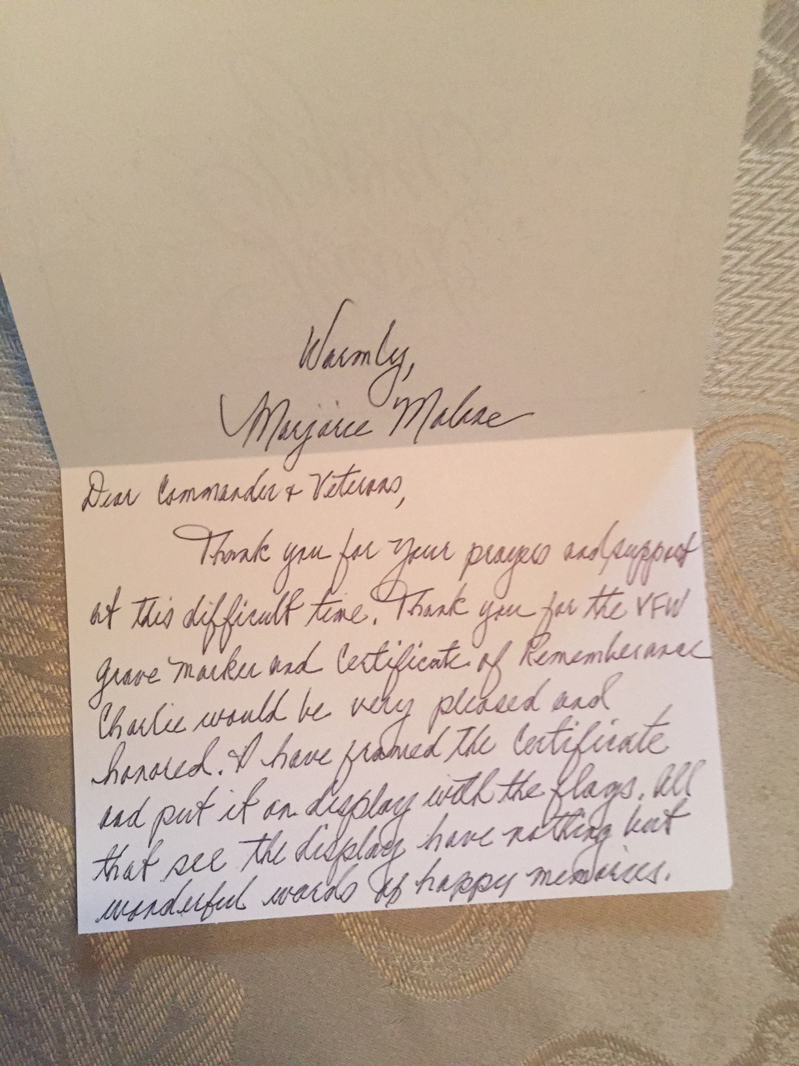

1. Consider Life Membership. You save money over the long run and eliminate the need to renew yearly. Below are the membership rates for Life membership and Installment Plan Life Membership.

Age on 31 Dec Payment in Full Installment Plan Option
Total: Initial Fee: 11 payments of:
Through Age 30 $425.00 $45.00 $38.64
31-40 $410.00 $45.00 $37.27
41-50 $375.00 $45.00 $34.09
51-60 $335.00 $45.00 $30.45
61-70 $290.00 $45.00 $26.36
71-80 $225.00 $45.00 $20.45
81 and over $170.00 $45.00 $15.45

2. Dues Renewal Reminder:

 | Tse, Tony |  |  |  | Current Until | 6/30/2020 | 27
 | Lewis, Daniel M |  |  |  | Current Until | 6/30/2020 | 27

Service Officer

1. Veterans are encouraged to enroll in the VA health care so they are on record should they ever need it. No cost to apply. Apply on line at www.va.gov/healtheligibility/vfw or call 1-877-222-8387.

2. DD Form 214 website. http://vetrecs.archives.gov. If you need assistance, contact the post service officer, Doug Encarcion.

3. Survivor Outreach Services. The website has a lot of information for those left behind when a service member or veteran passes. http://www.sos.army.mil/ or http://www.westpointmwr.com/acs/survivor_outreach_services.html

4. To someone going through a difficult time, one simple act has the power to make a difference. Reach out to veterans and service members in your life today – http://www.veteranscrisisline.net/ThePowerof1.aspx.

5. Online Health Care Application. www.vets.gov. or call 877-222-VETS (8387).

6. Veterans Representative on Staten Island. Monique L. Rada Engagement and Community Services Coordinator
NYC Department of Veterans’ Services 1 Centre Street, Suite 2208 New York, NY 10007 917-628-8487 mrada@veterans.nyc.gov

7. Vets.gov Connects Veterans to Services.

8. John Bartow, Assistant VSO, Veterans of Foreign Wars 518-626-5687.

9. The following web site is the medical providers close to your house who have accepted the VA Choice program and are registered to do so. Quite a few here on SI. It gives a map where you can see them in relation to where you live or work. You can also get contact information to reach out to them. https://www.va.gov/opa/apps/locator/

10. A VBA Representative at the Staten Island Vet Center every Wednesday. There are no walk-ins everyone must call (718)816-4499 to set up an appointment. All services are free. Samuel B. Cottes, Jr., Veterans Outreach
Specialist, Staten Island Veterans Center, US Department of Veterans Affairs; Readjustment Counseling Services, 60 Bay Street, Staten Island, NY 10301 Tel: (718) 816-4499 x 7747 Cell: (929) 359-2449 Fax: (718) 816-6899

11. Discharge Upgrade Online Tool.
http://www.ourveterans.nyc/discharge_upgrade_online_tool?utm_campaign=180129&utm_medium=email&utm_source=nycveteransalliance

12. Burial in a VA National Cemetery and for Memorial Products

What if I don’t have the discharge document(s)?
It is helpful if you are able to provide the discharge document(s). This will reduce delays and ensure we have the most accurate military information for inscribing the headstone or marker. However, if you do not have the Veteran’s discharge document(s), the Staten Island Vet Center will help obtain the information needed to determine eligibility.

What will a funeral director do?
A funeral director will assist the family by gathering and providing the documents needed by VA, calling the National Cemetery Scheduling Office to schedule the burial, acquiring a burial flag, requesting Military Funeral Honors from the Department of Defense and serving as a liaison between the family and VA for burial matters.

What does burial in a VA national cemetery include?
Veterans, Service members or family members eligible for burial in a VA national cemetery receive certain burial benefits at no cost. These burial benefits include:
- A gravesite in any of our 141 national cemeteries with available space,
- Opening and closing of the grave,
- A burial liner,
- A headstone or marker (no application needed),
- A Presidential Memorial Certificate (no application needed) and
- Perpetual (ongoing) care of the gravesite.
Can I plan ahead for my burial in a VA national cemetery?
Yes, you can plan ahead to make the process of applying for a burial in a VA national cemetery easier for your family members in the event of your death. To do this, you will need to apply for pre-need eligibility determination by completing a VA Form 40-10007, Application for Pre-need Determination of Eligibility for Burial in a VA National Cemetery and submitting it to the address on the form. Veterans, spouses, Retirees, National Guard and Reserve members are encouraged to apply. However, pre-need eligibility is not required.

Are Military Funeral Honors provided at a VA national cemetery?
The Department of Defense is responsible for providing Military Funeral Honors at VA national cemeteries. “Honoring Those Who Served,” calls for funeral directors to request Military Funeral Honors on behalf of Veterans’ families.
Veterans Service Organizations may assist in the provision of Military Funeral Honors. VA national cemetery staff may also assist to coordinate Military Funeral Honors.

Can a government headstone or marker be provided if a private headstone or marker is already on the grave?
If the Veteran died on or after November 1, 1990, is buried in a private cemetery, and the gravesite is marked with a privately-purchased headstone or marker, the Veteran is eligible for a government-furnished headstone or marker for placement on the same gravesite.
Employment and Education

1. Looking for a job? Need quality employees? USE VETJOBS! www.vetjobs.com

2. Vets looking for jobs, the website: 100000jobsmission.com. Go there to apply and search for available jobs specifically held for veterans.

Bottom of Form
General

1. Staten Island University Hospital's Military Appreciation Program. This program entitles active duty members and veterans free parking 12 times per year at the SIUH parking lot. Go to the Security Office with proof of military/veteran status. You will be given 12 parking stamps. Place them on parking ticket and no fee.

2. Free parking for veterans at Richmond County Medical Center. Veterans can park for free in the visitors parking lot where tokens are required. Stop at the main reception desk or security post, show proof you are a veteran (driver’s
license with vet on it, retired ID card, VA card or similar) and they will give you a free token for the parking lot. Get it on the way in as the reception/info desk is not manned all night. Use the token to exit the lot. Saves you $4 per visit.

3. The Defense POW/MIA Office announced the identification of remains belonging to the following personnel. Returned
home are:

USMCR Pfc. Charles D. Miller, 19, Co A, 1st Bn, 6th Marine Regt, 2nd Marine Div, Tarawa Atoll, Nov. 22, 1943.
Army Sgt. Jesse D. Hill, 20, Co C, 1st Bn, 32nd Inf Regt, 7th Infantry Div, Chosin Reservoir, North Korea, Dec. 2, 1950.
U.S. Navy Metalsmith 1st Class Leonard F. Smith, 29, USS Oklahoma, Pearl Harbor, Dec. 7, 1941.
USMCR Pfc. Thomas F. Johnson, 18, Co B, 1st Bn, 6th Marine Regt, 2nd Marine Div, Tarawa Atoll, Nov. 23, 1943.
Army Pvt. Charles Andrews, 25, Co K, 3rd Bn, 28th Inf Regt, 8th Infantry Div, Hürtgen Forest, Dec. 4, 1944.
USMCR Pvt. Howard E. Miller, 22, Co A, 1st Bn, 6th Marine Regt, 2nd Marine Div, Tarawa Atoll, Nov. 22, 1943.
Army Cpl. R.B. Cherry, 19, Co G, 2nd Bn, 24th Inf Regt, 25th Infantry Div, Anju, North Korea, Nov. 27, 1950.
Army Sgt. William E. Cavender, 20, HQ Co, 3rd Bn, 31st Inf Regt, Chosin Reservoir, North Korea, Nov. 28, 1950.
USMC Pfc. Mervin D. Galland, 24, Co B, 1st Bn, 6th Marine Regt, 2nd Marine Div, Tarawa Atoll, Nov. 22, 1943.
Navy Fireman 1st Class Louis J. Tushla, 25, USS Oklahoma, Pearl Harbor, Dec. 7, 1941.

4. The Defense POW/MIA Accounting Agency is seeking the public’s help to find and encourage more MIA families to donate a DNA sample to help speed the identification process of recovered remains. Each military service and the State Department has a service casualty office that can explain how to donate.

Army: 800-892-2490 | Navy: 800-443-9298 | State Department: 202-485-6106
Marine Corps: 800-847-1597 | Air Force: 800-531-5501

5. Staten Island Community TV: Veterans TV Shows are available 24 hours a day via Youtube. To view, google "Youtube, Ed Salek, In Honor of" or go to Youtube.com and search for Ed Salek, In Honor of.

6. Every year our post looks for students to compete in our annual contests for patriotic theme writing. This year our top patriots pen winner was second place in the State of NY and received collective prizes of $2000. National top prize is $5000. Patriots pen is for 6-8 grades and involves writing a theme on a prescribed patriotic topic of not more than 400 words. The second contest is called the Voice of Democracy and is for high school students.(all grades) Again the topic is a prescribed patriotic topic and the essay must be spoken into a dvd or zip stick for submission. This year our entrant made it to second place in our district and received $250. National top prize is a $30,000 scholarship. If you have children or grandchildren in these age groups please contact Paul Dietrich for an application as we would love to have a winner within our membership. Other contests include Scout of the year for Eagle or Gold Scouts again with scholarships. This year we had an entry who received $250. If you know a patriotic teacher, there is a teacher of the year contest with prizes of up to $1,000 for the teacher and the same for their school. Similar contests for emergency responders such as firemen, EMTs, police. If you know of one, please contact Paul Dietrich on how to apply.

Items of Interest

Company F, 40th Armor Regiment

BY FORCE AND VALOR

Constituted 13 January 1941 in the Regular Army s Company F, 4th Armored Regiment, an element of the 3rd Armored Division. Activated 15 April 1941 at Cam Beauregard, Louisiana. Redesignated 8 May 1941 as Company F, 40th Armored Regiment. Inactivated 1 January 1942 at Camp Beauregard, Louisiana (40th Armored Regiment concurrently relieved from assignment to the 3rd Armored Division). Activated 2 March 1942 at Camp Polk, Louisiana (40th Armored Regiment concurrently assigned to the 7th Armored Division). Absorbed in 40th Tank Battalion 20 September 1943 at Fort Benning, Georgia, in reorganization and redesignation of elements of the 40th Armored Regiment as 40th Tank Battalion, an element of the 7th Armored Division (40th Tank Battalion [less Companies C and D] reorganized and redesignated 25 July 1945 as 40th Amphibian Tractor Battalion; Companies C and D concurrently disbanded. 40th Amphibian Tractor Battalion inactivated 22 February 1946 at Camp Kilmer, New Jersey; redesignated 25 June 1948 as 40th Heavy Tank Battalion and assigned to 4th Infantry Division; activated 6 July 1948 at Fort Ord California; redesignated 18 November 1950 as 40th Tank Battalion, transferred [less personnel and equipment] from Fort Ord, California, to Fort Benning, Georgia, and reorganized; inactivated 1 April 1957 at Fort Lewis, Washington, and relieved from assignment to 4th Infantry Division). Former Company F, 40th Armored Regiment, reconstituted 15 October 1957 in the Regular Army and redesignated as Headquarters and Headquarters Company, 6th Medium Tank Battalion, 40th Armor. Redesignated 2 May 1958 as Company F (Patton), 40th Armor. Activated 1 June 1958 in Germany. Assigned 1 December 1963 to Berlin

Brigade. Redesignated 6th Battalion, 40th Armor September 1990. Inactivated May 1992.

Campaign Participation Credit

World War II, EAME

Northern France Ardennes-Alsace

Rhineland Central Europe

Decorations

Belgian Fourragere 1940 (40th Tank Battalion cited; DA GO 43, 1950)

Cited in the Order of the Day of the Belgian Army for action December 1944 in the ARDENNNES

Cited in the Order of the Day of the Belgian Army for action January 1945 in BELGIUM

Notable Unit Member: Sal Balistreri, 1963-66

